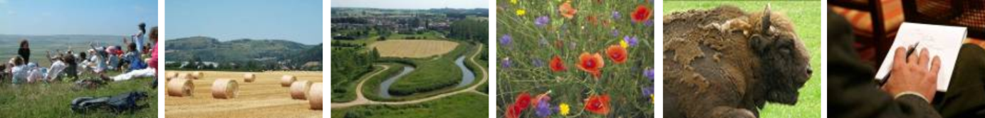

Natura 2000 Biogeographical Process - Alpine River Restoration Workshop
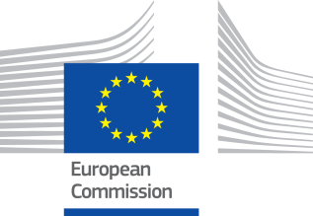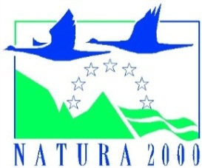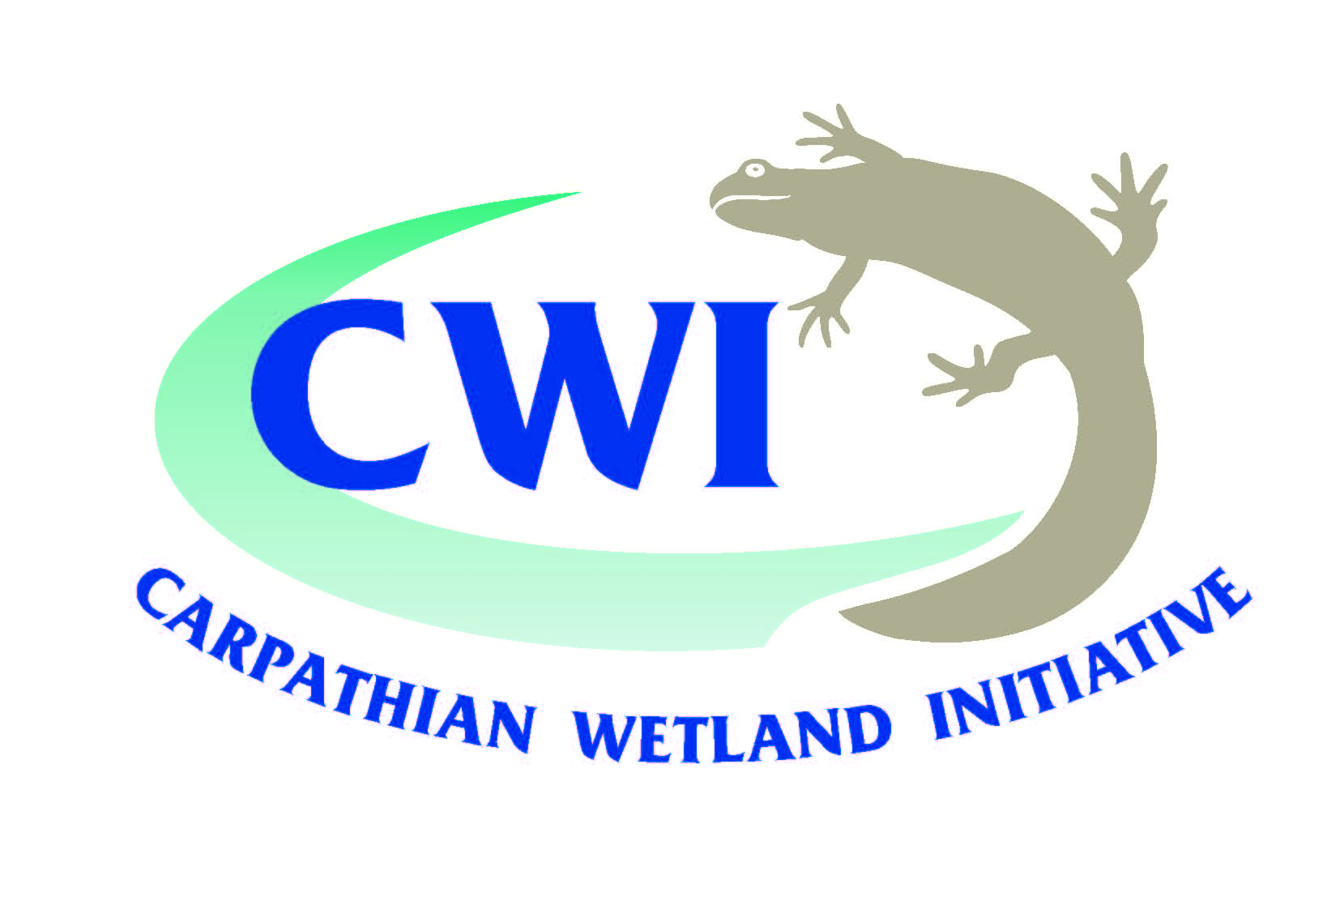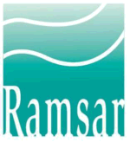

Hotel Tenis, Zvolen, Slovak Republic, 3 & 4 September 2014

Participants list

Name | Position | Organisation | Country | E-mail
Dr Sergei Afanasiev | Deputy Head | Institute of Hydrobiology National Academy of Sciences of Ukraine | Ukraine | safanasyev@ukr.net
Dr Štefan Aschenbrenner |  | Slovak Water Management, SVP š.p Banská Bystrica | Slovak Republic | stefan.aschenbrenner@svp.sk
Ms Martina Barancová | Programe Manager | Nadácia Ekopolis | Slovak Republic | paulikova@ekopolis.sk
Mr Peter Beleš | President | RIVER - civic association for the protection of watercourses | Slovak Republic | peter.beles@ozrieka.sk
Ms Olena Bilous | Senior Scientist | Institute of Hydrobology, National Academy of Sciences of Ukraine | Ukraine | safanasyev@ukr.net
Dr Mitja Brilly | Professor | University of Ljubljana | Slovenia | mbrilly@fgg.uni-lj.si
Mr Ján Černecký |  | State nature conservancy of the Slovak Republic | Slovak Republic | jan.cernecky@sopsr.sk
Ms Ramona Curelea | Geographer | National Administration Romanian Waters | Romania | ramona.curelea@rowater.ro
Ms Jana Durkošová | Senior Advisor | Ministry of the Environment of the Slovak Republic | Slovak Republic | jana.durkosova@enviro.gov.sk
Mr Bernie Fleming | Director | Fleming Ecology | United Kingdom | bernie@flemingecology.co.uk
Ms Renata Grofova | Expert in Water and Water Management | Slovak Environment Agency | Slovak Republic | renata.grofova@sazp.sk
Mr Marián Horváth | Expert | Coalition for Rivers | Czech Republic | marian.horvath@outlook.com
Mr Ján Kadlečík |  | State Nature Conservancy of the Slovak Republic | Slovak Republic | jan.kadlecik@sopsr.sk
Ms Simona Kaligaric | Senior Consultant | Institute of the Republic of Slovenia for Nature Conservation | Slovenia | simona.kaligaric@zrsvn.si
Mr Vlastimil Karlík | Statutory Representative | Coalition for Rivers | Czech Republic | karlik@koaliceproreky.cz
Mr Daniel Kindernay |  | Slovak Water Management | Slovak Republic | daniel.kindernay@svp.sk
Ms Mathilde Köck | Consultant | UNEP Vienna ISCC | Austria | mathilde.koeck@unvienna.org
Mr Igor Kokavec |  |  | Ukraine | kokavec99@gmail.com
Ms Adriana Kušíková | Nature Conservation Officer | Ministry of the Environment of the Slovak Republic | Slovak Republic | adriana.kusikova@enviro.gov.sk
Mr Ludovic Le Maresquier | Policy Officer | European Commission, DG Environment | Belgium | ludovic.le-maresquier@ec.europa.eu
Ms Zuzana Lichá |  | State Nature Conservancy of the Slovak Republic | Slovak Republic | zuzana.licha@sopsr.sk
Ms Olena Lietitska | Senior Scientist | Institute of Hydrobiology of the National Academy of Sciences | Ukraine | lietitska@ukr.net
Ms Laura Máiz-Tomé | Assistant Advisor for Europe | Ramsar Convention Secretariat | Switzerland | europe@ramsar.org
Ms Olena Marushevska | Project Manager | Zakarpattya Oblast Branch of All-Ukrainian League | Ukraine | pripyat@i.kiev.ua
Ms Carina Mielach | Scientific Assistant | Institute of Hydrobiology and Aquatic Ecosystem Management - University of Natural Resources and Life Sciences Vienna | Austria | carina.mielach@boku.ac.at
Mr Andrei Moarcas | Policy Officer | WWF DCP Romania | Romania | amoarcas@wwfdcp.ro
Mr Tomáš Navara | PhD Student | Faculty of Natural Sciences, Commenius University | Slovak Republic | navara.tomas@gmail.com
Dr Miroslava Plassmann |  | WWF Danube Carpathian Programme | Austria | mplassmann@wwfdpo.org
Mr Radoslav Považan |  | SAŽP | Slovakia | radoslav.povazan@sazp.sk
Mr Andrej Saxa |  | State Nature Conservancy of the Slovak Republic | Slovakia | andrej.saxa@sopsr.sk
Dipl.-Ing. Dr. Rafaela Schinegger | Post-doc Researcher | Institute of Hydrobiology and Aquatic Ecosystem Management, Department of Water, Atmosphere and Environment. BOKU, University of Natural Resources and Life Sciences | Austria | rafaela.schinegger@boku.ac.at
Ms Monika Supekova | Water Manager | Slovak Water Management Enterprise | Slovak Republic | monika.supekova@svp.sk
Ms Tereza Thompson |  | State Nature Conservancy of the Slovak Republic | Slovak Republic | tereza.thompson@sopsr.sk
Mr Tomas Trosko | Senior Advisor | Ministry of Environment, Water Section | Slovak Republic | tomas.trosko@enviro.gov.sk
Mr Andrej Vidmar | Senior Researcher | University of Ljubljana | Slovenia | avidmar@fgg.uni-lj.si
Ms Liliana Virtopeanu | Counsellor | Ministry of Environment and Climate Change | Romania | liliana.virtopeanu@mmediu.ro
Ms Katarina Zabret | Researcher | University of Ljubljana | Slovenia | katarina.kavcic@fgg.uni-lj.si
Mr Anton Žabensky |  | OZ Rieka | Slovakia

