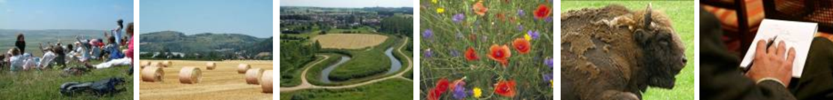

Natura 2000 Biogeographical Process

Alpine River Restoration Workshop
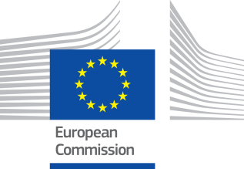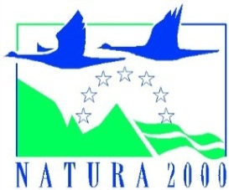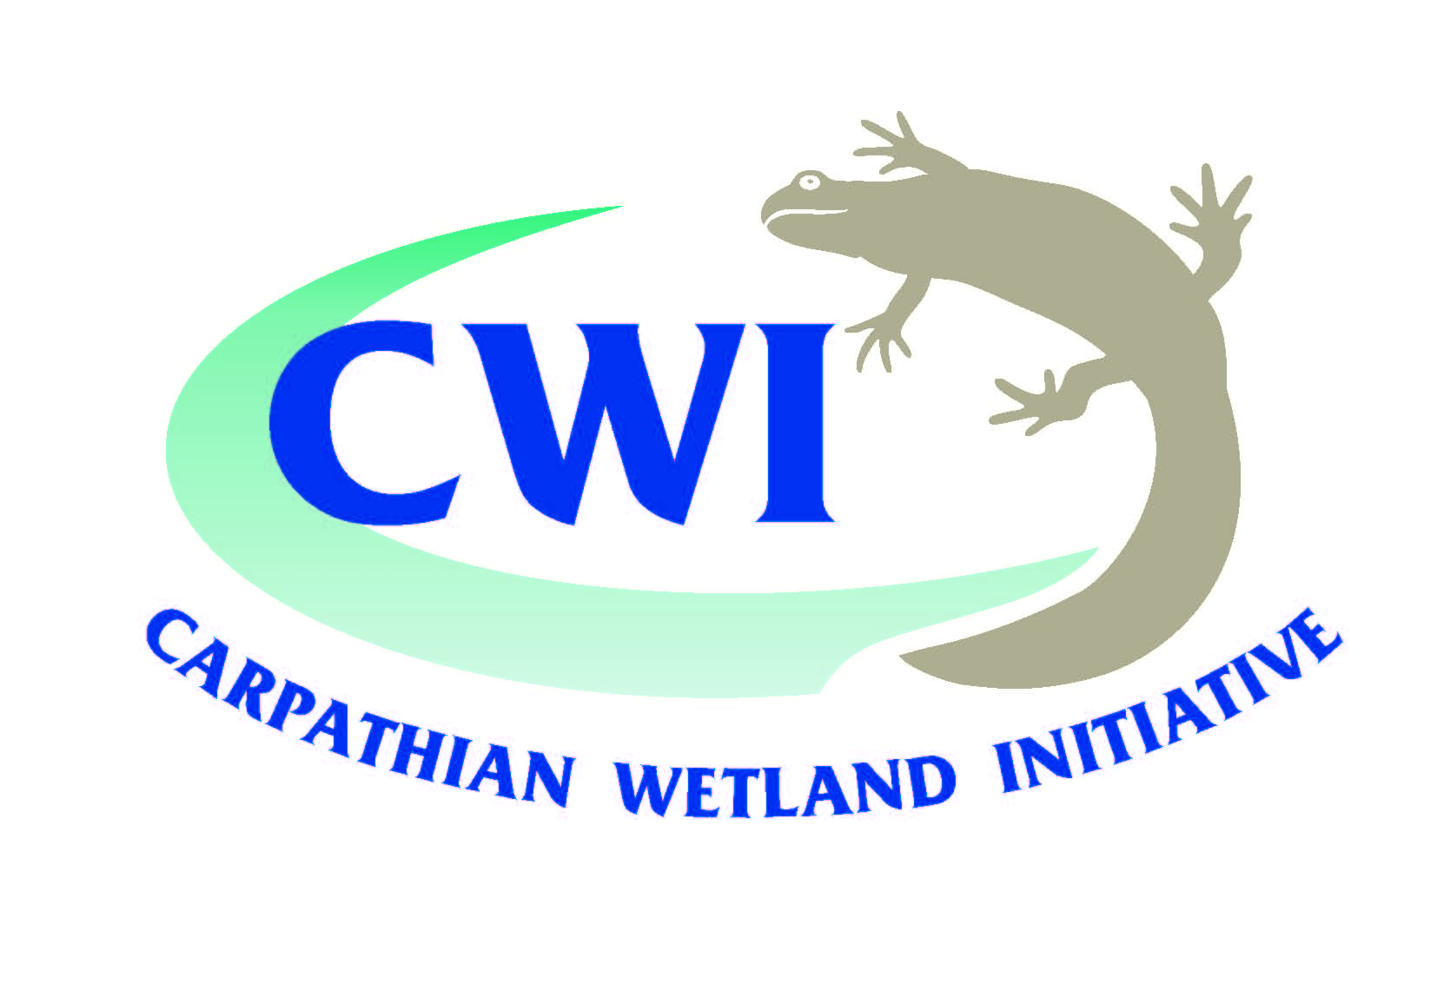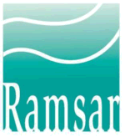

Hotel Tenis, Zvolen, Slovak Republic, 3 & 4 September 2014

Programme

Wednesday, 3 September, day 1
08:30 – 09:00 | Registration (and coffee)
Opening and introduction
09:00 – 09:30 | Official welcome & opening speeches  Ms Jana Durkošová, Division of Nature Protection and Landscape Development, chair of the workshop  Mr Ján Kadlečík, State Nature Conservancy of the Slovak Republic  Ms Laura Máiz-Tomé, Assistant Advisor for Europe, Ramsar Convention Secretariat  Ms Monika Supeková, Slovak Water Management Enterprise, state enterprise
09:30 – 09:45 | Introduction to the new biogeographic process)  Mr Ludovic Le Maresquier, European Commission, DG Environment
09:45 – 10:00 | Overview of the workshop program and introduction to site visits  Mr Bernie Fleming, ECNC-European Centre for Nature Conservation  Ms Tereza Thompson, State Nature Conservancy of the Slovak Republic
10:00 – 10:30 | Coffee and prepare to depart for site visits
Excursions and Knowledge Market
10:30– 18:00 | Excursion to the Hron/Slatina Rivers (tributary of the Danube)  (for details see page 4 – pack lunches are provided)
19:00 – 20:30 | Knowledge market and buffet dinner

With the support of | 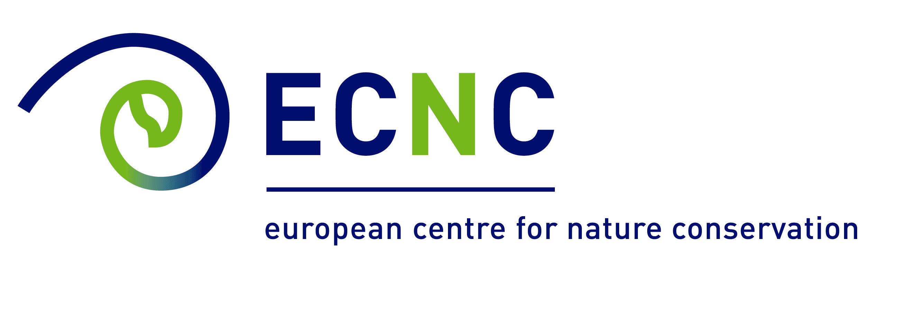

Thursday, 4 September, day 2

Framework presentations and discussion
09:00 – 09:15 | Re-cap of Day 1 and Introduction to Day 2  Ms Jana Durkosova, Chair and Mr Bernie Fleming, ECNC-European Centre for Nature Conservation
09:15 – 09:35 | Presentation on EU directives (Water framework and Nature directives, reporting requirements, EU guidelines)  Mr Ludovic Le Maresquier, European Commission, DG Environment
09:35 – 09:55 | Carpathian Wetland Initiative  Mr Jan Kadlecik, State Nature Conservancy of the Slovak Republic & Carpathian Wetland Initiative
09:55 – 10:15 | Strategic tools for sustainable hydropower development  Ms Carina Mielach, Institute of Hydrobiology and Aquatic Ecosystem Management  University of Natural Resources and Life Sciences, Vienna
10:15 – 10:30 | Discussion  Moderated by Mr Bernie Fleming
10:30 – 11:00 | Coffee break
Case study presentations and discussion - Impact assessment in Alpine rivers
11:00 – 11:15 | Assessment of impact of construction and operation of small Hydroelectro power plants on fish fauna and ecological state of Ukrainian Carpathians  Dr Sergei Afanasiev, Deputy Head & Ms Olena Bilous, Senior Scientist, Institute of Hydrobiology National Academy of Sciences of Ukraine, Ukraine
11:15 – 11:30 | Project AIM - Alpine space in Movement, targeted to water and energy capitalization  Ms Rafaela Schinegger, Institute of Hydrobiology and Aquatic Ecosystem Management  University of Natural Resources and Life Sciences, Vienna
11:30 12:30 | Questions & moderated plenary discussion  Moderated by Jana Durkosova and Bernie Fleming  - Lessons learned & best practices  - Common priorities  - Implications and opportunities for collaboration  - Follow up activities: twinning, study visits, transborder cooperation. Funding opportunities: LIFE, INTERREG, IPA, ERASMUS, see http://www.financing-natura2000.eu/
12:30 – 14:00 | Lunch & networking

Case study presentations and discussion - Restoration of Alpine rivers
14:00 – 14:20 | LIFE project “Ljubljanica connects”  Mr Andrej Vidmar, Senior Researcher, Ms Katarina Zabret, University of Ljubljana, Slovenia
14:20 – 14:40 | Restoration of ecological status of mountainous stream after forest cuttings in Ukrainian part of Tisza basin: biological, economic and social aspects  Ms Olena Lietitska, Senior Scientist, Institute of Hydrobiology of National Academy of Sciences, Ukraine & Ms Olena Marushevska, project manager, Zakarpattya Oblast Branch of All-Ukrainian League, Ukraine
14:40 - 15.40 | Questions & plenary discussion  Moderated by Jana Durkosova and Bernie Fleming  - Lessons learned & best practices  - Common priorities  - Implications and opportunities for collaboration  - Follow up activities: twinning, study visits, transborder cooperation. Funding opportunities: LIFE, INTERREG, IPA, ERASMUS, see http://www.financing-natura2000.eu/
15:40– 16:00 | Coffee break
Conclusions and recommendations
16:00 – 17:00 | Moderated by Jana Durkosova and Bernie Fleming  - Lessons learned & best practices  - Common priorities  - Implications and opportunities for collaboration  - Follow up activities: twinning, study visits, transborder cooperation. Funding opportunities: LIFE, INTERREG, IPA, ERASMUS, see http://www.financing-natura2000.eu/

Excursions:
There are 2 parallel excursions planned. For both, transport by bus will be organized (individual travelling by car may prefer to use their own vehicle) and guided tours provided, both for nature and water management issues.

1st excursion will be to the Slatina River, the Hriňová Water Dam and to the historical (former mining town) Banská Štiavnica with a unique system of “tajchy”, the Pstruša” Nature Reserve will be visited, too.
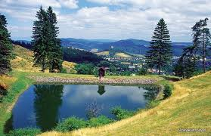

2nd excursion will follow the Hron River from its spring and meanders and valuable riverbed (all being protected areas), to the historically important set of water dams Dolný Harmanec, as well as Jelenec and Motyčky and migration barrier at Hronská Dúbrava.
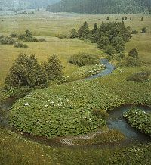

Telephone contacts on organisers (only during the workshop)
- Tereza Thompson 00421-948-502022
- Jan Kadlečík 00421-903-298105

