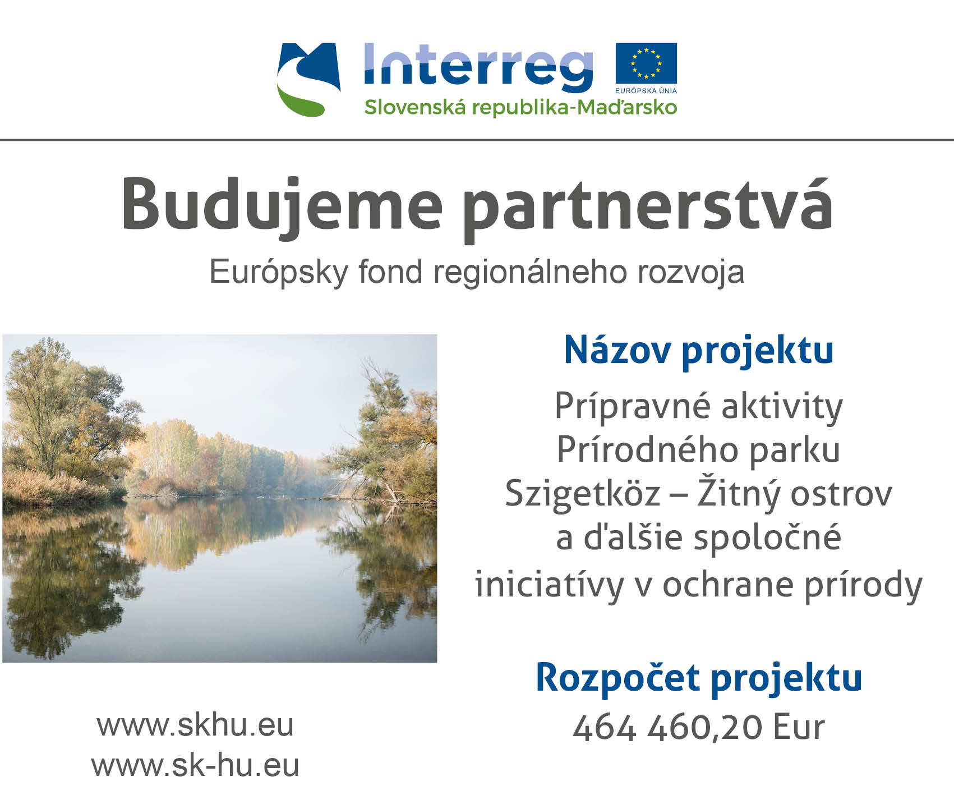
Programme: Interreg V-A Slovakia Hungary Cross Border Cooperation Programme
Priority Axis: PA4 | Enhancing cross-border cooperation of public authorities and people living in the border area
Názov projektu AJ: Preparation Activities of the Szigetköz-Žitný Ostrov Nature Park and Further Joint Nature Protection Initiatives
Acronym: NAT-NET DUNA/DUNAJ 2
Project Number: SKHU/1601/4.1/121
Project start date: 01.07.2017
Project end date: 30.06.2019
Project duration: 24 months
ŠOP SR budget: 109 374,00 Eur
Total project budget: 464 460,20 Eur
Lead Partner: Fertő-Hanság Nemzeti Park Igazgatóság
Project Partners:
- Regionálna rozvojová agentúra Šamorín
- Štátna ochrana prírody Slovenskej republiky
- Pisztráng Kör Waldorf Természetvédő és Természetjáró Egyesület
- Mosonmagyaróvár Város Önkormányzata
Project Description:
The foremost innovative element of the project is to combine all initiatives in the fields of nature conservation, rural development, environmental education, ecotourism and the preservation of natural and cultural heritage in the Szigetköz-Žitný ostrov region, and to establish the basic preconditions of a joint, cross-border institution (Nature Park) to co-ordinate these measures in a sustainable way. The LB is well experienced in this field, as the Fertő-Hanság National Park functions as a cross-border National Park along the AT-HU border together with the National Park Neusiedler See-Seewinkel. Thus the most important added value of the project is to establish all relevant preconditions to launch a joint Nature Park, enabling to represent the natural and cultural values of the Szigetköz-Žitný ostrov region much more effectively, then in the previous years.
The other project activities also contain numerous innovative features, e.g.: the mobile interactive exhibitions and the mobile lab to be developed by three project partners on both sides of the border are unprecedented in the project area. The main novelty element of these exhibitions is that they can be transported on a trailer or a micro bus, making it possible to present these exhibitions in various locations during the implementation period of the project reaching several thousands of visitors.
The establishment of the eco-mobile fleets has been an innovation of the previous NAT-NET DUNA/DUNAJ project, realised by the same project partners, this project is aiming at the extension of these fleets, by procuring further eco-mobile means of transport (including a new solar boat).
Another innovative element is the development of the Geocaching Greenway by PKE. Geocaching is one of the most innovative outdoor activities concerning hiking or ecotourism. By creating an app containing 5-5-5 routes of geocaching tours (on foot, by bike and by canoe) the interest will be increased towards this innovative service.
The long term objective of the project is to enhance cross-border co-operation of nature conservation organisations by creating a joint Nature/National Park in the Szigetköz-Žitný ostrov region.
The direct objectives of the project are:
• to realise joint activities aiming at the preparation of the Szigetköz Nature Park -Žitný ostrov National Park;
• to strengthen the co-operation between the HU and SK nature conservation institutions, and other organisations and to extend the fields of co-operation on the basis of the project results of the previous NAT-NET DUNA/DUNAJ project, realized by the same Project Partners within the HU-SK CBC Programme 2007-13;
• to enhance the already existing environmental education exchange programs of the HU partners, by procuring educational and outdoor equipment (e.g. binoculars, microscopes etc.) and organising joint workshops and field programs for HU and SK students;
• to enhance eco-mobility in the region by further developing and extending the eco-mobile fleets (established in the previous HU-SK project of the Project Partners), so that the natural values of the Szigetköz-Žitný ostrov region can be presented to the visitors using environment friendly, green means of transport, thus not risking the flora and fauna of the protected areas;
• to enhance the protection of the natural values in the Szigetköz-Žitný ostrov region, and to raise awareness of the local communities and students towards the protection of these values;
• to develop the Geocaching Greenway along the Danube, by extending the already created greenway by 20 new geocaching spots, and by creating an app containing several geocaching tours.

