Alpine Region

Background document

Draft 1

Prepared by: ECNC-European Centre for Nature Conservation (NL) and its consortium partners Arcadis Belgium (B), Aspen International (UK), Centre for Ecology and Hydrology (UK) and ILE SAS (SK), based on a pre-scoping document prepared by the ETC/BD

Authors: Ben Delbaere (ECNC)
Habitat information taken from pre-scoping document: Marita Arvela, Jerome Bailly Maitre, Zelmira Sipkova, Doug Evans, Brian Mac Sharry (MNHN), Mora Aronsson, Martin Tjernberg (SLU), Lubos Halada, Peter Gajdos (ILE-SAS) – ETC/BD
Carlos Romao - EEA

Copyright: © 2012 ECNC–European Centre for Nature Conservation

Funding: European Commission as part of contract number 07.0307/2011/60517/SER/B.3.

Disclaimer: ECNC is solely responsible for the content of this publication. It does not represent the opinion of the European Commission, nor is the European Commission responsible for any use that might be made of information appearing herein.

Introduction: the New Biogeographical Process (with specific reference to the Alpine biogeographical region)

The purpose of the New Biogeographical Process is to help Member States to manage Natura 2000 as a coherent ecological network, whilst exchanging experience and best practice, addressing objectives and priorities and enhancing cooperation and synergies. The process should contribute to the achievement of Favourable Conservation Status (FCS) for those habitats and species of community interest (listed in annex one of the Habitats Directive) that have been identified as having priority within the given biogeographical region, with a special focus on the contribution of the Natura 2000 network, but without ignoring horizontal measures where necessary.
In the context of the viability of the Natura 2000 network it is important to know how to ensure that habitats also achieve a level of favourable conservation status outside Natura 2000 site boundaries, and also how to address the major threats that occur there.
The process for each biogeographical region consists of three milestone meetings:
- Steering Committee (meetings): The Steering Committee has an essential role and each regional process starts with a meeting of the Steering Committee. It is composed of representatives of the Member States that fall in the biogeographical region and in addition the following organisations are also represented: European Commission (EC), European Environment Agency (EEA), and European Topic Centre on Biological Diversity (ETC/BD). Observers from other MS are also allowed to attend upon invitation. The Steering Committee reviews the pre-scoping document, and makes the final decision about the priority habitats and species, and the habitat groups.
- Preparatory Workshop: The workshop is used to prepare the seminar. The workshop is a very informal working meeting that provides the basic material and preparation for the Seminar. It is informed by the Background Document but does not consider the content or technical detail of the latter; rather it provides a set of themes (crosscutting or unique to the individual habitat groups) whose elaboration in terms of solutions and actions will form the basis of the seminar document. The role of the contractor regarding the preparatory workshop is to work with the EC and to assist MS in preparation, minutes, proceedings, organising, leading discussions, and to decide with MS on themes.
- Seminar: The Seminar is based on the Seminar Document whose content is derived from the preparatory workshop. Central to this document are a list of habitat groups related and crosscutting issues and problems whose solutions will directly contribute to achieving FCS. The seminar should draw conclusions and make recommendations regarding management and actions in relation to selected habitat types (based on the habitat specific and cross cutting issues). The seminar should result in a jointly agreed list of actions on the part of MS. As the seminar returns only once every five years, what happens in between is very important.
- Ad Hoc Expert Group Meetings can be held between the workshop and the seminar in order to address specific issues (which may be raised during the workshop or may become clear after the workshop).
- A pre-scoping document with lists of priority habitats and species is drafted by the ETC/BD. The pre-scoping document explains the selection of habitats and is posted on CIRCABC. The Contractor and partners are free to contact ETC/BD for information on the contents and composition of the pre-scoping doc.
- For each biogeographical region the pre-scoping document provides details on a selection of a manageable number of habitats and species: focusing on those habitat types where action is most needed. This first list is discussed and agreed with the Member States inside the biogeographical region during and shortly after a Steering Committee meeting.
- During any given biogeographical process, information is collected through the use of a targeted questionnaire. This is then compiled into a Background Document which informs the working groups within the preparatory workshop. The Background Document has a life beyond the seminar; it should therefore be continuously improved, modified and added to as each five-year cycle continues.
- The Seminar brings together key actors (including ministry and state institute officials, NGOs and stakeholders) from different countries for the exchange of practice and should result in the creation of expert networks about similar habitats inside a biogeographical region. The Biogeographical Process is to be used to assess of management practices and best practices and result in the formulation of recommendations based on the process.
- Internal Communication within the process for each biogeographical region is particularly important; thus:
- CIRCABC is currently the main internal information platform for the process: https://circabc.europa.eu;
- In order to make the relevant documents easily accessible, special interest groups for each Biogeographical Region (BGR) are created on CIRCABC;
- An Interest Group for the Alpine Steering Committee has already been created and is composed of representatives of the EC, the EEA, the ETC/BD and member states (MS).
- For the moment CIRCABC is to be used to store meeting agendas, minutes, documents.

The Alpine process is led by Austria. The Steering Committee of the Alpine process is composed of representatives of the 12 Member States (AT, BG, CZ, DE, ES, FR, FI, IT, PL, SE, SI, SK) and the EEA, ETC/BD, and EC. Based on the pre-scoping document and the discussions of the Steering Committee, four focus habitat groups were selected: forests, wetlands; grasslands; freshwater. For the Alpine process, a number of species has been identified that will be covered as part of cross-cutting issues.
An internet based platform for external and internal communication is being developed as part of project. The primary target audience for the internet platform should include those people that can take action for Natura 2000 (in a first instance site managers but also policy makers, civil society, and land owners).

The drafting process of the background document

The Alpine Background Document compiles the readily available information regarding 22 selected habitat types, as selected by the MS for the Alpine Seminar Process. In its first version it contains the habitat descriptions as included in a pre-scoping document, prepared by the European Topic Centre on Biological Diversity (ETC/BD) and the EEA. In a next steps, MS are invited to ask their habitat experts to complete an Expert Input Form to collect additional knowledge about the habitat types concerned.

The information that is collected in the pre-scoping document and by the expert input forms will be complemented by a selection of case studies that will illustrate specific issues that are referred to in the background document.

Description of the selected Habitat types

Introduction

This chapter provides overview information for each of the 22 selected priority habitat types.

The habitat types are presented in ascending order of their Natura 2000 code as introduced in Annex I of the EC Habitats Directive. The colour codes refer to the habitat groups to which they belong: freshwater (blue), grasslands (light green), wetlands (purple), forests (dark green).

CODE | HABITAT NAME
3140 | Hard oligo-mesotrophic waters with benthic vegetation of Chara spp.
3150 | Natural eutrophic lakes with Magnopotamion or Hydrocharition - type vegetation
3220 | Alpine rivers and the herbaceous vegetation along their banks
3230 | Alpine rivers and their ligneous vegetation with Myricaria germanica
3240 | Alpine rivers and their ligneous vegetation with Salix elaeagnos
3260 | Water courses of plain to montane levels with the Ranunculion fluitantis and Callitricho-Batrachion vegetation
6210 | Semi-natural dry grasslands and scrubland facies on calcareous substrates (Festuco - Brometalia) * important orchid sites
6230 | Species-rich Nardus grasslands, on silicious substrates in mountain areas (and sub-mountain areas in Continental Europe)
6410 | Molinia meadows on calcareous, peaty or clayey-silt-laden soils (Molinion caeruleae)
6430 | Hydrophilous tall herb fringe communities of plains and of the montane to alpine levels
6510 | Lowland hay meadows (Alopecurus pratensis, Sanguisorba officinalis)
6520 | Mountain hay meadows
7110 | Active raised bogs
7140 | Transition mires and quaking bogs
7230 | Alkaline fens
91D0 | Bog woodland
91E0 | Alluvial forests with Alnus glutinosa and Fraxinus excelsior (Alno-Padion, Alnion incanae, Salicion albae)
- 9130 | - Asperulo-Fagetum beech forests
- 9170 | - Galio-Carpinetum oak hornbeam forests
- 9180 | - Tilio-Acerion forests of slopes, screes and ravines
- 9260 | - Castanea sativa woods
- 9410 | - Acidophilous Picea forests of the montane to alpine levels (Vaccinio-Piceetea)

Legends for the maps, figures and tables

Factual information for each habitat type is given in the form of standard tables, figures and maps presented in the pre-scoping document. Reading and interpreting the maps, figures and tables provided by the EEA / ETC/BD requires a legend for their clear understanding. The respective legends and explanations are presented here, with cross-references to the sections within each habitat type.

Conservation status

For each habitat type, tables represent the conservation status of species and habitats.
code | status
FV | Favourable
U1 | Unfavourable – inadequate
U2 | Unfavourable – bad
XX | Unknown

Tables

Threats and pressures statistics

Pressures/threats are driven by the habitat type and the species sharing the same pressures/threats are noted in the table as well. This means that a species may have other pressures/threats as well, which do not appear in the table. Only those pressures/threats for habitat types are taken into account when they are reported by more than 1/3 of MS where the habitat type/species is present. If a pressure/threat is reported by more than 2/3 of MS this is indicated in light blue colour. If a pressure/threat is reported by all MS where the habitat type or species occurs, it is indicated with darker blue colour.

Habitat types and their associated species proposed by the ETC/BD

For each habitat type, a table presents the species that have been identified as particularly associated to the habitat type. It shows linkage at European level according to data by the ETC/BD. Where available additional information on country level has been included.

Explanations:
HD Annex II & IV species occurring in 8-12 MS
HD Annex II & IV species occurring in 3-7 MS
BD Annex I species occurring in 8-12 MS
BD Annex I species occurring in 3-7 MS

Background information sheets for selected 22 habitat types

Information is provided for the selected habitat types in the background information sheets on the following pages. Each of the selected habitat types has an information sheet including also information on the associated species (using Art 17 data).

A background information sheet for each habitat type includes:
- the description of each habitat type as in the EU Interpretation Manual of 2007;
- conservation status of the habitat types and the associated Annex II/IV species both at the Alpine region and at MS level (except for 9410, 9130, 9260 and 9170 no associated species given);
- most frequently reported threats and pressures (except for 9410, 9130, 9260 and 9170);
- number of SCIs and habitat area in hectares within the SCIs for the habitat type; and
- a map with SCIs and Article 17 distribution area of the habitat type in the Alpine region. The maps include information from D sites as well.

3140 - Hard oligo-mesotrophic waters with benthic vegetation of Chara spp.

Habitats Manual 2007
Lakes and pools with waters fairly rich in dissolved bases (pH often 6-7) (21.12) or with mostly blue to greenish, very clear, waters poor (to moderate) in nutrients, base-rich (pH often >7.5)(21.15). The bottom of these unpolluted water bodies are covered with charophyte, Chara and Nitella, algal carpets. In the Boreal region this habitat type includes small calcareous-rich oligomesotrophic gyttja pools with dense Chara (dominating species is C. strigosa) carpets, often surrounded by various eutrophic fens and pine bogs.

Conservation status (CS) assessed at the Alpine region and MS level:
N2K code | Habitat name |  | AT | BG | DE | ES | FR | IT | SE | SI | SK | REGION
3140 | Hard oligo-mesotrophic waters with benthic vegetation of Chara spp. | range | XX |  | FV | XX | FV | FV | FV | FV | XX | FV
 |  | area | XX |  | FV | XX | XX | U1 | FV | U1 | XX | XX
 |  | structure | XX |  | XX | XX | XX | XX | FV | U2 | XX | XX
 |  | future | XX |  | FV | XX | U1 | FV | FV | U1 | XX | U1
 |  | overall | XX |  | FV | XX | U1 | U1 | FV | U2 | XX | U1

Stoneworts (Chara spp) are aquatic green algae usually found in lakes which are nutrient poor but base rich. The plants often become encrusted with lime. Such lakes are widespread, particularly in northern Europe and the habitat has been reported from all biogeographical regions except Macaronesia.

Although reported as ‘favourable' in Poland (Continental), Portugal (Mediterranean) and Alpine Sweden this habitat is assessed as unfavourable by most countries and for all regions except the Pannonic where it is assessed as ‘unknown' with ‘unfavourable-bad' in the Atlantic and Continental regions. ‘Structure & functions' and ‘future prospects' are assessed as unfavourable (or unknown) in all regions.

Many countries note that the threats to this habitat include problems with water quality,
together with drainage and habitat destruction.

Main pressures to Hard oligo-mesotrophic waters with benthic vegetation of Chara spp.and their importance to associated species
Pressure description (2nd level) | Hard oligo-mesotrophic waters with benthic vegetation of Chara spp.
Outdoor sports and leisure activities | x
Modification of hydrographic functioning | x
Biocenotic evolution | x

Main threats to Hard oligo-mesotrophic waters with benthic vegetation of Chara spp. and their importance to associated species
Threats description (2nd level) | Hard oligo-mesotrophic waters with benthic vegetation of Chara spp.
Outdoor sports and leisure activities | x
Pollution | x
Landfill, land reclamation and drying out | x
Modification of hydrographic functioning | x
Biocenotic evolution

Other information
According to the ETC/BD calculations 0-50% of the area of this habitat type are within SCIs. This means that potentially important part of the management needs of this habitat types occurs outside Natura 2000 network.

Number of SCIs and habitat area (ha) within SCIs per Member State in the Alpine biogeographical region
 | AT | BG | DE | ES | FR | IT | SE | SI | SK
Number of sites | 17 | 2 | 13 | 4 | 15 | 20 | 4 | 2 | 3
Habitat area (ha) | 996 | 0 | 741 | 384 | 1013 | 1332 | 3692 | 894 | 10
The figures include all SCIs where the habitat type is mentioned including sites coded as D.

Map of SCIs proposed for Hard oligo-mesotrophic waters with benthic vegetation of Chara spp.& Article 17 distribution
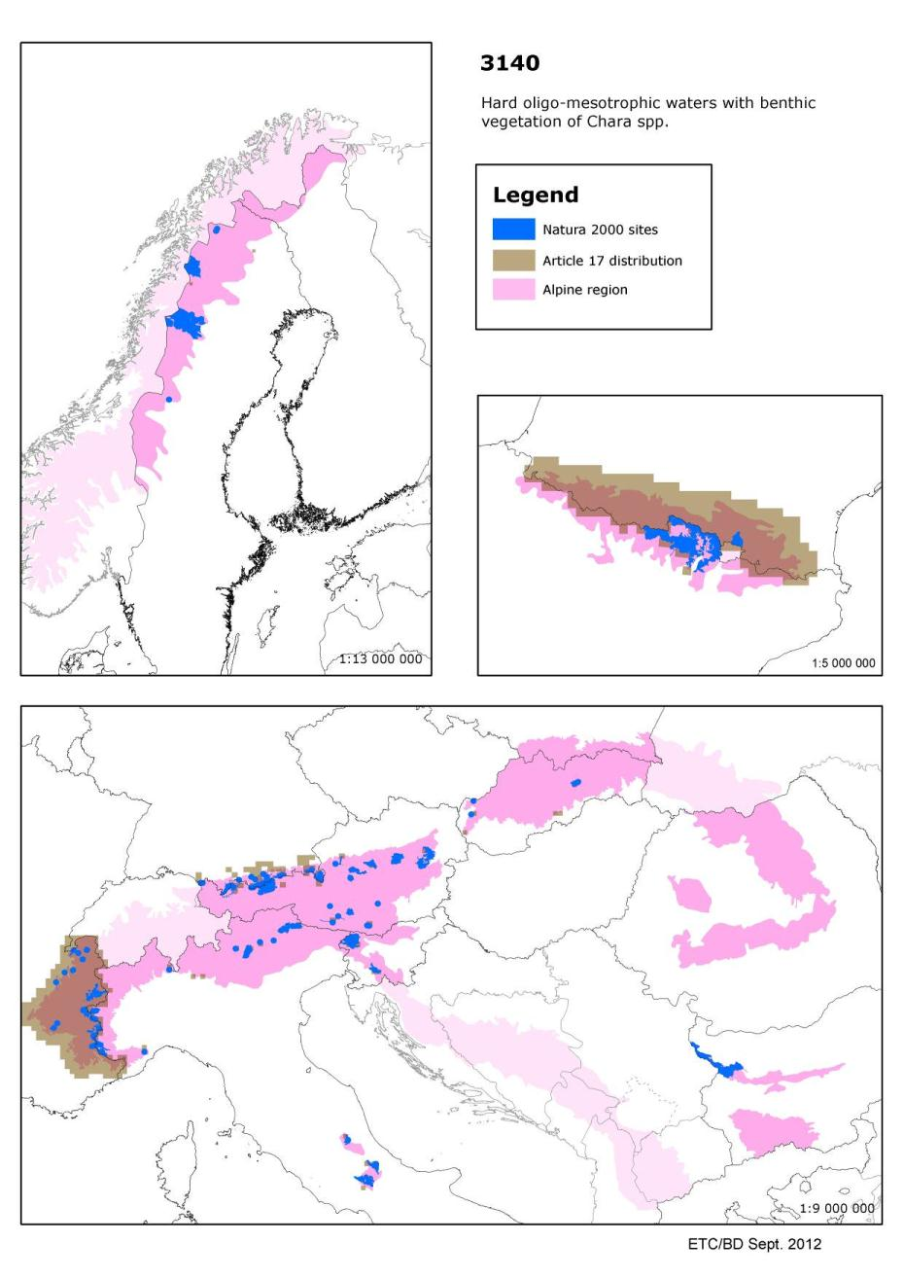

3150 - Natural eutrophic lakes with Magnopotamion or Hydrocharition - type vegetation

Habitats Manual 2007
Lakes and ponds with mostly dirty grey to blue-green, more or less turbid, waters, particularly rich in dissolved bases (pH usually > 7), with free-floating surface communities of the Hydrocharition or, in deep, open waters, with associations of large pondweeds (Magnopotamion).
The Habitats Manual lists the following Annex II/IV plant species: Aldrovanda vesiculosa

Conservation status (CS) assessed at the Alpine region and MS level:
N2K code | Habitat name |  | AT | BG | DE | ES | FR | IT | PL | RO | SE | SI | SK | REGION
3150 | Natural eutrophic lakes with Magnopotamion or Hydrocharition - type vegetation | range | XX |  | FV | XX | FV | FV | XX |  | FV | FV | XX | XX
 |  | area | XX |  | FV | U1 | U2 | FV | XX |  | FV | FV | XX | XX
 |  | structure | XX |  | XX | U1 | U2 | XX | XX |  | FV | FV | XX | XX
 |  | future | XX |  | FV | U1 | U1 | FV | U1 |  | FV | FV | XX | XX
 |  | overall | XX |  | FV | U1 | U2 | FV | U1 |  | FV | FV | XX | XX

These are lakes which are naturally rich in nutrients and with many floating aquatic plants, this habitat is found in all biogeographical regions. Lakes which become eutrophic because of pollution are not included in this habitat type.
Although reported as ‘favourable' in Italy (all three regions), Portugal (Mediterranean)and Alpine Sweden this habitat is assessed as unfavourable or unknown by most countries and for all regions, with ‘unfavourable-bad' in the Atlantic and Continental regions. ‘Structure & functions' and ‘future prospects' are assessed as unfavourable (or unknown) in all regions.
The pressures and threats reported include changes in water quality due to pollution and it seems unlikely that Italian lakes have escaped the pollution found elsewhere in Europe.
Better information required (Summary sheet of the online report on Article 17 of the Habitats Directive).

Species associated to Natural eutrophic lakes with Magnopotamion or Hydrocharition - type vegetation and their CS at the Alpine region and MS level
N2K code | Species name | Group |  | AT | ES | PL | RO | SK | REGION
1042 | Leucorrhinia pectoralis | Invertebrates | range | FV | XX | XX |  | U2 | XX
 |  |  | population | XX | XX | XX |  | U2 | XX
 |  |  | habitat | U2 | XX | XX |  | U1 | U2
 |  |  | future | U2 | XX | XX |  | U1 | U2
 |  |  | overall | U2 | XX | XX |  | U2 | U2

N2K code | Species name | Group |  | AT | BG | DE | SI | SK | REGION
1134 | Rhodeus sericeus amarus | Fish | range | XX |  | XX | FV | FV | XX
 |  |  | population | U1 |  | XX | XX | FV | U1
 |  |  | habitat | U1 |  | XX | U1 | FV | U1
 |  |  | future | U1 |  | XX | U1 | FV | U1
 |  |  | overall | U1 |  | XX | U1 | FV | U1

N2K code | Species name | Group |  | AT | BG | DE | FR | PL | RO | SK | REGION
1166 | Triturus cristatus | Amphibians | range | FV |  | XX | U2 | FV |  | U2 | U2
 |  |  | population | U1 |  | U1 | U2 | XX |  | U2 | U2
 |  |  | habitat | U1 |  | U1 | U2 | U1 |  | U2 | U2
 |  |  | future | U2 |  | U2 | U2 | XX |  | U2 | U2
 |  |  | overall | U2 |  | U2 | U2 | U1 |  | U2 | U2

N2K code | Species name | Group |  | AT | BG | IT | SI | REGION
1167 | Triturus carnifex | Amphibians | range | FV |  | U1 | FV | U1
 |  |  | population | U1 |  | U1 | XX | U1
 |  |  | habitat | U1 |  | U1 | U1 | U1
 |  |  | future | U1 |  | XX | U1 | XX
 |  |  | overall | U1 |  | U1 | U1 | U1

N2K code | Species name | Group |  | AT | DE | FR | IT | SI | REGION
1177 | Salamandra atra | Amphibians | range | FV | FV | U2 | U1 | FV | FV
 |  |  | population | XX | FV | U2 | U1 | XX | XX
 |  |  | habitat | FV | FV | XX | FV | XX | FV
 |  |  | future | FV | FV | XX | U1 | FV | FV
 |  |  | overall | FV | FV | U2 | U1 | XX | FV

N2K code | Species name | Group |  | BG | PL | RO | SK | REGION
1197 | Pelobates fuscus | Amphibians | range |  | XX |  | U1 | U1
 |  |  | population |  | XX |  | U1 | U1
 |  |  | habitat |  | XX |  | U1 | U1
 |  |  | future |  | XX |  | U1 | U1
 |  |  | overall |  | XX |  | U1 | U1

N2K code | Species name | Group |  | AT | BG | DE | IT | PL | RO | SI | SK | REGION
1201 | Bufo viridis | Amphibians | range | U1 |  | U2 | FV | FV |  | FV | FV | FV
 |  |  | population | U1 |  | U2 | FV | XX |  | XX | U1 | U1
 |  |  | habitat | U1 |  | U2 | FV | XX |  | XX | U1 | U1
 |  |  | future | U1 |  | U1 | FV | FV |  | XX | FV | FV
 |  |  | overall | U1 |  | U2 | FV | XX |  | XX | U1 | U1

N2K code | Species name | Group |  | AT | ES | FR | REGION
1202 | Bufo calamita | Amphibians | range | U1 | XX | U2 | U2
 |  |  | population | U2 | XX | U2 | U2
 |  |  | habitat | U2 | XX | U2 | U2
 |  |  | future | U2 | XX | U2 | U2
 |  |  | overall | U2 | XX | U2 | U2

N2K code | Species name | Group |  | AT | BG | DE | ES | FR | IT | PL | RO | SI | SK | REGION
1203 | Hyla arborea | Amphibians | range | FV |  | FV | XX | U2 | U1 | FV |  | FV | FV | FV
 |  |  | population | U1 |  | U1 | XX | U2 | U1 | XX |  | XX | XX | XX
 |  |  | habitat | U1 |  | U1 | XX | U2 | FV | XX |  | U1 | U1 | U1
 |  |  | future | U1 |  | U1 | XX | U2 | U1 | FV |  | XX | XX | XX
 |  |  | overall | U1 |  | U1 | XX | U2 | U1 | XX |  | U1 | U1 | U1

N2K code | Species name | Group |  | AT | DE | PL | SI | SK | REGION
1207 | Rana lessonae | Amphibians | range | XX | XX | FV | FV | U2 | XX
 |  |  | population | U1 | XX | XX | XX | U2 | XX
 |  |  | habitat | U1 | XX | XX | U1 | U2 | XX
 |  |  | future | U1 | XX | XX | XX | U2 | XX
 |  |  | overall | U1 | XX | XX | U1 | U2 | XX

N2K code | Species name | Group |  | AT | BG | DE | FR | IT | RO | SI | SK | REGION
1209 | Rana dalmatina | Amphibians | range | FV |  | FV | U1 | XX |  | FV | FV | U1
 |  |  | population | U1 |  | XX | U2 | XX |  | XX | U1 | U1
 |  |  | habitat | U1 |  | XX | U2 | XX |  | U1 | U1 | U1
 |  |  | future | U1 |  | XX | U1 | XX |  | FV | U1 | U1
 |  |  | overall | U1 |  | XX | U2 | XX |  | U1 | U1 | U1

N2K code | Species name | Group |  | AT | PL | RO | SE | REGION
1214 | Rana arvalis | Amphibians | range | FV | XX |  | FV | FV
 |  |  | population | U1 | XX |  | FV | FV
 |  |  | habitat | U1 | XX |  | FV | FV
 |  |  | future | U1 | XX |  | FV | FV
 |  |  | overall | U1 | XX |  | FV | FV

N2K code | Species name | Group |  | BG | ES | IT | SI | REGION
1220 | Emys orbicularis | Reptiles | range |  | XX | XX | XX | XX
 |  |  | population |  | XX | XX | XX | XX
 |  |  | habitat |  | XX | XX | U1 | XX
 |  |  | future |  | XX | XX | U2 | U2
 |  |  | overall |  | XX | XX | U2 | U2

N2K code | Species name | Group |  | BG | PL | SI | SK | REGION
4045 | Coenagrion ornatum | Invertebrates | range |  | XX | U1 | U2 | U2
 |  |  | population |  | XX | U1 | U1 | U1
 |  |  | habitat |  | XX | U1 | U1 | U1
 |  |  | future |  | XX | U1 | FV | U1
 |  |  | overall |  | XX | U1 | U2 | U2

N2K code | Species name | Group |  | BG | RO | SI | SK | REGION
4046 | Cordulegaster heros | Invertebrates | range |  |  | FV | U2 | FV
 |  |  | population |  |  | FV | XX | FV
 |  |  | habitat |  |  | FV | FV | FV
 |  |  | future |  |  | FV | FV | FV
 |  |  | overall |  |  | FV | U2 | FV

Main pressures to Natural eutrophic lakes with Magnopotamion or Hydrocharition - type vegetation and their importance to associated species
Pressure description (2nd level) | Natural eutrophic lakes with Magnopotamion or Hydrocharition - type vegetation | Leucorrhinia pectoralis | Rhodeus sericeus amarus | Triturus cristatus | Triturus carnifex | Salamandra atra | Pelobates fuscus | Bufo viridis
Fertilisation | x |  |  |  | x
Modification of hydrographic functioning | x | x
Biocenotic evolution | x

Pressure description (2nd level) | Bufo calamita | Hyla arborea | Rana lessonae | Rana dalmatina | Rana arvalis | Emys orbicularis | Coenagrion ornatum | Cordulegaster heros
Fertilisation | x |  | x
Modification of hydrographic functioning | x | x | x |  |  | x
Biocenotic evolution

Main threats to Natural eutrophic lakes with Magnopotamion or Hydrocharition - type vegetation and their importance to associated species
Threats description (2nd level) | Natural eutrophic lakes with Magnopotamion or Hydrocharition - type vegetation | Leucorrhinia pectoralis | Rhodeus sericeus amarus | Triturus cristatus | Triturus carnifex | Salamandra atra | Pelobates fuscus | Bufo viridis
Fertilisation | x |  |  |  | x
Landfill, land reclamation and drying out | x | x |  |  | x
Modification of hydrographic functioning | x | x | x
Biocenotic evolution | x

Threats description (2nd level) | Bufo calamita | Hyla arborea | Rana lessonae | Rana dalmatina | Rana arvalis | Emys orbicularis | Coenagrion ornatum | Cordulegaster heros
Fertilisation | x |  | x
Landfill, land reclamation and drying out | x |  |  |  | x |  | x
Modification of hydrographic functioning | x | x | x |  |  | x
Biocenotic evolution |  |  |  |  |  |  | x

Other information
According to the ETC/BD calculations 0-50% of the area of this habitat type are within SCIs. This means that potentially important part of the management needs of this habitat types occurs outside Natura 2000 network.

Number of SCIs and habitat area (ha) within SCIs per Member State in the Alpine biogeographical region
 | AT | BG | DE | ES | FR | IT | PL | RO | SE | SI | SK
Number of sites | 23 | 1 |  | 9 | 10 | 63 | 2 | 2 | 2 | 1 | 13
Habitat area (ha) | 755 | 360 |  | 740 | 1521 | 3516 | 7 | 545 | 472 | 304 | 158
The figures include all SCIs where the habitat type is mentioned including sites coded as D.

Map of SCIs proposed for Natural eutrophic lakes with Magnopotamion or Hydrocharition - type vegetation& Article 17 distribution
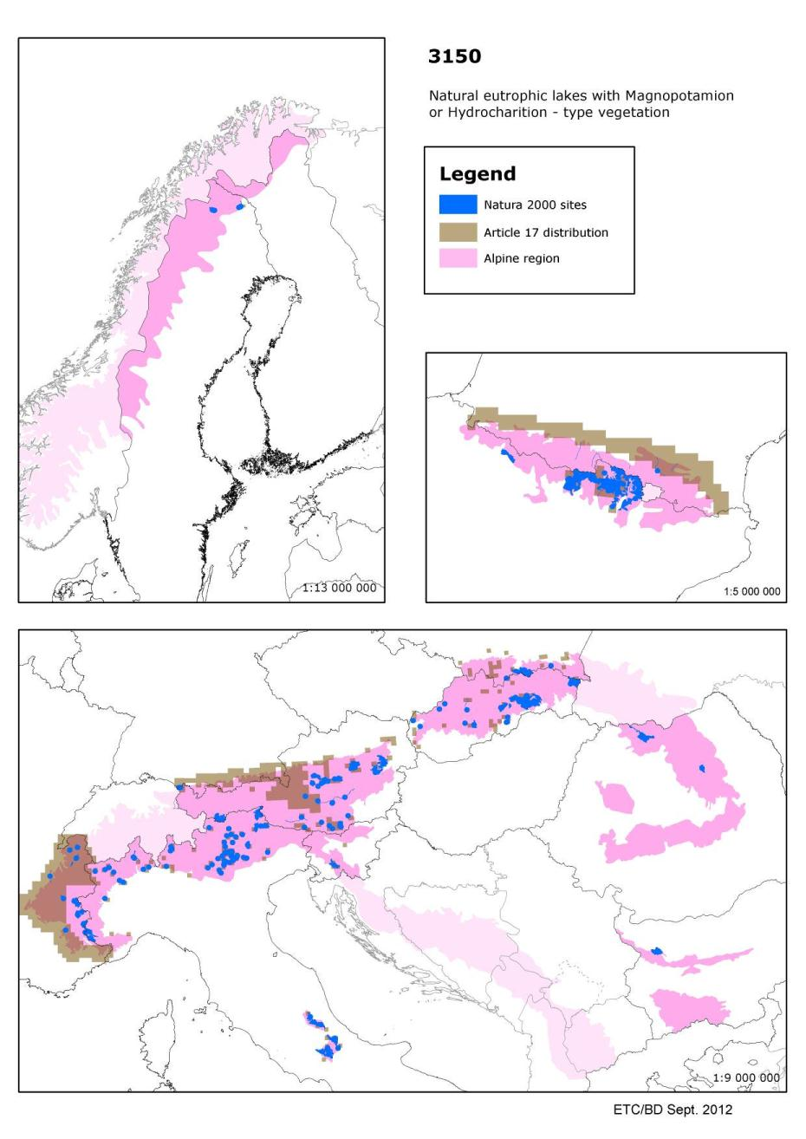

3220 - Alpine rivers and the herbaceous vegetation along their banks

Habitats Manual 2007
- Open assemblages of herbaceous or suffrutescent pioneering plants, rich in alpine species, colonising gravel beds of streams with an alpine, summer-high, flow regime, formed in northern boreal and lower Arctic mountains, hills and sometimes lowlands, as well as in the alpine and subalpine zones of higher, glaciated, mountains of more southern regions, sometimes with abyssal stations at lower altitudes (Epilobion fleischeri p.).
- Open or closed assemblages of herbaceous or suffrutescent pioneering plants, colonising, within the montane or sub-montane levels, gravel beds of streams with an alpine, summer-high, flow regime, born in high mountains (Epilobion fleischeri p., Calamagrostion pseudophragmitis).

Conservation status (CS) assessed at the Alpine region and MS level:
N2K code | Habitat name |  | AT | DE | FI | FR | IT | PL | RO | SE | SI | SK | REGION
3220 | Alpine rivers and the herbaceous vegetation along their banks | range | U2 | U1 | FV | U1 | FV | FV |  | FV | FV | XX | U1
 |  | area | U2 | U1 | FV | U1 | FV | U1 |  | FV | U1 | XX | U1
 |  | structure | XX | U1 | FV | U1 | XX | FV |  | FV | U2 | U1 | U1
 |  | future | U1 | U1 | FV | U1 | FV | XX |  | FV | U2 | XX | U1
 |  | overall | U2 | U1 | FV | U1 | FV | U1 |  | FV | U2 | U1 | U1

This habitat includes rivers in the Alps and other high mountains where the banks are dominated by herbaceous plants rather than trees or scrubs. Although typical of the Alpine biogeographical region it is also reported from the Boreal, Continental, Macaronesian and Mediterranean regions.

In the Alps, where some 98% of this habitat occurs within the Europe an Union, the habitat is assessed as ‘unfavourable-inadequate' both overall and for all four parameters. This covers a wide range of variation, from ‘unfavourable-bad' in Austria and Slovenia to ‘favourable' in Italy and in the Finnish-Swedish subregion.

The habitat is also assessed as ‘favourable ' in the Boreal region giving a clear difference in conservation status between north and central/southern Europe , it is also ‘favourable ' in Macaronesia where this is a rare habitat and only in Portugal. In the Continental region the assessment is ‘unfavourable-bad' overall and for all parameters except structure and function' which is unknown but unlikely to favourable given the reported threats and pressures which are mostly linked to human impact such as river engineering. In both the Atlantic and Mediterranean regions where the habitat is only reported by Spain the assessment is ‘unknown' for all parameters. Better information required, especially from Spain.

Species associated to Alpine rivers and the herbaceous vegetation along their banks and their CS at the Alpine region and MS level
N2K code | Species name | Group |  | AT | DE | RO | SI | SK | REGION
1105 | Hucho hucho | Fish | range | U2 | XX |  | FV | XX | U2
 |  |  | population | U2 | XX |  | U1 | XX | U2
 |  |  | habitat | U2 | XX |  | U1 | XX | U2
 |  |  | future | U2 | XX |  | U1 | XX | U2
 |  |  | overall | U2 | XX |  | U1 | XX | U2

N2K code | Species name | Group |  | AT | IT | SI | SK | REGION
1114 | Rutilus pigus | Fish | range | U2 | U1 | FV | XX | U1
 |  |  | population | U2 | U1 | U1 | XX | U1
 |  |  | habitat | U2 | XX | U1 | XX | U1
 |  |  | future | U2 | U1 | U1 | XX | U1
 |  |  | overall | U2 | U1 | U1 | XX | U1

N2K code | Species name | Group |  | AT | BG | RO | SI | SK | REGION
1122 | Gobio uranoscopus | Fish | range | U2 |  |  | XX | XX | U2
 |  |  | population | U2 |  |  | XX | XX | U2
 |  |  | habitat | U2 |  |  | XX | XX | U2
 |  |  | future | U2 |  |  | U1 | XX | U2
 |  |  | overall | U2 |  |  | U1 | XX | U2

N2K code | Species name | Group |  | AT | BG | FR | IT | RO | SI | REGION
1131 | Leuciscus souffia | Fish | range | U2 |  | U1 | FV |  | FV | U2
 |  |  | population | U2 |  | U1 | FV |  | XX | U2
 |  |  | habitat | U2 |  | U1 | XX |  | XX | U2
 |  |  | future | U2 |  | U1 | FV |  | U1 | U2
 |  |  | overall | U2 |  | U1 | FV |  | U1 | U2

N2K code | Species name | Group |  | BG | ES | IT | SI | REGION
1137 | Barbus plebejus | Fish | range |  | XX | U1 | FV | U1
 |  |  | population |  | XX | U1 | U1 | U1
 |  |  | habitat |  | XX | XX | U1 | XX
 |  |  | future |  | XX | U1 | U1 | U1
 |  |  | overall |  | XX | U1 | U1 | U1

N2K code | Species name | Group |  | BG | ES | FR | IT | PL | RO | SI | SK | REGION
1138 | Barbus meridionalis | Fish | range |  | XX | U1 | U1 | U1 |  | FV | XX | U1
 |  |  | population |  | XX | U1 | U1 | U2 |  | XX | XX | U2
 |  |  | habitat |  | XX | U1 | XX | U1 |  | U1 | XX | U1
 |  |  | future |  | XX | U1 | U1 | U1 |  | U1 | XX | U1
 |  |  | overall |  | XX | U1 | U1 | U2 |  | U1 | XX | U2

N2K code | Species name | Group |  | AT | SI | SK | REGION
1160 | Zingel streber | Fish | range | U2 | FV | XX | U2
 |  |  | population | U2 | XX | XX | U2
 |  |  | habitat | U2 | U1 | XX | U2
 |  |  | future | U2 | U1 | XX | U2
 |  |  | overall | U2 | U1 | XX | U2

N2K code | Species name | Group |  | AT | FR | IT | REGION
1545 | Trifolium saxatile | Vascular plants | range | XX | FV | FV | XX
 |  |  | population | XX | FV | FV | XX
 |  |  | habitat | XX | FV | XX | XX
 |  |  | future | U1 | U1 | FV | U1
 |  |  | overall | U1 | U1 | FV | U1

N2K code | Species name | Group |  | PL | SI | SK | REGION
2511 | Gobio kessleri | Fish | range | FV | FV | XX | XX
 |  |  | population | FV | XX | XX | XX
 |  |  | habitat | FV | XX | XX | XX
 |  |  | future | FV | XX | XX | XX
 |  |  | overall | FV | XX | XX | XX

Main pressures to Alpine rivers and the herbaceous vegetation along their banks and their importance to associated species
Pressure description (2nd level) | Alpine rivers and the herbaceous vegetation along their banks | Hucho hucho | Rutilus pigus | Gobio uranoscopus | Leuciscus souffia
Modification of hydrographic functioning | x

Pressure description (2nd level) | Barbus plebejus | Barbus meridionalis | Zingel streber | Trifolium saxatile | Gobio kessleri
Modification of hydrographic functioning | x | x |  |  | x

Main threats to Alpine rivers and the herbaceous vegetation along their banks and their importance to associated species
Threats description (2nd level) | Alpine rivers and the herbaceous vegetation along their banks | Hucho hucho | Rutilus pigus | Gobio uranoscopus | Leuciscus souffia
Sand and gravel extraction | x
Modification of hydrographic functioning | x |  | x | x | x

Threats description (2nd level) | Barbus plebejus | Barbus meridionalis | Zingel streber | Trifolium saxatile | Gobio kessleri
Sand and gravel extraction
Modification of hydrographic functioning |  |  | x | x

Other information
According to the ETC/BD calculations 0-50% of the area of this habitat type are within SCIs. This means that potentially important part of the management needs of this habitat types occurs outside Natura 2000 network.

Number of SCIs and habitat area (ha) within SCIs per Member State in the Alpine biogeographical region
 | AT | DE | FI | FR | IT | PL | RO | SE | SI | SK
Number of sites | 25 | 10 | 11 | 34 | 104 | 14 | 29 | 80 | 7 | 18
Habitat area (ha) | 4454 | 213 | 11301 | 4694 | 6173 | 244 | 13890 | 34258 | 1416 | 60
The figures include all SCIs where the habitat type is mentioned including sites coded as D.

Map of SCIs proposed for Alpine rivers and the herbaceous vegetation along their banks & Article 17 distribution
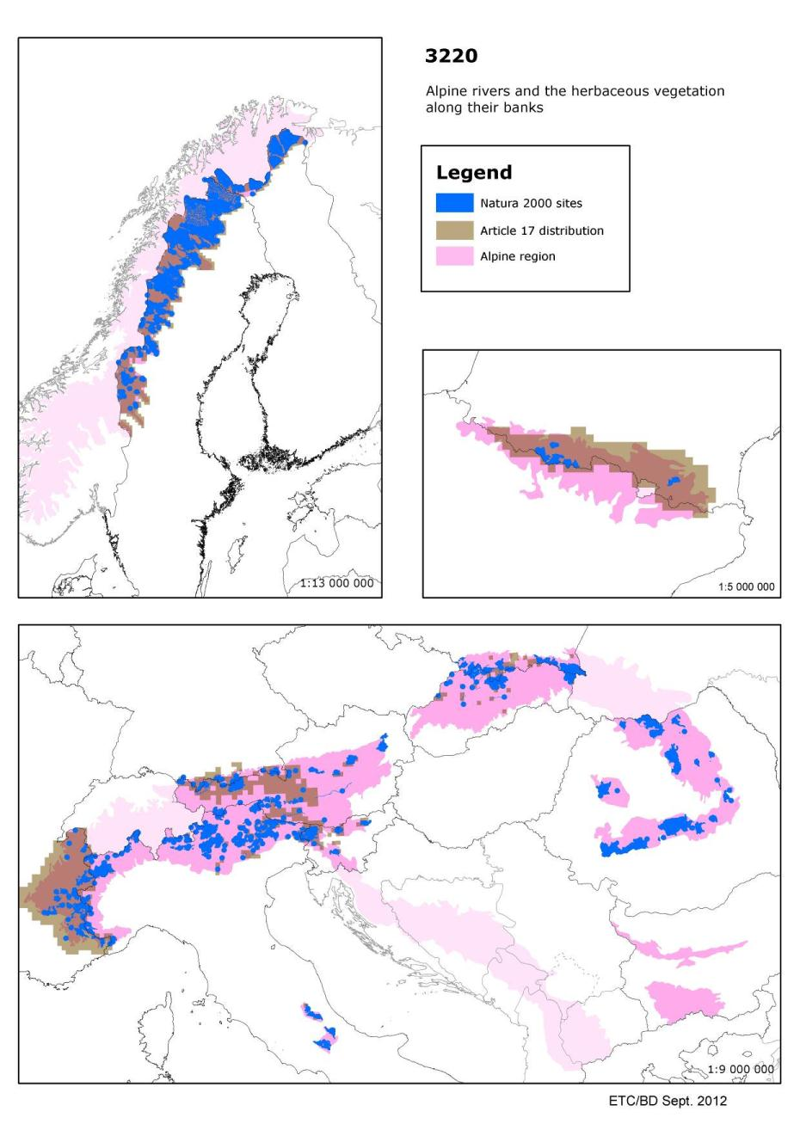

3230 - Alpine rivers and their ligneous vegetation with Myricaria germanica

Habitats Manual 2007
Communities of low shrubby pioneers invading the herbaceous formations of 24.221 and 24.222 on gravel deposits rich in fine silt, of mountain and northern boreal streams with an alpine, summer-high, flow regime. Myricaria germanica and Salix spp. are characteristic (Salici-Myricarietum).

Conservation status (CS) assessed at the Alpine region and MS level:
N2K code | Habitat name |  | AT | DE | ES | FI | FR | IT | PL | RO | SI | SK | REGION
3230 | Alpine rivers and their ligneous vegetation with Myricaria germanica | range | U2 | FV | XX | FV | U1 | FV | U1 |  | U1 | U1 | U1
 |  | area | U2 | U2 | XX | FV | U2 | U1 | U1 |  | U1 | U1 | U2
 |  | structure | XX | U1 | XX | FV | U1 | XX | FV |  | U1 | FV | U1
 |  | future | U1 | U1 | XX | FV | U2 | FV | XX |  | U1 | U1 | U2
 |  | overall | U2 | U2 | XX | FV | U2 | U1 | U1 |  | U1 | U1 | U2

German tamarisk (Myricaria germanica) occurs along rivers in the Alps and other mountains growing on silt rich gravel deposits. These deposits are usually dynamic, often being destroyed and recreated in floods.

Assessed as ‘unfavourable-bad' in all three regions. Only in Finland is the habitat considered ‘favourable' (although the species itself is noted as ‘vulnerable' on the 2001 Finnish Red list). Elsewhere ‘area' is always assessed as unfavourable except in Spain where it is unknown and ‘unfavourable-bad' in the countries where the habitat is most wide spread. This is due to habitat destruction, often resulting from river engineering, which in many cases alters the natural flood regime. Several countries report one or more parameters as ‘unknown' and better information is required, particularly from Spain.

Species associated to Alpine rivers and their ligneous vegetation with Myricaria germanica and their CS at the Alpine region and MS level
N2K code | Species name | Group |  | AT | DE | RO | SI | SK | REGION
1105 | Hucho hucho | Fish | range | U2 | XX |  | FV | XX | U2
 |  |  | population | U2 | XX |  | U1 | XX | U2
 |  |  | habitat | U2 | XX |  | U1 | XX | U2
 |  |  | future | U2 | XX |  | U1 | XX | U2
 |  |  | overall | U2 | XX |  | U1 | XX | U2

Main pressures to Alpine rivers and their ligneous vegetation with Myricaria germanica and their importance to associated species
Pressure description (2nd level) | Alpine rivers and their ligneous vegetation with Myricaria germanica | Hucho hucho
Modification of hydrographic functioning | x

Main threats to Alpine rivers and their ligneous vegetation with Myricaria germanica and their importance to associated species
Threats description (2nd level) | Alpine rivers and their ligneous vegetation with Myricaria germanica | Hucho hucho
Sand and gravel extraction | x
Modification of hydrographic functioning | x

Other information
According to the ETC/BD calculations 76-100% of the area of this habitat type are within SCIs. This means that Natura 2000 network provides an important framework for the management of this habitat type.

Number of SCIs and habitat area (ha) within SCIs per Member State in the Alpine biogeographical region
 | AT | DE | ES | FI | FR | IT | PL | RO | SI | SK
Number of sites | 4 | 4 | 5 | 2 | 13 | 15 | 5 | 21 | 3 | 6
Habitat area (ha) | 665 | 56 | 286 | 16 | 2580 | 729 | 10 | 6134 | 769 | 4
The figures include all SCIs where the habitat type is mentioned including sites coded as D.

Map of SCIs proposed for Alpine rivers and their ligneous vegetation with Myricaria germanica & Article 17 distribution
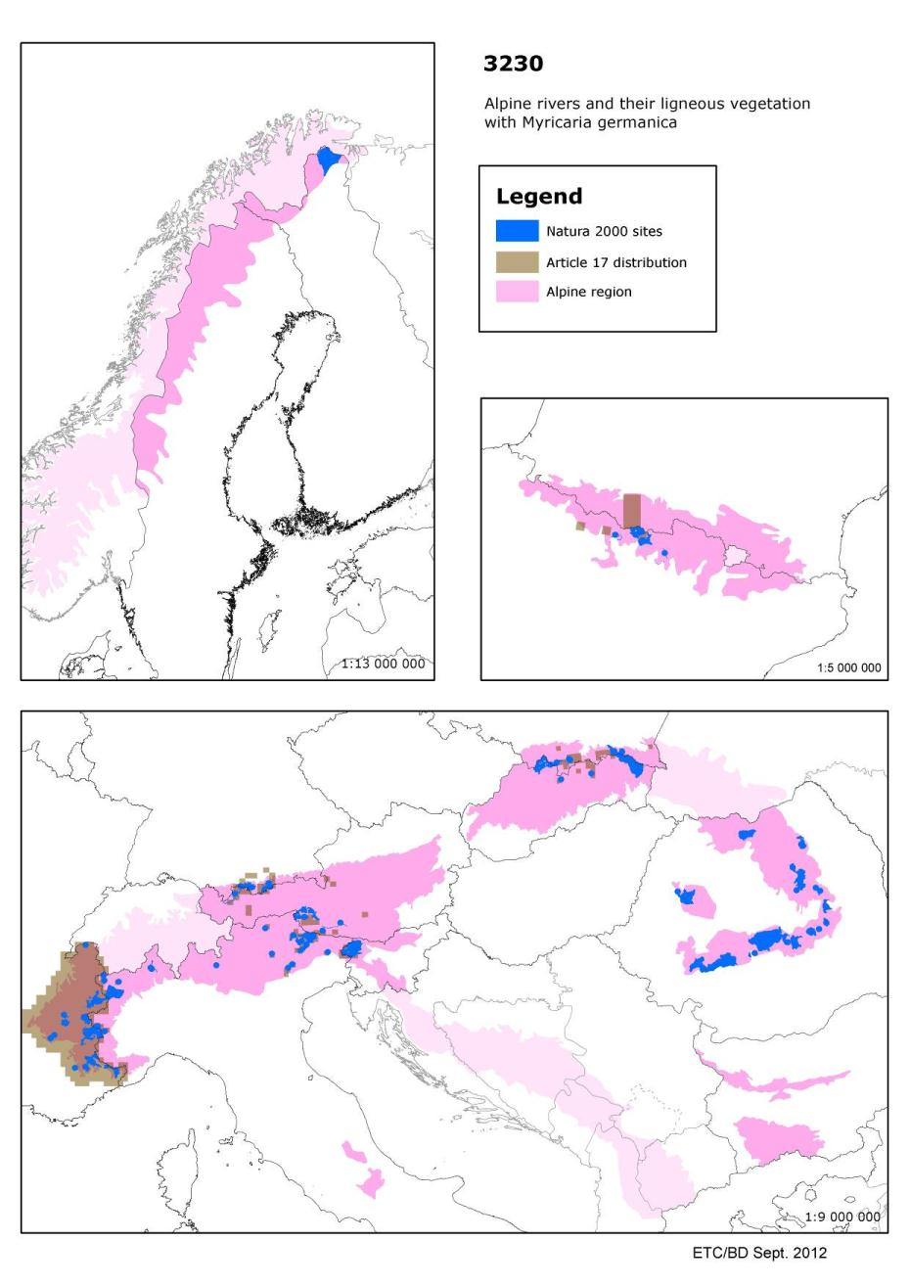

3240 - Alpine rivers and their ligneous vegetation with Salix elaeagnos

Habitats Manual 2007
Thickets or woods of, among others, Salix spp., Hippophae rhamnoides, Alnus spp., Betula spp., on stream gravels of mountain and northern boreal streams with an alpine, summer-high, flow regime. Formations of Salix elaeagnos, Salix purpurea ssp. gracilis, Salix daphnoides, Salix nigricans and Hippophae rhamnoides of higher gravel shoals in Alpine and peri-Alpine valleys.

Conservation status (CS) assessed at the Alpine region and MS level:
N2K code | Habitat name |  | AT | DE | ES | FR | IT | PL | RO | SI | SK | REGION
3240 | Alpine rivers and their ligneous vegetation with Salix elaeagnos | range | FV | FV | XX | U1 | FV | U1 |  | FV | FV | U1
 |  | area | U1 | U1 | XX | U1 | FV | U1 |  | U1 | FV | U1
 |  | structure | U1 | U1 | XX | U1 | FV | FV |  | U1 | U1 | U1
 |  | future | U1 | U1 | XX | U1 | FV | XX |  | U1 | FV | U1
 |  | overall | U1 | U1 | XX | U1 | FV | U1 |  | U1 | U1 | U1

This habitat occurs along alpine rivers with banks dominated by woody vegetation including rosemary willow (Salix elaeagnos), other species of willow (Salix spp), birch (Betula spp), alder (Alnus spp) and sea buckthorn (Hippophae rhamnoides). The habitat occurs in the Alps together with other mountain ranges such as the Apennines, Cantabrians, Carpathians, and Pyrenees.

Spain has reported all parameters for this habitat as ‘unknown' leading to regional assessments as ‘unknown' for both the Atlantic and Mediterranean regions although reported as ‘favourable' in the other Mediterranean countries where the habitat is present.

Assessed as ‘unfavourable-inadequate ' in the Alpine region for all parameters, with only. Italy assessing the habitat as ‘favourable'. In many cases ‘range' is assessed as ‘favourable ' but the other parameters are mostly unfavourable, usually as a result of human impact including modification of the riverbed, including canalisation, and gravel extraction. Assessed as ‘unfavourable-bad' in the Continental region and also for Austria, Czech Republic and France within the region with similar pressures as found in the Alpine region. Again only Italy has reported this habitat as ‘favourable' although similar pressures and threats are noted. Better information is needed, particularly from Spain.

Species associated to Alpine rivers and their ligneous vegetation with Salix elaeagnos and their CS at the Alpine region and MS level
N2K code | Species name | Group |  | AT | DE | RO | SI | SK | REGION
1105 | Hucho hucho | Fish | range | U2 | XX |  | FV | XX | U2
 |  |  | population | U2 | XX |  | U1 | XX | U2
 |  |  | habitat | U2 | XX |  | U1 | XX | U2
 |  |  | future | U2 | XX |  | U1 | XX | U2
 |  |  | overall | U2 | XX |  | U1 | XX | U2

Main pressures to Alpine rivers and their ligneous vegetation with Salix elaeagnos and their importance to associated species
Pressure description (2nd level) | Alpine rivers and their ligneous vegetation with Salix elaeagnos | Hucho hucho
Sand and gravel extraction | x
Modification of hydrographic functioning

Main threats to Alpine rivers and their ligneous vegetation with Salix elaeagnos and their importance to associated species
Threats description (2nd level) | Alpine rivers and their ligneous vegetation with Salix elaeagnos | Hucho hucho
Sand and gravel extraction | x
Canalisation | x
Modification of hydrographic functioning

Other information
According to the ETC/BD calculations 76-100% of the area of this habitat type are within SCIs. This means that Natura 2000 network provides an important framework for the management of this habitat type.

Number of SCIs and habitat area (ha) within SCIs per Member State in the Alpine biogeographical region
 | AT | DE | ES | FR | IT | PL | RO | SI | SK
Number of sites | 17 | 18 | 34 | 34 | 85 | 7 | 18 | 6 | 9
Habitat area (ha) | 1531 | 781 | 2100 | 4614 | 5649 | 75 | 5977 | 997 | 63
The figures include all SCIs where the habitat type is mentioned including sites coded as D.

Map of SCIs proposed for Alpine rivers and their ligneous vegetation with Salix elaeagnos & Article 17 distribution
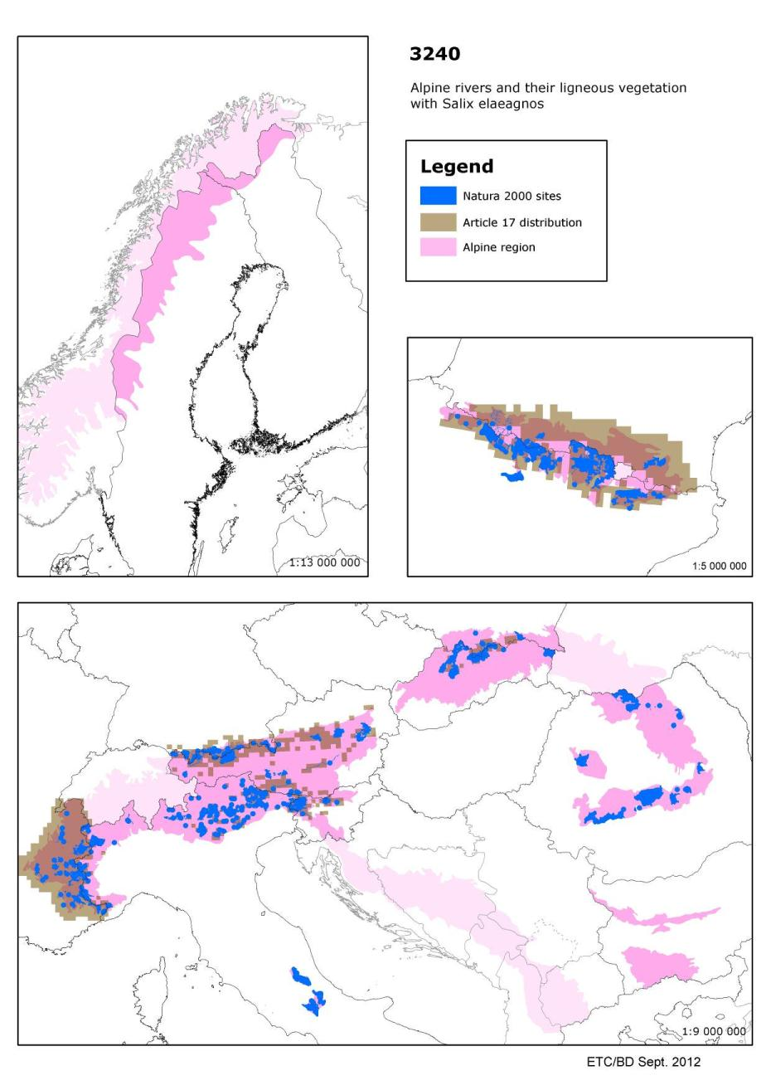

3260 - Water courses of plain to montane levels with the Ranunculion fluitantis and Callitricho-Batrachion vegetation

Habitats Manual 2007
Water courses of plain to montane levels, with submerged or floating vegetation of the Ranunculion fluitantis and Callitricho-Batrachion (low water level during summer) or aquatic mosses.
This habitat is sometimes associated with Butomus umbellatus bank communities. It is important to take this point into account in the process of site selection.

Conservation status (CS) assessed at the Alpine region and MS level:
N2K code | Habitat name |  | AT | BG | DE | FI | FR | IT | RO | SE | SI | SK | REGION
3260 | Water courses of plain to montane levels with the Ranunculionfluitantis and Callitricho-Batrachion vegetation | range | XX |  | FV | FV | FV | FV |  | FV | FV | XX | FV
 |  | area | XX |  | FV | FV | U1 | U1 |  | FV | XX | XX | U1
 |  | structure | XX |  | XX | FV | U1 | XX |  | FV | U1 | FV | U1
 |  | future | XX |  | XX | FV | U1 | FV |  | FV | XX | FV | U1
 |  | overall | XX |  | XX | FV | U1 | U1 |  | FV | U1 | XX | U1

Rivers of temperate and northern Europe with floating vegetation often dominated by water crowfoot (Ranuculus spp) and other aquatic plants including mosses. The habitat is very widespread throughout Europe, although rare to the south.

Assessed as ‘unfavourable-inadequate' in the Alpine and Continental regions, ‘unfavourable-bad' in the Atlantic, Boreal and Pannonic regions while in the Mediterranean region it is ‘unknown but not favourable'. Only in the Alpine regions of Finland and Sweden and in Greece is the habitat reported as ‘favourable'. The former is probably a result of the low human impact in these areas while in Greece the habitat is naturally rare.
Reported threats and pressures mostly relate to human impact including modification of rivers (often related to navigation) and pollution.

Many countries (EU25) reported one or more parameters as unknown and better information is required, particularly from Austria, Luxembourg and Spain (Summary sheet of the online report on Article 17 of the Habitats Directive).

Species associated to Water courses of plain to montane levels with the Ranunculion fluitantis and Callitricho-Batrachion vegetation and their CS at the Alpine region and MS level
N2K code | Species name | Group |  | AT | BG | DE | PL | SI | SK | REGION
1032 | Unio crassus | Molluscs | range | U2 |  | U2 | FV | XX | FV | U2
 |  |  | population | U2 |  | U2 | U2 | U1 | FV | U2
 |  |  | habitat | U2 |  | U2 | U2 | U1 | FV | U2
 |  |  | future | U2 |  | U2 | U1 | U1 | FV | U2
 |  |  | overall | U2 |  | U2 | U2 | U1 | FV | U2

N2K code | Species name | Group |  | AT | PL | RO | SK | REGION
1037 | Ophiogomphus cecilia | Invertebrates | range | U1 | XX |  | U2 | U1
 |  |  | population | U1 | XX |  | U1 | U1
 |  |  | habitat | U1 | XX |  | FV | U1
 |  |  | future | U1 | XX |  | U1 | U1
 |  |  | overall | U1 | XX |  | U2 | U1

N2K code | Species name | Group |  | AT | DE | PL | SK | REGION
1039 | Sympecma braueri | Invertebrates | range | U1 | XX | XX | U2 | XX
 |  |  | population | U1 | XX | XX | U2 | XX
 |  |  | habitat | U2 | XX | XX | U2 | XX
 |  |  | future | U2 | XX | XX | U1 | XX
 |  |  | overall | U2 | XX | XX | U2 | XX

N2K code | Species name | Group |  | AT | DE | FR | REGION
1044 | Coenagrion mercuriale | Invertebrates | range | FV | FV | U2 | U2
 |  |  | population | U2 | U1 | U2 | U2
 |  |  | habitat | U2 | XX | U2 | U2
 |  |  | future | U2 | U1 | U2 | U2
 |  |  | overall | U2 | U1 | U2 | U2

N2K code | Species name | Group |  | AT | ES | FR | IT | SI | REGION
1092 | Austropotamobius pallipes | Invertebrates | range | FV | U1 | U1 | U1 | FV | U1
 |  |  | population | U2 | XX | U2 | U1 | XX | U2
 |  |  | habitat | FV | XX | U2 | U1 | U1 | U2
 |  |  | future | U2 | U2 | U2 | U1 | U1 | U2
 |  |  | overall | U2 | U2 | U2 | U1 | U1 | U2

N2K code | Species name | Group |  | AT | BG | DE | IT | SI | SK | REGION
1093 | Austropotamobius torrentium | Invertebrates | range | U1 |  | XX | XX | FV | U1 | U1
 |  |  | population | U1 |  | U1 | XX | XX | U2 | U1
 |  |  | habitat | FV |  | U1 | U1 | U1 | FV | U1
 |  |  | future | U1 |  | XX | U1 | U1 | U1 | U1
 |  |  | overall | U1 |  | U1 | U1 | U1 | U2 | U1

N2K code | Species name | Group |  | FR | PL | SK | REGION
1096 | Lampetra planeri | Fish | range | FV | XX | XX | XX
 |  |  | population | XX | XX | XX | XX
 |  |  | habitat | XX | FV | XX | XX
 |  |  | future | U1 | FV | XX | U1
 |  |  | overall | U1 | XX | XX | U1

N2K code | Species name | Group |  | ES | FI | FR | SE | REGION
1106 | Salmo salar | Fish | range | XX | FV | U2 | FV | FV
 |  |  | population | XX | FV | U2 | U2 | U2
 |  |  | habitat | XX | FV | U2 | FV | FV
 |  |  | future | XX | FV | U2 | U1 | U1
 |  |  | overall | XX | FV | U2 | U2 | U2

N2K code | Species name | Group |  | BG | PL | RO | SI | SK | REGION
1146 | Sabanejewia aurata | Fish | range |  | FV |  | FV | XX | XX
 |  |  | population |  | FV |  | XX | XX | XX
 |  |  | habitat |  | FV |  | XX | XX | XX
 |  |  | future |  | FV |  | U1 | XX | XX
 |  |  | overall |  | FV |  | U1 | XX | XX

N2K code | Species name | Group |  | AT | BG | IT | PL | SI | SK | REGION
1149 | Cobitis taenia | Fish | range | U2 |  | U1 | XX | FV | XX | XX
 |  |  | population | U2 |  | U1 | FV | XX | XX | XX
 |  |  | habitat | U2 |  | XX | FV | U1 | XX | XX
 |  |  | future | U2 |  | U1 | FV | U1 | XX | U1
 |  |  | overall | U2 |  | U1 | FV | U1 | XX | U1

N2K code | Species name | Group |  | AT | BG | DE | ES | FR | IT | PL | RO | SE | SI | SK | REGION
1163 | Cottus gobio | Fish | range | FV |  | FV | XX | FV | U1 | FV |  | FV | FV | XX | FV
 |  |  | population | FV |  | XX | XX | FV | U1 | FV |  | FV | XX | XX | U1
 |  |  | habitat | FV |  | FV | XX | XX | XX | FV |  | FV | U1 | XX | XX
 |  |  | future | FV |  | FV | U1 | FV | U1 | FV |  | FV | U1 | XX | U1
 |  |  | overall | FV |  | FV | U1 | FV | U1 | FV |  | FV | U1 | XX | U1

N2K code | Species name | Group |  | AT | BG | DE | FR | IT | PL | RO | SI | SK | REGION
1193 | Bombina variegata | Amphibians | range | FV |  | FV | U2 | U1 | FV |  | FV | FV | FV
 |  |  | population | U1 |  | XX | U2 | U1 | FV |  | XX | U1 | U1
 |  |  | habitat | U1 |  | FV | XX | U1 | XX |  | U1 | U1 | U1
 |  |  | future | U1 |  | FV | U1 | U1 | FV |  | FV | U1 | U1
 |  |  | overall | U1 |  | FV | U2 | U1 | FV |  | U1 | U1 | U1

N2K code | Species name | Group |  | AT | DE | FR | PL | RO | SE | SK | REGION
1337 | Castor fiber | Mammals | range | U1 | FV | FV | FV |  | FV | FV | FV
 |  |  | population | U1 | FV | FV | FV |  | FV | FV | FV
 |  |  | habitat | XX | FV | XX | FV |  | FV | FV | FV
 |  |  | future | U1 | FV | FV | FV |  | FV | FV | FV
 |  |  | overall | U1 | FV | FV | FV |  | FV | FV | FV

N2K code | Species name | Group |  | AT | BG | DE | ES | FI | PL | RO | SE | SI | SK | REGION
1355 | Lutra lutra | Mammals | range | U2 |  | XX | XX | FV | FV |  | FV | U1 | U1 | U1
 |  |  | population | U2 |  | XX | XX | FV | FV |  | FV | U1 | U1 | U1
 |  |  | habitat | XX |  | XX | XX | FV | FV |  | FV | FV | U1 | U1
 |  |  | future | U1 |  | XX | XX | FV | FV |  | FV | U1 | FV | FV
 |  |  | overall | U2 |  | XX | XX | FV | FV |  | FV | U1 | U1 | U1

Main pressures to Water courses of plain to montane levels with the Ranunculion fluitantis and Callitricho-Batrachion vegetation and their importance to associated species
Pressure description (2nd level) | Water courses of plain to montane levels with the Ranunculionfluitantis and Callitricho-Batrachion vegetation | Unio crassus | Ophiogomphus cecilia | Sympecma braueri | Coenagrion mercuriale | Austropotamobius pallipes
Fertilisation | x | x
Pollution | x
Modification of hydrographic functioning | x | x | x |  | x | x

Pressure description (2nd level) | Austropotamobius torrentium | Lampetra planeri | Salmo salar | Sabanejewia aurata | Cobitis taenia | Cottus gobio | Bombina variegata | Castor fiber | Lutra lutra
Fertilisation |  |  |  |  |  |  | x
Pollution |  |  |  |  | x | x | x |  | x
Modification of hydrographic functioning | x |  |  | x |  |  |  |  | x

Main threats to Water courses of plain to montane levels with the Ranunculion fluitantis and Callitricho-Batrachion vegetation and their importance to associated species
Threats description (2nd level) | Water courses of plain to montane levels with the Ranunculionfluitantis and Callitricho-Batrachion vegetation | Unio crassus | Ophiogomphus cecilia | Sympecma braueri | Coenagrion mercuriale | Austropotamobius pallipes
Fertilisation | x | x
Pollution | x |  | x |  |  | x
Modification of hydrographic functioning | x | x | x |  | x | x

Threats description (2nd level) | Austropotamobius torrentium | Lampetra planeri | Salmo salar | Sabanejewia aurata | Cobitis taenia | Cottus gobio | Bombina variegata | Castor fiber | Lutra lutra
Fertilisation |  |  |  |  |  |  | x
Pollution | x |  | x |  |  | x | x |  | x
Modification of hydrographic functioning | x | x |  |  |  |  |  |  | x

Other information
According to the ETC/BD calculations 76-100% of the area of this habitat type are within SCIs. This means that Natura 2000 network provides an important framework for the management of this habitat type.

Number of SCIs and habitat area (ha) within SCIs per Member State in the Alpine biogeographical region
 | AT | BG | DE | ES | FI | FR | IT | RO | SE | SI | SK
Number of sites | 13 | 10 | 6 | 6 | 6 | 10 | 22 | 4 | 11 | 7 | 9
Habitat area (ha) | 852 | 1275 | 25 | 93 | 32 | 1040 | 1252 | 863 | 1966 | 2198 | 134
The figures include all SCIs where the habitat type is mentioned including sites coded as D.

Map of SCIs proposed for Water courses of plain to montane levels with the Ranunculion fluitantis and Callitricho-Batrachion vegetation & Article 17 distribution
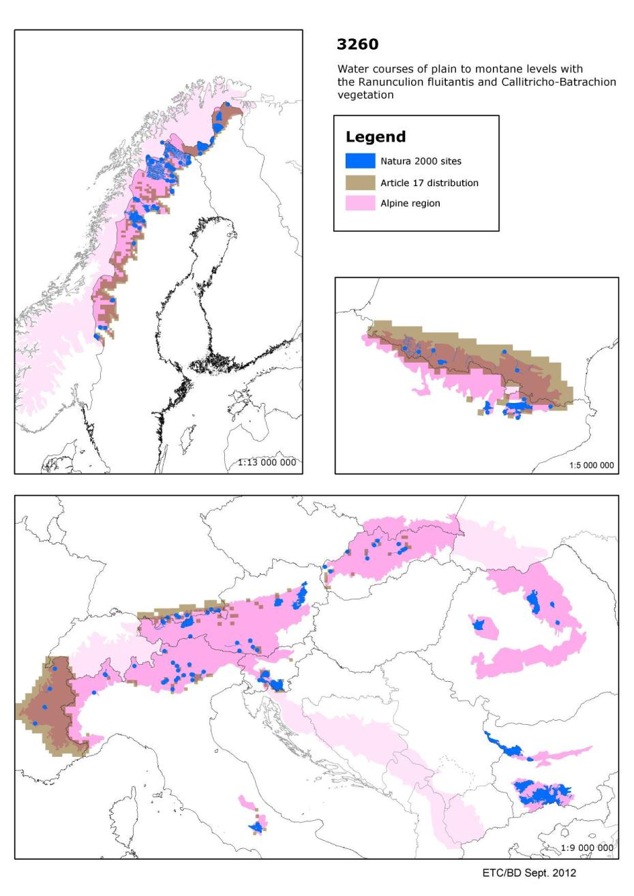

6210 - Semi-natural dry grasslands and scrubland facies on calcareous substrates (Festuco-Brometalia) (* important orchid sites)

Habitats Manual 2007
Dry to semi-dry calcareous grasslands of the Festuco-Brometea. This habitat is formed on the one hand by steppic or subcontinental grasslands (Festucetalia valesiacae) and, on the other, by the grasslands of more oceanic and sub-Mediterranean regions (Brometalia erecti); in the latter case, a distinction is made between primary Xerobromion grasslands and secondary (semi-natural) Mesobromion grasslands with Bromus erectus; the latter are characterised by their rich orchid flora. Abandonment results in thermophile scrub with an intermediate stage of thermophile fringe vegetation (Trifolio-Geranietea).
Important orchid sites should be interpreted as sites that are important on the basis of one or more of the following three criteria:
(a) the site hosts a rich suite of orchid species
(b) the site hosts an important population of at least one orchid species considered not very common on the national territory
(c) the site hosts one or several orchid species considered to be rare, very rare or exceptional on the national territory.
Often in association with scrubland and thermophile forests and with dry pioneer Sedum meadows (Sedo-Scleranthea).

Conservation status (CS) assessed at the Alpine region and MS level
N2K code | Habitat name |  | AT | BG | DE | ES | FR | IT | PL | RO | SE | SI | SK | REGION
6210 | Semi-natural dry grasslands and scrubland facies on calcareous substrates (Festuco-Brometalia)  (* important orchid sites) | range | FV |  | FV | XX | FV | FV | U1 |  | FV | FV | U1 | XX
 |  | area | U1 |  | U1 | XX | U1 | FV | U1 |  | U2 | U2 | XX | XX
 |  | structure | XX |  | U1 | XX | XX | FV | U1 |  | U2 | U2 | FV | XX
 |  | future | U1 |  | U1 | XX | U1 | FV | U1 |  | U2 | U2 | XX | XX
 |  | overall | U1 |  | U1 | XX | U1 | FV | U1 |  | U2 | U2 | U1 | XX

Grasslands on chalk or limestone typical of much of Europe, where the habitat is orchid rich it is considered to be a ‘priority' habitat.
Assessed as ‘unfavourable-bad' in the Atlantic, Boreal, Continental and Pannonic regions. In all these regions all parameters except ‘range' are ‘unfavourable-bad'. Within these regions only Italy (Continental) assessed this habitat as ‘favourable' although Spain reported ‘unknown' for its Atlantic region.
Assessed as ‘unknown but not favourable' for the Alpine and Mediterranean regions largely as a result of Spain reporting ‘unknown' for both regions. Again Italy assessed the habitat as ‘favourable' for both regions as did Portugal (Mediterranean).Many threats and pressures are reported but many countries note changes in agriculture, leading to both abandonment and overgrazing. Better information required, especially from Spain (Summary sheet of the online report on Article 17 of the Habitats Directive).

Species associated to Semi-natural dry grasslands and scrubland facies on calcareous substrates (Festuco-Brometalia) and their CS at the Alpine region and MS level
N2K code | Species name | Group |  | AT | IT | RO | SK | REGION
1050 | Saga pedo | Invertebrates | range | FV | U2 |  | U1 | U1
 |  |  | population | U1 | U2 |  | U1 | U1
 |  |  | habitat | U1 | U1 |  | U1 | U1
 |  |  | future | U1 | U1 |  | XX | XX
 |  |  | overall | U1 | U2 |  | U1 | U1

N2K code | Species name | Group |  | AT | BG | FR | IT | RO | SI | SK | REGION
1053 | Zerynthia polyxena | Invertebrates | range | XX |  | XX | FV |  | FV | FV | XX
 |  |  | population | XX |  | XX | FV |  | U1 | FV | XX
 |  |  | habitat | XX |  | XX | FV |  | U1 | FV | XX
 |  |  | future | XX |  | XX | U1 |  | U1 | FV | XX
 |  |  | overall | XX |  | XX | U1 |  | U1 | FV | XX

N2K code | Species name | Group |  | AT | BG | DE | ES | FR | IT | PL | RO | SI | SK | REGION
1056 | Parnassius mnemosyne | Invertebrates | range | FV |  | FV | XX | FV | U2 | U1 |  | FV | FV | U1
 |  |  | population | FV |  | XX | XX | FV | U1 | U1 |  | U1 | FV | U1
 |  |  | habitat | U1 |  | FV | U1 | FV | FV | XX |  | U1 | FV | U1
 |  |  | future | U1 |  | FV | XX | FV | FV | U1 |  | U1 | FV | U1
 |  |  | overall | U1 |  | FV | U1 | FV | U2 | U1 |  | U1 | FV | U1

N2K code | Species name | Group |  | AT | BG | DE | ES | FR | IT | PL | RO | SI | SK | REGION
1057 | Parnassius apollo | Invertebrates | range | U1 |  | FV | XX | FV | FV | FV |  | U2 | U1 | U1
 |  |  | population | U1 |  | FV | XX | FV | FV | FV |  | U2 | U1 | U1
 |  |  | habitat | U1 |  | FV | XX | FV | FV | U1 |  | U2 | U1 | U1
 |  |  | future | U1 |  | FV | XX | FV | U1 | FV |  | U2 | U1 | U1
 |  |  | overall | U1 |  | FV | XX | FV | U1 | U1 |  | U2 | U1 | U1

N2K code | Species name | Group |  | AT | BG | DE | ES | FR | IT | PL | RO | SI | SK | REGION
1058 | Maculinea arion | Invertebrates | range | FV |  | FV | XX | FV | U2 | XX |  | FV | FV | U1
 |  |  | population | FV |  | FV | XX | XX | U2 | U2 |  | U1 | U1 | U2
 |  |  | habitat | U1 |  | FV | XX | FV | U1 | U1 |  | U1 | U1 | U1
 |  |  | future | U1 |  | FV | XX | FV | U1 | U1 |  | U1 | U1 | U1
 |  |  | overall | U1 |  | FV | XX | FV | U2 | U2 |  | U1 | U1 | U2

N2K code | Species name | Group |  | AT | BG | DE | ES | FR | IT | RO | SI | REGION
1065 | Euphydryas aurinia | Invertebrates | range | FV |  | FV | XX | FV | FV |  | FV | FV
 |  |  | population | FV |  | XX | XX | FV | FV |  | U1 | U1
 |  |  | habitat | U1 |  | FV | XX | FV | FV |  | U1 | U1
 |  |  | future | U1 |  | FV | U1 | FV | FV |  | U1 | U1
 |  |  | overall | U1 |  | FV | U1 | FV | FV |  | U1 | U1

N2K code | Species name | Group |  | AT | DE | FR | IT | SI | SK | REGION
1067 | Lopinga achine | Invertebrates | range | U1 | XX | U1 | FV | FV | U2 | U1
 |  |  | population | FV | U1 | XX | FV | FV | U2 | FV
 |  |  | habitat | U1 | U1 | U1 | FV | FV | FV | U1
 |  |  | future | U2 | FV | U1 | FV | FV | U1 | U2
 |  |  | overall | U2 | U1 | U1 | FV | FV | U2 | U2

N2K code | Species name | Group |  | AT | IT | SI | REGION
1072 | Erebia calcaria | Invertebrates | range | FV | U1 | U1 | U1
 |  |  | population | FV | FV | FV | FV
 |  |  | habitat | U1 | FV | FV | FV
 |  |  | future | U1 | FV | U1 | U1
 |  |  | overall | U1 | U1 | U1 | U1

N2K code | Species name | Group |  | AT | BG | ES | FR | IT | RO | SI | SK | REGION
1310 | Miniopterus schreibersii | Mammals | range | U2 |  | XX | U1 | U1 |  | FV | U1 | U1
 |  |  | population | U2 |  | XX | U2 | U1 |  | U1 | U2 | U2
 |  |  | habitat | U2 |  | XX | XX | U2 |  | XX | XX | XX
 |  |  | future | U2 |  | U1 | U2 | U1 |  | XX | XX | U2
 |  |  | overall | U2 |  | U1 | U2 | U2 |  | U1 | U2 | U2

N2K code | Species name | Group |  | AT | BG | SK | REGION
1335 | Spermophilus citellus | Mammals | range | U2 |  | U2 | U2
 |  |  | population | U2 |  | U2 | U2
 |  |  | habitat | U2 |  | U1 | U1
 |  |  | future | U2 |  | U2 | U2
 |  |  | overall | U2 |  | U2 | U2

N2K code | Species name | Group |  | AT | FR | IT | REGION
1419 | Botrychium simplex | Vascular plants | range | FV | FV | U2 | U2
 |  |  | population | U1 | U2 | U2 | U2
 |  |  | habitat | XX | FV | XX | XX
 |  |  | future | U1 | U2 | U2 | U2
 |  |  | overall | U1 | U2 | U2 | U2

N2K code | Species name | Group |  | AT | ES | FR | IT | RO | SK | REGION
1689 | Dracocephalum austriacum | Vascular plants | range | FV | U2 | FV | FV |  | U1 | FV
 |  |  | population | U1 | XX | FV | FV |  | U2 | U1
 |  |  | habitat | U1 | XX | U1 | XX |  | U1 | U1
 |  |  | future | U2 | XX | U1 | FV |  | U1 | U1
 |  |  | overall | U2 | U2 | U1 | FV |  | U2 | U1

N2K code | Species name | Group |  | AT | BG | DE | ES | FR | IT | PL | RO | SE | SI | SK | REGION
1902 | Cypripedium calceolus | Vascular plants | range | FV |  | FV | U1 | U1 | FV | U1 |  | FV | FV | FV | FV
 |  |  | population | XX |  | FV | XX | FV | FV | U1 |  | FV | FV | U1 | XX
 |  |  | habitat | FV |  | FV | XX | FV | XX | U1 |  | FV | FV | FV | FV
 |  |  | future | FV |  | FV | U1 | U1 | FV | U1 |  | FV | FV | U1 | FV
 |  |  | overall | FV |  | FV | U1 | U1 | FV | U1 |  | FV | FV | U1 | FV

Main pressures to Semi-natural dry grasslands and scrubland facies on calcareous substrates (Festuco-Brometalia) and their importance to associated species
Pressure description  (2nd level) | Semi-natural dry grasslands and scrubland facies on calcareous substrates (Festuco-Brometalia) (* important orchid sites) | Saga pedo | Zerynthia polyxena | Parnassius mnemosyne | Parnassius apollo | Maculinea arion | Euphydryas aurinia
Cultivation | x | x |  |  |  | x | x
Fertilisation | x
Grazing |  | x | x | x |  |  | x
General Forestry management | x |  | x |  | x | x
Biocenotic evolution

Pressure description  (2nd level) | Lopinga achine | Erebia calcaria | Miniopterus schreibersii | Spermophilus citellus | Botrychium simplex | Dracocephalum austriacum | Cypripedium calceolus
Cultivation |  |  |  |  |  | x
Fertilisation |  |  |  |  | x
Grazing |  |  |  |  | x
General Forestry management |  |  |  | x | x | x
Biocenotic evolution

Main threats to Semi-natural dry grasslands and scrubland facies on calcareous substrates (Festuco-Brometalia) and their importance to associated species
Threats description  (2nd level) | Semi-natural dry grasslands and scrubland facies on calcareous substrates (Festuco-Brometalia) (* important orchid sites) | Saga pedo | Zerynthia polyxena | Parnassius mnemosyne | Parnassius apollo | Maculinea arion | Euphydryas aurinia
Cultivation | x | x |  |  |  |  | x
Fertilisation | x
Grazing | x |  | x | x |  |  | x
General Forestry management | x |  | x |  | x | x
Biocenotic evolution | x

Threats description  (2nd level) | Lopinga achine | Erebia calcaria | Miniopterus schreibersii | Spermophilus citellus | Botrychium simplex | Dracocephalum austriacum | Cypripedium calceolus
Cultivation |  |  |  |  |  | x
Fertilisation |  |  |  |  | x
Grazing |  |  |  |  | x | x
General Forestry management |  |  | x | x | x | x | x
Biocenotic evolution

Other information
According to the ETC/BD calculations 76-100% of the area of this habitat type are within SCIs. This means that Natura 2000 network provides an important framework for the management of this habitat type.

Number of SCIs and habitat area (ha) within SCIs per Member State in the Alpine biogeographical region
 | AT | BG | DE | ES | FR | IT | PL | RO | SE | SI | SK
Number of sites | 18 | 13 | 22 | 53 | 77 | 130 | 5 | 9 | 2 | 4 | 103
Habitat area (ha) | 3687 | 39895 | 2313 | 24515 | 29221 | 41794 | 107 | 4482 | 5 | 2072 | 2987
The figures include all SCIs where the habitat type is mentioned including sites coded as D.

Map of SCIs proposed for Semi-natural dry grasslands and scrubland facies on calcareous substrates (Festuco-Brometalia) & Article 17 distribution
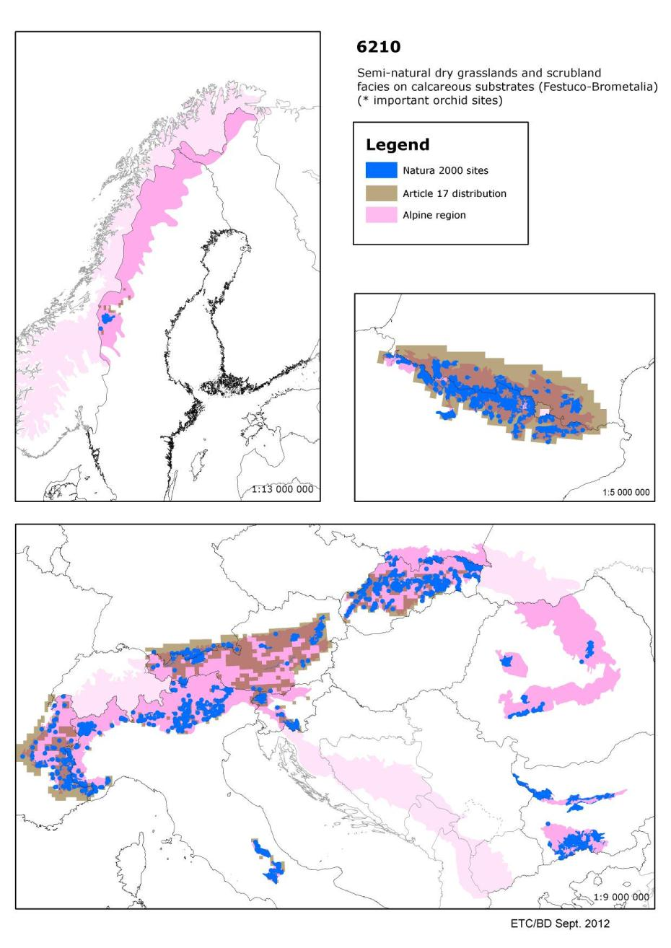

6230 - Species-rich Nardus grasslands, on silicious substrates in mountain areas (and submountain areas in Continental Europe)

Habitats Manual 2007
Closed, dry or mesophile, perennial Nardus grasslands occupying siliceous soils in Atlantic or sub-Atlantic or boreal lowland, hill and montane regions. Vegetation highly varied, but the variation is characterised by continuity. Nardetalia: 35.1-Violo-Nardion (Nardo-Galion saxatilis, Violion caninae); 36.31- Nardion. Species-rich sites should be interpreted as sites with are remarkable for a high number of species. In general, the habitats which have become irreversibly degraded through overgrazing should be excluded.

Conservation status (CS) assessed at the Alpine region and MS level:
N2K code | Habitat name |  | AT | BG | DE | ES | FR | IT | PL | RO | SE | SI | SK | REGION
6230 | Species-rich Nardus grasslands, on silicious substrates in mountain areas (and submountain areas in Continental Europe) | range | FV |  | FV | XX | U1 | FV | U1 |  | FV | FV | XX | FV
 |  | area | U1 |  | U1 | XX | U1 | FV | U2 |  | U1 | U1 | XX | U1
 |  | structure | XX |  | FV | XX | FV | FV | U1 |  | U2 | U1 | U1 | XX
 |  | future | U1 |  | U1 | XX | FV | FV | U2 |  | U2 | U1 | XX | U1
 |  | overall | U1 |  | U1 | XX | U1 | FV | U2 |  | U2 | U1 | U1 | U1

This is a semi-natural grassland widespread across much of the European Union with distinct upland and lowland subtypes. The definition of this habitat has caused problems as several countries have large areas of species poor grassland dominated by matgrass (Nardus stricta) as a result of long periods of overgrazing of little interest for nature conservation - these grasslands should not be included in this habitat.
Assessed as either ‘unfavourable-inadequate' or ‘unfavourable-bad' across all countries except for Greece and Italy who reported ‘favourable' in all regions. As the pressures reported elsewhere as responsible for its unfavourable conservation status (abandonment of grazing or overgrazing) are likely to exist in these countries it is not clear why there should be such a difference (Summary sheet of the online report on Article 17 of the Habitats Directive).

Species associated to Species-rich Nardus grasslands, on silicious substrates in mountain areas (and submountain areas in Continental Europe) and their CS at the Alpine region and MS level
N2K code | Species name | Group |  | AT | IT | RO | SK | REGION
1050 | Saga pedo | Invertebrates | range | FV | U2 |  | U1 | U1
 |  |  | population | U1 | U2 |  | U1 | U1
 |  |  | habitat | U1 | U1 |  | U1 | U1
 |  |  | future | U1 | U1 |  | XX | XX
 |  |  | overall | U1 | U2 |  | U1 | U1

N2K code | Species name | Group |  | AT | BG | FR | IT | RO | SI | SK | REGION
1053 | Zerynthia polyxena | Invertebrates | range | XX |  | XX | FV |  | FV | FV | XX
 |  |  | population | XX |  | XX | FV |  | U1 | FV | XX
 |  |  | habitat | XX |  | XX | FV |  | U1 | FV | XX
 |  |  | future | XX |  | XX | U1 |  | U1 | FV | XX
 |  |  | overall | XX |  | XX | U1 |  | U1 | FV | XX

N2K code | Species name | Group |  | AT | BG | DE | ES | FR | IT | PL | RO | SI | SK | REGION
1056 | Parnassius mnemosyne | Invertebrates | range | FV |  | FV | XX | FV | U2 | U1 |  | FV | FV | U1
 |  |  | population | FV |  | XX | XX | FV | U1 | U1 |  | U1 | FV | U1
 |  |  | habitat | U1 |  | FV | U1 | FV | FV | XX |  | U1 | FV | U1
 |  |  | future | U1 |  | FV | XX | FV | FV | U1 |  | U1 | FV | U1
 |  |  | overall | U1 |  | FV | U1 | FV | U2 | U1 |  | U1 | FV | U1

N2K code | Species name | Group |  | AT | BG | DE | ES | FR | IT | PL | RO | SI | SK | REGION
1057 | Parnassius apollo | Invertebrates | range | U1 |  | FV | XX | FV | FV | FV |  | U2 | U1 | U1
 |  |  | population | U1 |  | FV | XX | FV | FV | FV |  | U2 | U1 | U1
 |  |  | habitat | U1 |  | FV | XX | FV | FV | U1 |  | U2 | U1 | U1
 |  |  | future | U1 |  | FV | XX | FV | U1 | FV |  | U2 | U1 | U1
 |  |  | overall | U1 |  | FV | XX | FV | U1 | U1 |  | U2 | U1 | U1

N2K code | Species name | Group |  | AT | BG | DE | ES | FR | IT | PL | RO | SI | SK | REGION
1058 | Maculinea arion | Invertebrates | range | FV |  | FV | XX | FV | U2 | XX |  | FV | FV | U1
 |  |  | population | FV |  | FV | XX | XX | U2 | U2 |  | U1 | U1 | U2
 |  |  | habitat | U1 |  | FV | XX | FV | U1 | U1 |  | U1 | U1 | U1
 |  |  | future | U1 |  | FV | XX | FV | U1 | U1 |  | U1 | U1 | U1
 |  |  | overall | U1 |  | FV | XX | FV | U2 | U2 |  | U1 | U1 | U2

N2K code | Species name | Group |  | AT | BG | DE | ES | FR | IT | RO | SI | REGION
1065 | Euphydryas aurinia | Invertebrates | range | FV |  | FV | XX | FV | FV |  | FV | FV
 |  |  | population | FV |  | XX | XX | FV | FV |  | U1 | U1
 |  |  | habitat | U1 |  | FV | XX | FV | FV |  | U1 | U1
 |  |  | future | U1 |  | FV | U1 | FV | FV |  | U1 | U1
 |  |  | overall | U1 |  | FV | U1 | FV | FV |  | U1 | U1

N2K code | Species name | Group |  | AT | DE | FR | IT | SI | SK | REGION
1067 | Lopinga achine | Invertebrates | range | U1 | XX | U1 | FV | FV | U2 | U1
 |  |  | population | FV | U1 | XX | FV | FV | U2 | FV
 |  |  | habitat | U1 | U1 | U1 | FV | FV | FV | U1
 |  |  | future | U2 | FV | U1 | FV | FV | U1 | U2
 |  |  | overall | U2 | U1 | U1 | FV | FV | U2 | U2

N2K code | Species name | Group |  | AT | IT | SI | REGION
1072 | Erebia calcaria | Invertebrates | range | FV | U1 | U1 | U1
 |  |  | population | FV | FV | FV | FV
 |  |  | habitat | U1 | FV | FV | FV
 |  |  | future | U1 | FV | U1 | U1
 |  |  | overall | U1 | U1 | U1 | U1

N2K code | Species name | Group |  | AT | BG | ES | FR | IT | RO | SI | SK | REGION
1310 | Miniopterus schreibersii | Mammals | range | U2 |  | XX | U1 | U1 |  | FV | U1 | U1
 |  |  | population | U2 |  | XX | U2 | U1 |  | U1 | U2 | U2
 |  |  | habitat | U2 |  | XX | XX | U2 |  | XX | XX | XX
 |  |  | future | U2 |  | U1 | U2 | U1 |  | XX | XX | U2
 |  |  | overall | U2 |  | U1 | U2 | U2 |  | U1 | U2 | U2

N2K code | Species name | Group |  | AT | BG | SK | REGION
1335 | Spermophilus citellus | Mammals | range | U2 |  | U2 | U2
 |  |  | population | U2 |  | U2 | U2
 |  |  | habitat | U2 |  | U1 | U1
 |  |  | future | U2 |  | U2 | U2
 |  |  | overall | U2 |  | U2 | U2

N2K code | Species name | Group |  | AT | FR | IT | REGION
1419 | Botrychium simplex | Vascular plants | range | FV | FV | U2 | U2
 |  |  | population | U1 | U2 | U2 | U2
 |  |  | habitat | XX | FV | XX | XX
 |  |  | future | U1 | U2 | U2 | U2
 |  |  | overall | U1 | U2 | U2 | U2

N2K code | Species name | Group |  | AT | FR | IT | SI | REGION
1604 | Eryngium alpinum | Vascular plants | range | FV | FV | U1 | U1 | U1
 |  |  | population | XX | FV | U1 | U1 | U1
 |  |  | habitat | XX | U1 | XX | U1 | XX
 |  |  | future | XX | U1 | U1 | U1 | U1
 |  |  | overall | XX | U1 | U1 | U1 | U1

N2K code | Species name | Group |  | PL | RO | SK | REGION
4070 | Campanula serrata | Vascular plants | range | FV |  | FV | U1
 |  |  | population | FV |  | FV | U1
 |  |  | habitat | U1 |  | FV | U1
 |  |  | future | FV |  | XX | XX
 |  |  | overall | U1 |  | FV | U1

Main pressures to Species-rich Nardus grasslands, on silicious substrates in mountain areas (and submountain areas in Continental Europe) and their importance to associated species
Pressure description  (2nd level) | Species-rich Nardus grasslands, on silicious substrates in mountain areas (and submountain areas in Continental Europe) | Saga pedo | Zerynthia polyxena | Parnassius mnemosyne | Parnassius apollo | Maculinea arion | Euphydryas aurinia
Cultivation | x | x |  |  |  | x | x
Fertilisation | x
Grazing |  | x | x | x |  |  | x
General Forestry management | x |  | x |  | x | x
Sport and leisure structures | x
Outdoor sports and leisure activities | x
Biocenotic evolution | x

Pressure description  (2nd level) | Lopinga achine | Erebia calcaria | Miniopterus schreibersii | Spermophilus citellus | Botrychium simplex | Eryngium alpinum | Campanula serrata
Cultivation |  |  |  |  |  | x | x
Fertilisation |  |  |  |  | x
Grazing |  |  |  |  | x | x
General Forestry management |  |  |  | x | x |  | x
Sport and leisure structures |  | x |  | x |  |  | x
Outdoor sports and leisure activities |  |  |  |  |  | x | x
Biocenotic evolution

Main threats to Species-rich Nardus grasslands, on silicious substrates in mountain areas (and submountain areas in Continental Europe) and their importance to associated species
Threats description (2nd level) | Species-rich Nardus grasslands, on silicious substrates in mountain areas (and submountain areas in Continental Europe) | Saga pedo | Zerynthia polyxena | Parnassius mnemosyne | Parnassius apollo | Maculinea arion | Euphydryas aurinia
Cultivation | x | x |  |  |  |  | x
Fertilisation | x
Grazing | x |  | x | x |  |  | x
General Forestry management | x |  | x |  | x | x
Biocenotic evolution | x

Threats description (2nd level) | Lopinga achine | Erebia calcaria | Miniopterus schreibersii | Spermophilus citellus | Botrychium simplex | Eryngium alpinum | Campanula serrata
Cultivation |  |  |  |  |  |  | x
Fertilisation |  |  |  |  | x
Grazing |  |  |  |  | x
General Forestry management |  |  | x | x | x
Biocenotic evolution

Other information
According to the ETC/BD calculations 51-75% of the area of this habitat type are within SCIs. This means that Natura 2000 network provides an important framework for the management of this habitat type.

Number of SCIs and habitat area (ha) within SCIs per Member State in the Alpine biogeographical region
 | AT | BG | DE | ES | FR | IT | PL | RO | SE | SI | SK
Number of sites | 28 | 9 | 11 | 6 | 45 | 165 | 16 | 23 | 13 | 5 | 34
Habitat area (ha) | 17046 | 25343 | 122 | 4227 | 24701 | 37716 | 1406 | 3912 | 115 | 2785 | 6269
The figures include all SCIs where the habitat type is mentioned including sites coded as D.

Map of SCIs proposed for Species-rich Nardus grasslands, on silicious substrates in mountain areas (and submountain areas in Continental Europe) & Article 17 distribution
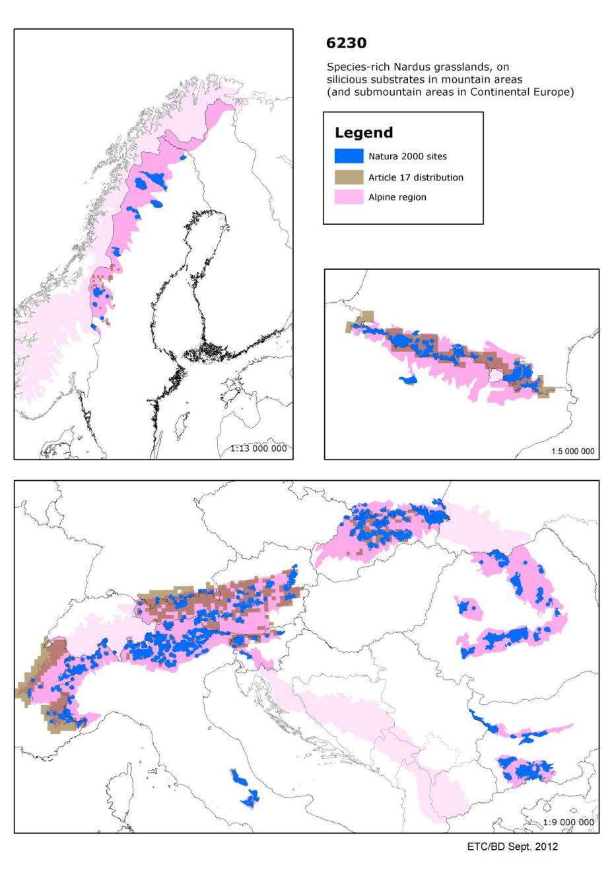

6410 - Molinia meadows on calcareous, peaty or clayey-silt-laden soils (Molinion caeruleae)

Habitats Manual 2007
Molinia meadows of plain to montane levels, on more or less wet nutrient poor soils (nitrogen, phosphorus). They stem from extensive management, sometimes with a mowing late in the year or, they correspond to a deteriorated stage of draining peat bogs.
Sub-types: 37.311: on neutro-alkaline to calcareous soils with a fluctuating water table, relatively rich in species (Eu-molinion). The soil is sometimes peaty and becomes dry in summer. 37.312: on more acid soils of the Junco-Molinion (Juncion acutiflori) except species-poor meadows or on degraded peaty soils.
In some regions, these grasslands are in close contact with Nardetalia communities. For the Molinia meadows of river valleys, a transition toward Cnidion dubii alliance is observed.

Conservation status (CS) assessed at the Alpine region and MS level
N2K code | Habitat name |  | AT | BG | DE | ES | FR | IT | PL | RO | SE | SI | SK | REGION
6410 | Molinia meadows on calcareous, peaty or clayey-silt-laden soils (Molinion caeruleae) | range | FV |  | FV | XX | U1 | FV | FV |  | U2 | FV | U1 | U1
 |  | area | U1 |  | FV | XX | U1 | U1 | U1 |  | U2 | U2 | U1 | U2
 |  | structure | XX |  | XX | U1 | U1 | FV | U1 |  | U2 | U1 | U1 | U1
 |  | future | U1 |  | XX | U1 | U1 | XX | U1 |  | U2 | U2 | FV | U2
 |  | overall | U1 |  | XX | U1 | U1 | U1 | U1 |  | U2 | U2 | U1 | U2

Meadows with purple moorgrass (Molinia caerulea) on wet, unfertile soils resulting from long periods of traditional management such as mowing. Species-poor meadows dominated by purple moorgrass, often a result of draining peat bogs, are not included in this habitat. This habitat is wide spread across central, northern and western Europe, it also occurs more rarely in the Mediterranean region.
Assessed as ‘unfavourable-bad' in all regions in which it occurs except for the Mediterranean region where it is ‘unknown' as a result of Spain reporting all parameters as ‘unknown'. Only in Estonia (Boreal) and Portugal (Atlantic and Mediterranean) has this habitat been assessed as ‘favourable '. Most countries include changes in agricultural management amongst threats and pressures, many also note drainage. Better information required, particularly from Spain and Luxembourg (Summary sheet of the online report on Article 17 of the Habitats Directive).

Species associated to Molinia meadows on calcareous, peaty or clayey-silt-laden soils (Molinion caeruleae) and their CS at the Alpine region and MS level
N2K code | Species name | Group |  | AT | ES | PL | RO | SK | REGION
1042 | Leucorrhinia pectoralis | Invertebrates | range | FV | XX | XX |  | U2 | XX
 |  |  | population | XX | XX | XX |  | U2 | XX
 |  |  | habitat | U2 | XX | XX |  | U1 | U2
 |  |  | future | U2 | XX | XX |  | U1 | U2
 |  |  | overall | U2 | XX | XX |  | U2 | U2

N2K code | Species name | Group |  | AT | BG | FR | IT | PL | RO | SI | SK | REGION
1060 | Lycaena dispar | Invertebrates | range | FV |  | FV | U1 | FV |  | FV | FV | FV
 |  |  | population | FV |  | XX | U1 | XX |  | U1 | FV | U1
 |  |  | habitat | FV |  | FV | U1 | FV |  | U1 | FV | FV
 |  |  | future | FV |  | FV | U1 | FV |  | U1 | FV | FV
 |  |  | overall | FV |  | FV | U1 | FV |  | U1 | FV | U1

N2K code | Species name | Group |  | AT | BG | DE | FR | IT | PL | RO | SI | SK | REGION
1193 | Bombina variegata | Amphibians | range | FV |  | FV | U2 | U1 | FV |  | FV | FV | FV
 |  |  | population | U1 |  | XX | U2 | U1 | FV |  | XX | U1 | U1
 |  |  | habitat | U1 |  | FV | XX | U1 | XX |  | U1 | U1 | U1
 |  |  | future | U1 |  | FV | U1 | U1 | FV |  | FV | U1 | U1
 |  |  | overall | U1 |  | FV | U2 | U1 | FV |  | U1 | U1 | U1

N2K code | Species name | Group |  | BG | PL | RO | SK | REGION
1197 | Pelobates fuscus | Amphibians | range |  | XX |  | U1 | U1
 |  |  | population |  | XX |  | U1 | U1
 |  |  | habitat |  | XX |  | U1 | U1
 |  |  | future |  | XX |  | U1 | U1
 |  |  | overall |  | XX |  | U1 | U1

N2K code | Species name | Group |  | AT | BG | DE | IT | PL | RO | SI | SK | REGION
1201 | Bufo viridis | Amphibians | range | U1 |  | U2 | FV | FV |  | FV | FV | FV
 |  |  | population | U1 |  | U2 | FV | XX |  | XX | U1 | U1
 |  |  | habitat | U1 |  | U2 | FV | XX |  | XX | U1 | U1
 |  |  | future | U1 |  | U1 | FV | FV |  | XX | FV | FV
 |  |  | overall | U1 |  | U2 | FV | XX |  | XX | U1 | U1

N2K code | Species name | Group |  | AT | ES | FR | REGION
1202 | Bufo calamita | Amphibians | range | U1 | XX | U2 | U2
 |  |  | population | U2 | XX | U2 | U2
 |  |  | habitat | U2 | XX | U2 | U2
 |  |  | future | U2 | XX | U2 | U2
 |  |  | overall | U2 | XX | U2 | U2

N2K code | Species name | Group |  | AT | BG | FR | PL | RO | SK | REGION
1758 | Ligularia sibirica | Vascular plants | range | FV |  | FV | XX |  | FV | U2
 |  |  | population | U1 |  | FV | U1 |  | FV | U1
 |  |  | habitat | U1 |  | FV | U1 |  | U1 | U1
 |  |  | future | U2 |  | U1 | XX |  | U1 | U2
 |  |  | overall | U2 |  | U1 | U1 |  | U1 | U2

N2K code | Species name | Group |  | BG | PL | SI | SK | REGION
4045 | Coenagrion ornatum | Invertebrates | range |  | XX | U1 | U2 | U2
 |  |  | population |  | XX | U1 | U1 | U1
 |  |  | habitat |  | XX | U1 | U1 | U1
 |  |  | future |  | XX | U1 | FV | U1
 |  |  | overall |  | XX | U1 | U2 | U2

N2K code | Species name | Group |  | BG | RO | SI | SK | REGION
4046 | Cordulegaster heros | Invertebrates | range |  |  | FV | U2 | FV
 |  |  | population |  |  | FV | XX | FV
 |  |  | habitat |  |  | FV | FV | FV
 |  |  | future |  |  | FV | FV | FV
 |  |  | overall |  |  | FV | U2 | FV

N2K code | Species name | Group |  | IT | SI | SK | REGION
4068 | Adenophora lilifolia | Vascular plants | range | FV | FV | FV | FV
 |  |  | population | FV | FV | FV | FV
 |  |  | habitat | XX | FV | XX | XX
 |  |  | future | FV | FV | XX | XX
 |  |  | overall | FV | FV | XX | XX

N2K code | Species name | Group |  | BG | DE | FR | IT | SI | REGION
4096 | Gladiolus palustris | Vascular plants | range |  | FV | XX | FV | FV | FV
 |  |  | population |  | FV | XX | FV | U1 | U1
 |  |  | habitat |  | FV | XX | XX | U1 | XX
 |  |  | future |  | FV | XX | FV | U1 | U1
 |  |  | overall |  | FV | XX | FV | U1 | U1

Main pressures to Molinia meadows on calcareous, peaty or clayey-silt-laden soils (Molinion caeruleae) and their importance to associated species
Pressure description  (2nd level) | Molinia meadows on calcareous, peaty or clayey-silt-laden soils (Molinion caeruleae) | Leucorrhinia pectoralis | Lycaena dispar | Bombina variegata | Pelobates fuscus | Bufo viridis
Cultivation |  |  |  | x | x | x
Grazing | x
General Forestry management | x |  |  | x
Drainage | x |  | x | x
Biocenotic evolution

Pressure description  (2nd level) | Bufo calamita | Ligularia sibirica | Coenagrion ornatum | Cordulegaster heros | Adenophora lilifolia | Gladiolus palustris
Cultivation | x |  | x |  |  | x
Grazing |  | x |  |  |  | x
General Forestry management |  | x |  | x
Drainage | x | x
Biocenotic evolution |  |  |  |  |  | x

Main threats to Molinia meadows on calcareous, peaty or clayey-silt-laden soils (Molinion caeruleae) and their importance to associated species
Threats description  (2nd level) | Molinia meadows on calcareous, peaty or clayey-silt-laden soils (Molinion caeruleae) | Leucorrhinia pectoralis | Lycaena dispar | Bombina variegata | Pelobates fuscus | Bufo viridis
Cultivation | x |  |  | x | x | x
Fertilisation | x |  |  | x
General Forestry management | x |  |  | x
Landfill, land reclamation and drying out | x | x | x
Drainage |  |  | x | x
Biocenotic evolution

Threats description  (2nd level) | Bufo calamita | Ligularia sibirica | Coenagrion ornatum | Cordulegaster heros | Adenophora lilifolia | Gladiolus palustris
Cultivation | x |  | x |  |  | x
Fertilisation | x
General Forestry management |  | x |  | x
Landfill, land reclamation and drying out | x | x | x
Drainage | x | x
Biocenotic evolution |  | x | x |  |  | x

Other information
According to the ETC/BD calculations 76-100% of the area of this habitat type are within SCIs. This means that Natura 2000 network provides an important framework for the management of this habitat type.

Number of SCIs and habitat area (ha) within SCIs per Member State in the Alpine biogeographical region
 | AT | BG | DE | ES | FR | IT | PL | RO | SE | SI | SK
Number of sites | 33 | 4 | 21 | 24 | 34 | 100 | 1 | 15 | 5 | 12 | 13
Habitat area (ha) | 1421 | 69 | 432 | 1821 | 4403 | 4211 | 14 | 873 | 854 | 2301 | 84
The figures include all SCIs where the habitat type is mentioned including sites coded as D.

Map of SCIs proposed for Molinia meadows on calcareous, peaty or clayey-silt-laden soils (Molinion caeruleae) & Article 17 distribution
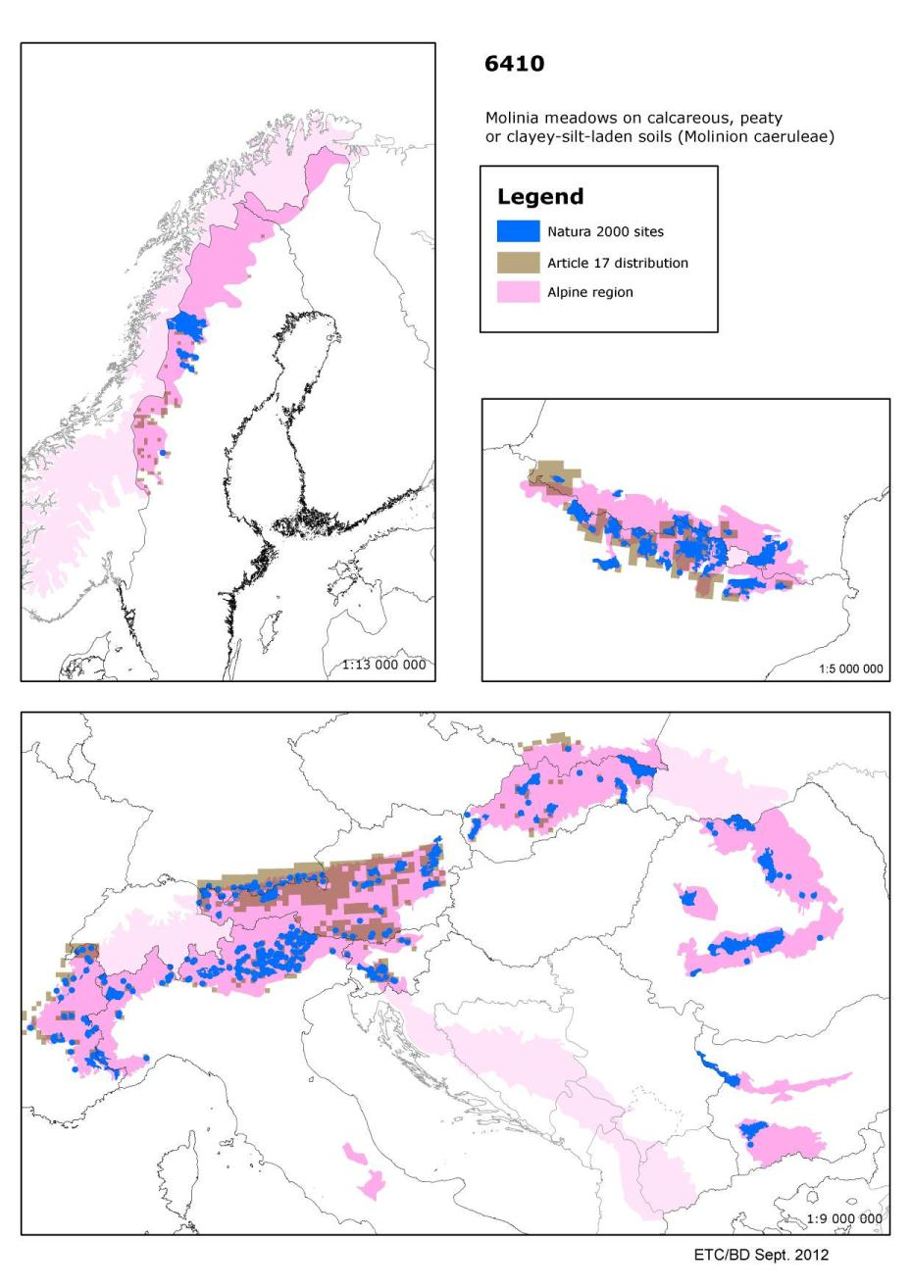

6430 - Hydrophilous tall herb fringe communities of plains and of the montane to alpine levels

Habitats Manual 2007
- Wet and nitrophilous tall herb edge communities, along water courses and woodland borders belonging to the Glechometalia hederaceae and the Convolvuletalia sepium orders (Senecion fluviatilis, Aegopodion podagrariae, Convolvulion sepium, Filipendulion) (37.7.)
- Hygrophilous perennial tall herb communities of montane to alpine levels of the Betulo- Adenostyletea class (37.8.).

Similar communities to 37.8, with a weak development, occur at lower altitude along rivers and forest borders (in Wallonia-Belgium for example). Nitrophilous edge communities comprising only basal, common species in the region have no conservation priority. These tall herb communities could also develop in wet meadows, let lie fallow, without any cutting. Large areas of wet meadows let lie fallow and neophyte communities with Helianthus tuberosus, Impatiens glandulifera, should not be taken into account.

Conservation status (CS) assessed at the Alpine region and MS level:
N2K code | Habitat name |  | AT | BG | DE | ES | FI | FR | IT | PL | RO | SE | SI | SK | REGION
6430 | Hydrophilous tall herb fringe communities of plains and of the montane to alpine levels | range | XX |  | FV | XX | FV | FV | FV | FV |  | FV | FV | FV | FV
 |  | area | XX |  | FV | XX | XX | XX | FV | FV |  | FV | XX | FV | XX
 |  | structure | XX |  | FV | XX | FV | FV | FV | FV |  | FV | U1 | U1 | U1
 |  | future | FV |  | FV | XX | FV | FV | FV | FV |  | FV | XX | FV | FV
 |  | overall | XX |  | FV | XX | FV | FV | FV | FV |  | FV | U1 | U1 | U1

This habitat is formed by tall herbs (sometimes known as ‘megaforbs') typical of wet, fertile soils often on cliff ledges, woodland margins and riverbanks. The habitat is widespread throughout Europe although restricted to mountains in some countries.

Assessed as ‘unfavourable-inadequate' Alpine, Boreal and Continental regions. In the Alpine region this is due to ‘structure and function' in Slovenia and Slovakia. All other countries in the Alpine region assessed this habitat as ‘favourable ' except Spain where all parameters were reported as ‘unknown'. In the Boreal region the assessment is a result of poor ‘structure and function' and ‘future prospects' in Finland and Lithuania, elsewhere the habitat has been assessed as ‘favourable' except for Sweden where it is ‘unknown'. Countries in the Continental region reported a range of assessments, including ‘unfavourable-bad' (Czech R epublic), ‘favourable ' (Germany, Italy) and ‘unknown' (Austria, Denmark, Luxembourg).

Assessed as ‘unfavourable-bad' for the Atlantic and Pannonian regions due to ‘structure and functions' in Belgium, France and the United Kingdom (Atlantic) and all parameters in Hungary. No country in these regions has assessed this habitat as ‘favourable'.
Assessed as ‘unknown but not favourable ' in the Mediterranean region due to all parameters in Spain being reported as ‘unknown'. Assessed as ‘favourable' by Italy and ‘unfavourable-inadequate' elsewhere in the region, excluding Spain would lead to a regional assessment as ‘unfavourable-inadequate'. Better information required.

Species associated to Hydrophilous tall herb fringe communities of plains and of the montane to alpine levels and their CS at the Alpine region and MS level
N2K code | Species name | Group |  | AT | FR | IT | SI | REGION
1604 | Eryngium alpinum | Vascular plants | range | FV | FV | U1 | U1 | U1
 |  |  | population | XX | FV | U1 | U1 | U1
 |  |  | habitat | XX | U1 | XX | U1 | XX
 |  |  | future | XX | U1 | U1 | U1 | U1
 |  |  | overall | XX | U1 | U1 | U1 | U1

N2K code | Species name | Group |  | AT | BG | FR | PL | RO | SK | REGION
1758 | Ligularia sibirica | Vascular plants | range | FV |  | FV | XX |  | FV | U2
 |  |  | population | U1 |  | FV | U1 |  | FV | U1
 |  |  | habitat | U1 |  | FV | U1 |  | U1 | U1
 |  |  | future | U2 |  | U1 | XX |  | U1 | U2
 |  |  | overall | U2 |  | U1 | U1 |  | U1 | U2

N2K code | Species name | Group |  | BG | PL | RO | SK | REGION
4116 | Tozzia carpathica | Vascular plants | range |  | FV |  | FV | FV
 |  |  | population |  | FV |  | FV | FV
 |  |  | habitat |  | FV |  | FV | FV
 |  |  | future |  | FV |  | XX | XX
 |  |  | overall |  | FV |  | FV | FV

Main pressures to Hydrophilous tall herb fringe communities of plains and of the montane to alpine levels and their importance to associated species
Pressure description (2nd level) | Hydrophilous tall herb fringe communities of plains and of the montane to alpine levels | Eryngium alpinum | Ligularia sibirica | Tozzia carpathica
Drainage | x |  | x | x
Modification of hydrographic functioning | x |  | x
Biocenotic evolution | x |  |  | x

Main threats to Hydrophilous tall herb fringe communities of plains and of the montane to alpine levels and their importance to associated species
Threats description (2nd level) | Hydrophilous tall herb fringe communities of plains and of the montane to alpine levels | Eryngium alpinum | Ligularia sibirica | Tozzia carpathica
Drainage | x |  | x | x
Modification of hydrographic functioning | x |  | x
Biocenotic evolution | x |  | x | x

Other information
According to the ETC/BD calculations 76-100% of the area of this habitat type are within SCIs. This means that Natura 2000 network provides an important framework for the management of this habitat type.

Number of SCIs and habitat area (ha) within SCIs per Member State in the Alpine biogeographical region
 | AT | BG | DE | ES | FI | FR | IT | PL | RO | SE | SI | SK
Number of sites | 60 | 12 | 38 | 23 | 4 | 85 | 212 | 18 | 48 | 26 | 9 | 97
Habitat area (ha) | 3608 | 4327 | 4143 | 1687 | 776 | 9408 | 17095 | 918 | 12811 | 5327 | 1756 | 1507
The figures include all SCIs where the habitat type is mentioned including sites coded as D.

Map of SCIs proposed for Hydrophilous tall herb fringe communities of plains and of the montane to alpine levels & Article 17 distribution
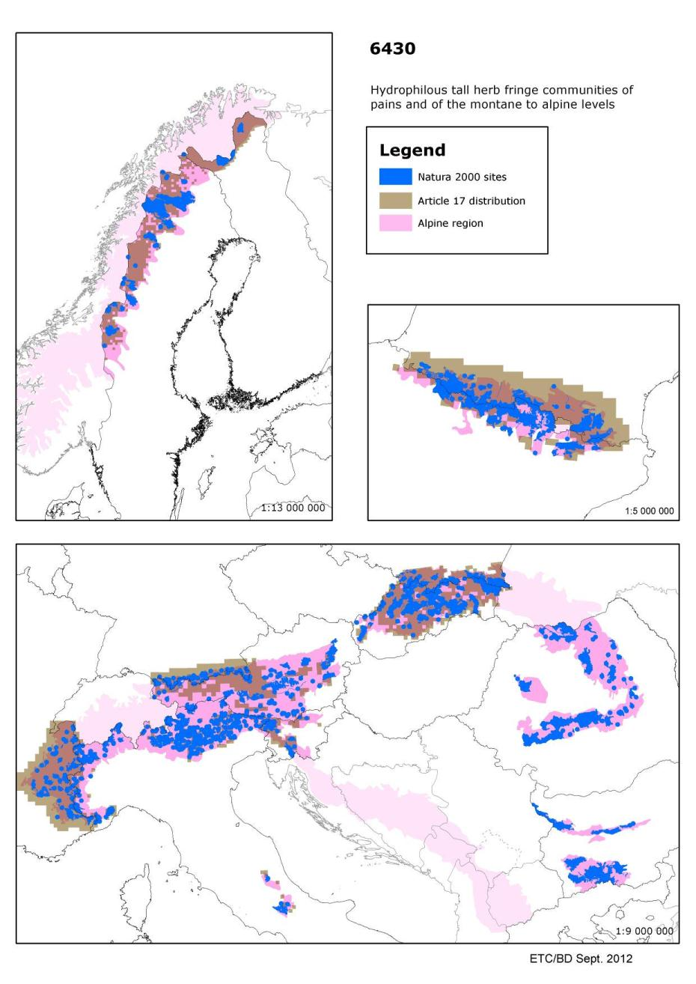

6510 - Lowland hay meadows (Alopecurus pratensis, Sanguisorba officinalis)

Habitats Manual 2007
Species-rich hay meadows on lightly to moderately fertilised soils of the plain to submontane levels, belonging to the Arrhenatherion and the Brachypodio-Centaureion nemoralis alliances. These extensive grasslands are rich in flowers and are not cut before the grasses flower and then only one or two times per year.
Wet to dry sub-types occur. If management practices become intensive with heavy applications of fertiliser, the species diversity rapidly declines.

Conservation status (CS) assessed at the Alpine region and MS level:
N2K code | Habitat name |  | AT | BG | DE | ES | FR | IT | PL | RO | SI | SK | REGION
6510 | Lowland hay meadows (Alopecurus pratensis, Sanguisorba officinalis) | range | U1 |  | U1 | XX | FV | FV | FV |  | FV | FV | FV
 |  | area | U1 |  | U2 | XX | U1 | U1 | U1 |  | U1 | FV | U1
 |  | structure | XX |  | XX | XX | U1 | FV | U1 |  | U1 | FV | U1
 |  | future | U2 |  | U1 | XX | U1 | FV | U1 |  | U2 | FV | U1
 |  | overall | U2 |  | U2 | XX | U1 | U1 | U1 |  | U2 | FV | U1

Hay meadows at low altitudes which are mown after most of the plants have flowered, they maybe lightly fertilised but frequent or heavy fertilisation quickly reduces the species diversity. These meadows are important for a wide range of invertebrates as well as plants. This habitat is wide spread in central and northern Europe, also occurring, but more rarely, in the Mediterranean region.
Unfavourable-inadequate' in the Alpine and Continental regions where the habitat is most abundant with only ‘range' assessed as ‘favourable'. Only Slovakia (Alpine) has assessed this habitat as ‘favourable' for these two regions although Spain reported all parameters as ‘unknown' for the Alpine region.
Assessed as ‘unfavourable-bad' in the Atlantic and Pannonian regions with no country reporting ‘favourable' although Spain reported all parameters as ‘unknown'. The United Kingdom reported ‘unfavourable-bad but improving'. Assessed as ‘unknown but not favourable' for the Mediterranean region as Spain reported all parameters as ‘unknown'.
Excluding Spain from the regional assessment would lead to ‘unfavourable-bad' due to the French assessment although reported as ‘favourable' by Italy. The threats and pressures reported by the countries are varied but most note changes to agricultural practice. Better information required, especially from Spain (Summary sheet of the online report on Article 17 of the Habitats Directive).

Species associated to Lowland hay meadows (Alopecurus pratensis, Sanguisorba officinalis) and their CS at the Alpine region and MS level
N2K code | Species name | Group |  | AT | BG | DE | ES | FR | IT | PL | RO | SI | SK | REGION
1058 | Maculinea arion | Invertebrates | range | FV |  | FV | XX | FV | U2 | XX |  | FV | FV | U1
 |  |  | population | FV |  | FV | XX | XX | U2 | U2 |  | U1 | U1 | U2
 |  |  | habitat | U1 |  | FV | XX | FV | U1 | U1 |  | U1 | U1 | U1
 |  |  | future | U1 |  | FV | XX | FV | U1 | U1 |  | U1 | U1 | U1
 |  |  | overall | U1 |  | FV | XX | FV | U2 | U2 |  | U1 | U1 | U2

N2K code | Species name | Group |  | AT | DE | FR | IT | PL | RO | SI | SK | REGION
1059 | Maculinea teleius | Invertebrates | range | FV | U1 | U1 | U2 | XX |  | U2 | FV | U1
 |  |  | population | FV | U1 | XX | U2 | XX |  | U2 | FV | U1
 |  |  | habitat | U1 | U1 | U2 | U2 | XX |  | U2 | FV | U2
 |  |  | future | U1 | U1 | XX | U2 | XX |  | U2 | FV | U1
 |  |  | overall | U1 | U1 | U2 | U2 | XX |  | U2 | FV | U2

N2K code | Species name | Group |  | AT | BG | DE | FR | PL | SK | REGION
1061 | Maculinea nausithous | Invertebrates | range | FV |  | FV | U1 | XX | U2 | FV
 |  |  | population | FV |  | FV | XX | XX | U1 | FV
 |  |  | habitat | U1 |  | FV | U1 | XX | XX | U1
 |  |  | future | U1 |  | FV | U2 | XX | XX | U1
 |  |  | overall | U1 |  | FV | U2 | XX | U2 | U1

N2K code | Species name | Group |  | DE | FR | RO | SE | REGION
4038 | Lycaena helle | Invertebrates | range | U2 | FV |  | XX | U2
 |  |  | population | U1 | XX |  | XX | XX
 |  |  | habitat | U1 | FV |  | XX | U1
 |  |  | future | U1 | FV |  | XX | U1
 |  |  | overall | U2 | FV |  | XX | U2

Main pressures to Lowland hay meadows (Alopecurus pratensis, Sanguisorba officinalis) and their importance to associated species
Pressure description  (2nd level) | Lowland hay meadows (Alopecurus pratensis, Sanguisorba officinalis) | Maculinea arion | Maculinea teleius | Maculinea nausithous | Lycaena helle
Cultivation |  | x
Fertilisation | x |  | x | x
Grazing | x |  | x | x
Restructuring agricultural land holding | x
General Forestry management | x | x | x | x
Urbanised areas, human habitation | x | x |  | x

Main threats to Lowland hay meadows (Alopecurus pratensis, Sanguisorba officinalis) and their importance to associated species
Threats description  (2nd level) | Lowland hay meadows (Alopecurus pratensis, Sanguisorba officinalis) | Maculinea arion | Maculinea teleius | Maculinea nausithous | Lycaena helle
Cultivation
Fertilisation | x |  | x | x
Grazing | x |  | x | x
Restructuring agricultural land holding | x |  |  | x
General Forestry management | x | x | x | x
Urbanised areas, human habitation | x | x |  | x
Biocenotic evolution | x |  | x | x

Other information
According to the ETC/BD calculations 0-50% of the area of this habitat type are within SCIs. This means that potentially important part of the management needs of this habitat types occurs outside Natura 2000 network.

Number of SCIs and habitat area (ha) within SCIs per Member State in the Alpine biogeographical region
 | AT | BG | DE | ES | FR | IT | PL | RO | SI | SK
Number of sites | 27 | 8 | 11 | 47 | 18 | 107 | 16 | 8 | 7 | 135
Habitat area (ha) | 1444 | 327 | 240 | 8953 | 2583 | 7269 | 17480 | 1598 | 10274 | 9248
The figures include all SCIs where the habitat type is mentioned including sites coded as D.

Map of SCIs proposed for Lowland hay meadows (Alopecurus pratensis, Sanguisorba officinalis) & Article 17 distribution
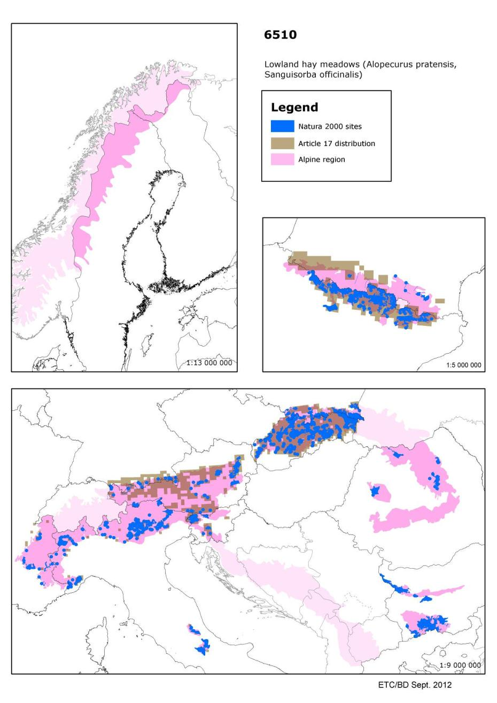

6520 - Mountain hay meadows

Habitats Manual 2007
Species-rich mesophile hay meadows of the montane and sub-alpine levels (mostly above 600 metres) usually dominated by Trisetum flavescens and with Heracleum sphondylium, Viola cornuta, Astrantia major, Carum carvi, Crepis mollis, C. pyrenaica, Bistorta major, (Polygonum bistorta), Silene dioica, S. vulgaris, Campanula glomerata, Salvia pratensis, Centaurea nemoralis, Anthoxanthum odoratum, Crocus albiflorus, Geranium phaeum, G. sylvaticum, Narcissus poeticus, Malva moschata, Valeriana repens, Trollius europaeus, Pimpinella major, Muscari botryoides, Lilium bulbiferum, Thlaspi caerulescens, Viola tricolor ssp. subalpina, Phyteuma halleri, P. orbiculare, Primula elatior, Chaerophyllum hirsutum and many others.

Conservation status (CS) assessed at the Alpine region and MS level:
N2K code | Habitat name |  | AT | BG | DE | ES | FR | IT | PL | RO | SE | SI | SK | REGION
6520 | Mountain hay meadows | range | U1 |  | FV | XX | FV | FV | FV |  | FV | FV | U1 | FV
 |  | area | U2 |  | U1 | XX | U2 | U1 | U2 |  | U2 | U1 | U1 | U2
 |  | structure | XX |  | XX | XX | U1 | FV | U2 |  | U2 | U1 | U1 | U1
 |  | future | U2 |  | U1 | XX | U2 | FV | U1 |  | U2 | U1 | FV | U2
 |  | overall | U2 |  | U1 | XX | U2 | U1 | U2 |  | U2 | U1 | U1 | U2

Hay meadows at higher altitudes (usually 600m or higher), often in mountain valleys. These meadows are traditionally managed for hay production and are often very species-rich. Most wide spread in the hills and mountains of central Europe, this habitat also occurs in other mountain ranges such as the Pyrenees, Massif Central and the hills of Great Britain and Fenno-Scandinavia.

Assessed as ‘unfavourable-bad' in all regions except for the Continental region where it has been assessed as ‘unfavourable-inadequate. No country has assessed this habitat as ‘favourable' although Spain has reported ‘unknown' for the Alpine region. The United Kingdom (Atlantic) reported ‘unfavourable-bad but improving' while in the Boreal region, both Finland and Sweden reported ‘unfavourable-bad and deteriorating'.

A variety of threats and pressures have been reported, most countries note changes in agricultural and several ski developments (Summary sheet of the online report on Article 17 of the Habitats Directive).

Species associated to Mountain hay meadows and their CS at the Alpine region and MS level
N2K code | Species name | Group |  | AT | FR | IT | SI | REGION
1604 | Eryngium alpinum | Vascular plants | range | FV | FV | U1 | U1 | U1
 |  |  | population | XX | FV | U1 | U1 | U1
 |  |  | habitat | XX | U1 | XX | U1 | XX
 |  |  | future | XX | U1 | U1 | U1 | U1
 |  |  | overall | XX | U1 | U1 | U1 | U1

N2K code | Species name | Group |  | DE | FR | RO | SE | REGION
4038 | Lycaena helle | Invertebrates | range | U2 | FV |  | XX | U2
 |  |  | population | U1 | XX |  | XX | XX
 |  |  | habitat | U1 | FV |  | XX | U1
 |  |  | future | U1 | FV |  | XX | U1
 |  |  | overall | U2 | FV |  | XX | U2

N2K code | Species name | Group |  | PL | RO | SK | REGION
4070 | Campanula serrata | Vascular plants | range | FV |  | FV | U1
 |  |  | population | FV |  | FV | U1
 |  |  | habitat | U1 |  | FV | U1
 |  |  | future | FV |  | XX | XX
 |  |  | overall | U1 |  | FV | U1

Main pressures to Mountain hay meadows and their importance to associated species
Pressure description (2nd level) | Mountain hay meadows | Eryngium alpinum | Lycaena helle | Campanula serrata
Cultivation |  | x |  | x
Fertilisation | x
Grazing |  | x
Biocenotic evolution | x

Main threats to Mountain hay meadows and their importance to associated species
Threats description (2nd level) | Mountain hay meadows | Eryngium alpinum | Lycaena helle | Campanula serrata
Cultivation |  |  |  | x
Grazing | x
Biocenotic evolution | x

Other information
According to the ETC/BD calculations 76-100% of the area of this habitat type are within SCIs. This means that Natura 2000 network provides an important framework for the management of this habitat type.

Number of SCIs and habitat area (ha) within SCIs per Member State in the Alpine biogeographical region
 | AT | BG | DE | ES | FR | IT | PL | RO | SE | SI | SK
Number of sites | 18 | 14 | 15 | 12 | 59 | 132 | 13 | 43 | 28 | 5 | 17
Habitat area (ha) | 3205 | 23822 | 761 | 976 | 14176 | 15039 | 2951 | 115936 | 101 | 2811 | 2027
The figures include all SCIs where the habitat type is mentioned including sites coded as D.

Map of SCIs proposed for Mountain hay meadows & Article 17 distribution
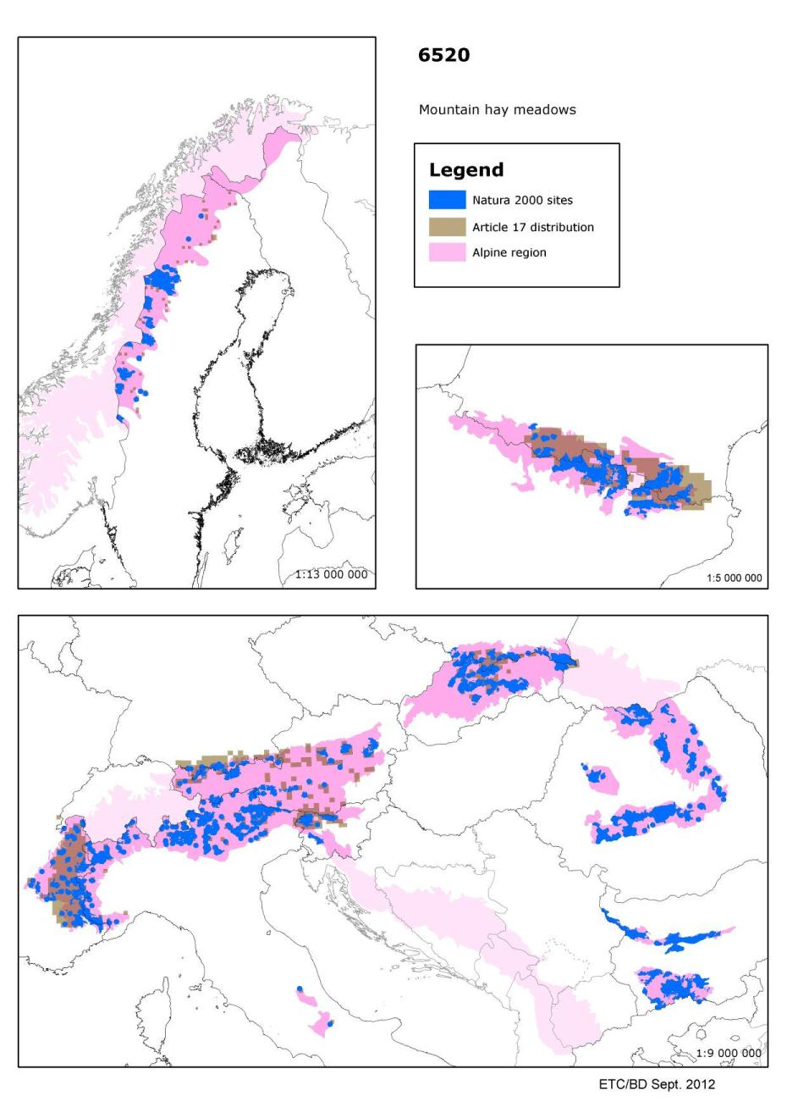

7110 - Active raised bogs

Habitats Manual 2007
Acid bogs, ombrotrophic, poor in mineral nutrients, sustained mainly by rainwater, with a water level generally higher than the surrounding water table, with perennial vegetation dominated by colourful Sphagna hummocks allowing for the growth of the bog (Erico-Sphagnetalia magellanici, Scheuchzerietalia palustris p., Utricularietalia intermedio-minoris p., Caricetalia fuscae p.). The term "active" must be taken to mean still supporting a significant area of vegetation that is normally peat forming, but bogs where active peat formation is temporarily at a standstill, such as after a fire or during a natural climatic cycle e.g., a period of drought, are also included.
In order to support the conservation of this ecosystem over its geographic range and its genetic diversity, marginal areas of lower quality as a result of damage or degradation which abut active raised bogs may need to be included, protected and, where practicable, regenerated. There are very few intact or near-intact raised bogs in Europe, except in Finland and Sweden where active raised bogs are the predominant mire complex type in hemiboreal and southern boreal regions.

Conservation status (CS) assessed at the Alpine region and MS level
N2K code | Habitat name |  | AT | DE | ES | FR | IT | PL | RO | SI | SK | REGION
7110 | Active raised bogs | range | U1 | FV | XX | U1 | FV | FV |  | FV | FV | U1
 |  | area | U2 | FV | XX | U2 | FV | U1 |  | FV | U1 | U2
 |  | structure | U1 | XX | XX | U2 | XX | U1 |  | U1 | FV | U2
 |  | future | U1 | FV | XX | U2 | FV | U1 |  | FV | U1 | U2
 |  | overall | U2 | FV | XX | U2 | FV | U1 |  | U1 | U1 | U2

Raised bogs are formed by bog mosses (Sphagnum species) and are dependent on rainfall for their nutrients. They often form a dome with an internal water table higher than the surrounding water table. The habitat is widely distributed across northern Europe, particularly in the Atlantic, Boreal and Continental regions. Active raised bogs are those which are peat forming, disturbed bogs which are no longer active are the non-priority habitat type ‘7120 Degraded raised bogs capable of natural regeneration'.
Assessed as ‘unfavourable -bad' in the Alpine, Atlantic, Continental, Macaronesian and Mediterranean regions. Within these regions only Germany and Italy (both for the Alpine region) have reported this habitat as ‘favourable' although Spain reported Alpine, Atlantic and Mediterranean regions as ‘unknown'. The United Kingdom (Atlantic) reports the habitat as ‘improving' while Sweden (Continental') notes ‘deteriorating. ‘Unfavourable-inadequate' for the Boreal and Pannonic regions with Estonia noting that the conservation status is deteriorating.
A variety of threats and pressures have been reported but many countries mention drainage, peat extraction and pollution/eutrophication. Better information required, particularly from Spain (Summary sheet of the online report on Article 17 of the Habitats Directive).

Main pressures to Active raised bogs and their importance to associated species
Pressure description (2nd level) | Active raised bogs
General Forestry management | x
Peat extraction | x
Outdoor sports and leisure activities | x
Pollution | x
Trampling, overuse | x
Modification of hydrographic functioning | x
Biocenotic evolution | x

Main threats to Active raised bogs and their importance to associated species
Threats description (2nd level) | Active raised bogs
Outdoor sports and leisure activities | x
Pollution | x
Trampling, overuse | x
Modification of hydrographic functioning | x
Biocenotic evolution | x

Other information
According to the ETC/BD calculations 76-100% of the area of this habitat type are within SCIs. This means that Natura 2000 network provides an important framework for the management of this habitat type.

Number of SCIs and habitat area (ha) within SCIs per Member State in the Alpine biogeographical region
 | AT | DE | ES | FI | FR | IT | PL | RO | SI | SK
Number of sites | 34 | 15 | 7 | 1 | 53 | 48 | 7 | 22 | 3 | 12
Habitat area (ha) | 2351 | 421 | 407 | 0 | 3928 | 435 | 468 | 5037 | 315 | 78
The figures include all SCIs where the habitat type is mentioned including sites coded as D.

Map of Active raised bog
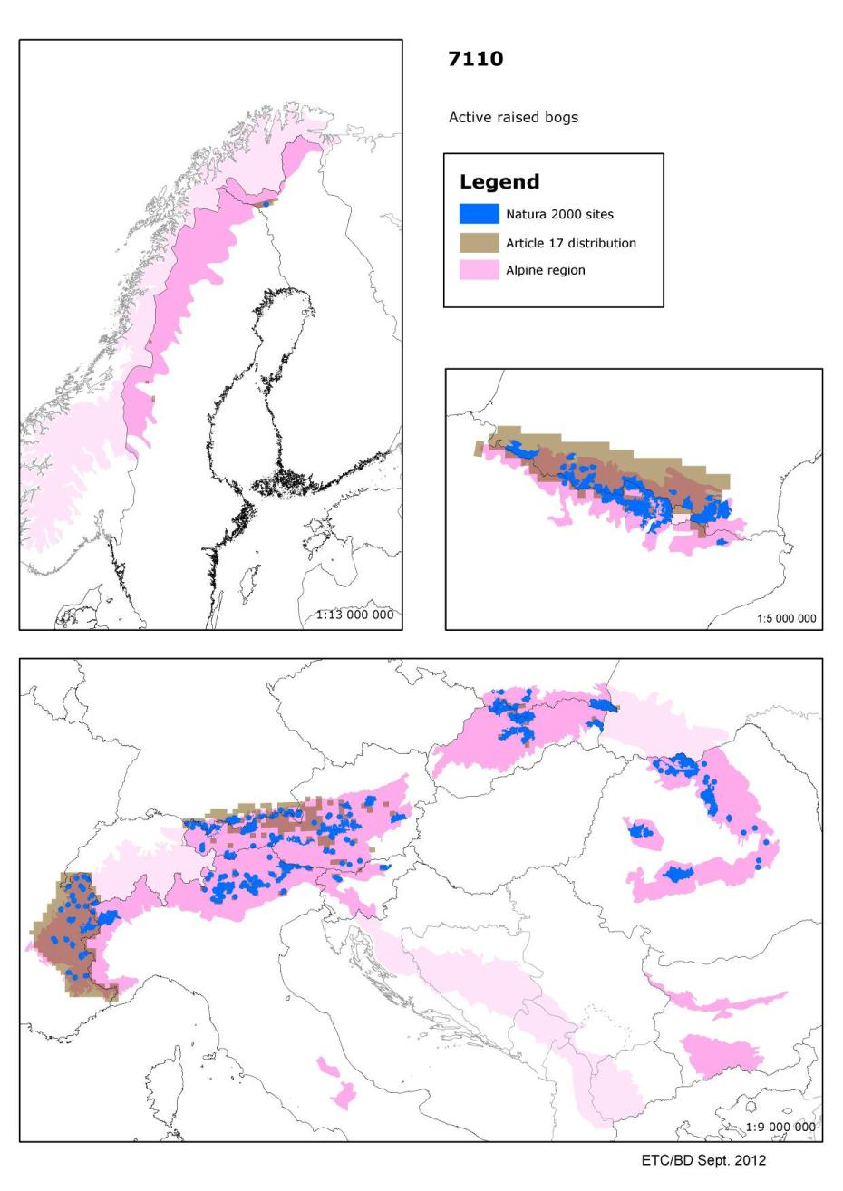

7140 - Transition mires and quaking bogs

Habitats Manual 2007
Peat-forming communities developed at the surface of oligotrophic to mesotrophic waters, with characteristics intermediate between soligenous and ombrogenous types. They present a large and diverse range of plant communities. In large peaty systems, the most prominent communities are swaying swards, floating carpets or quaking mires formed by medium-sized or small sedges, associated with sphagnum or brown mosses. They are generally accompanied by aquatic and amphibious communities. In the Boreal region this habitat type includes minerotrophic fens that are not part of a larger mire complex, open swamps and small fens in the transition zone between water (lakes, ponds) and mineral soil. These mires and bogs belong to the Scheuchzerietalia palustris order (oligotrophic floating carpets among others) and to the Caricetalia fuscae order (quaking communities). Oligotrophic water-land interfaces with Carex rostrata are included.
The Habitats Manual lists the following Annex II/IV plant: Liparis loeselii.
Associated with amphibious communities (22.3), fens (54.2 et 54.4), bogs (51.1-2) or humid grasslands (37.2-3).

Conservation status (CS) assessed at the Alpine region and MS level:
N2K code | Habitat name |  | AT | BG | DE | ES | FI | FR | IT | PL | RO | SE | SI | SK | REGION
7140 | Transition mires and quaking bogs | range | XX |  | FV | XX | FV | U1 | FV | FV |  | FV | FV | U1 | U1
 |  | area | U2 |  | FV | XX | FV | U2 | FV | U1 |  | FV | FV | U1 | U2
 |  | structure | XX |  | XX | XX | FV | U2 | FV | U1 |  | FV | FV | U1 | U2
 |  | future | U2 |  | FV | XX | FV | U2 | FV | U1 |  | FV | FV | U1 | U2
 |  | overall | U2 |  | FV | XX | FV | U2 | FV | U1 |  | FV | FV | U1 | U2

Peat forming plant communities with a wide range of variation depending on local conditions and often associated with aquatic, open water habitats. Widely distributed across the European Union although more local to the south, the distribution in Spain is much greater than shown on the map.
Assessed as ‘unfavourable-bad' in the Alpine, Atlantic, Continental, Mediterranean and Pannonian regions with no parameters assessed as ‘favourable'. Several countries assessed the Alpine region as ‘favourable' and the regional assessment is largely a result of the French report and it is possible that the French proportion of this habitat has been overestimated. Elsewhere the habitat has been assessed as ‘favourable for Italy (Continental) and Czech Republic (Pannonic). Assessed as ‘unfavourable-inadequate' in the Boreal and Macaronesian regions. In the Boreal region ‘range' is the parameter considered ‘favourable' although the habitat was assessed as ‘favourable' in Latvia. A variety of threats and pressures have been reported but many countries mention changes to the water regime, peat extraction and pollution/eutrophication. Better information required, especially from Spain (Summary sheet of the online report on Article 17 of the Habitats Directive).

Species associated to Transition mires and quaking bogs and their CS at the Alpine region and MS level
N2K code | Species name | Group |  | AT | BG | FR | IT | PL | RO | SI | SK | REGION
1060 | Lycaena dispar | Invertebrates | range | FV |  | FV | U1 | FV |  | FV | FV | FV
 |  |  | population | FV |  | XX | U1 | XX |  | U1 | FV | U1
 |  |  | habitat | FV |  | FV | U1 | FV |  | U1 | FV | FV
 |  |  | future | FV |  | FV | U1 | FV |  | U1 | FV | FV
 |  |  | overall | FV |  | FV | U1 | FV |  | U1 | FV | U1

N2K code | Species name | Group |  | BG | PL | RO | SE | REGION
1389 | Meesia longiseta | Non-vascular plants | range |  | FV |  | FV | FV
 |  |  | population |  | XX |  | FV | FV
 |  |  | habitat |  | XX |  | FV | FV
 |  |  | future |  | XX |  | FV | FV
 |  |  | overall |  | XX |  | FV | FV

N2K code | Species name | Group |  | AT | BG | DE | ES | FI | FR | IT | PL | RO | SE | SI | SK | REGION
1393 | Drepano-  cladus vernicosus | Non-vascular plants | range | U2 |  | U1 | XX | XX | FV | U1 | FV |  | FV | FV | XX | XX
 |  |  | population | U2 |  | U1 | XX | XX | U2 | U1 | U1 |  | FV | XX | XX | XX
 |  |  | habitat | U1 |  | U1 | XX | XX | U2 | XX | U1 |  | FV | U1 | XX | XX
 |  |  | future | U2 |  | U1 | XX | XX | U2 | U1 | U1 |  | FV | U1 | XX | XX
 |  |  | overall | U2 |  | U1 | XX | XX | U2 | U1 | U1 |  | FV | U1 | XX | XX

N2K code | Species name | Group |  | AT | DE | ES | FR | IT | SI | REGION
1900 | Spiranthes aestivalis | Vascular plants | range | FV | FV | XX | U2 | FV | U1 | U1
 |  |  | population | U1 | U1 | XX | U2 | FV | U1 | U1
 |  |  | habitat | XX | XX | XX | U2 | XX | U2 | XX
 |  |  | future | U1 | FV | XX | U2 | FV | U1 | U1
 |  |  | overall | U1 | U1 | XX | U2 | FV | U2 | U1

Main pressures to Transition mires and quaking bogs and their importance to associated species
Pressure description  (2nd level) | Transition mires and quaking bogs | Lycaena dispar | Meesia longiseta | Drepanocladus vernicosus | Spiranthes aestivalis
Grazing | x
Modification of hydrographic functioning | x | x
Biocenotic evolution | x

Main threats to Transition mires and quaking bogs and their importance to associated species
Threats description  (2nd level) | Transition mires and quaking bogs | Lycaena dispar | Meesia longiseta | Drepanocladus vernicosus | Spiranthes aestivalis
Grazing | x
Pollution | x
Modification of hydrographic functioning | x | x
Biocenotic evolution | x |  | x | x | x

Other information
According to the ETC/BD calculations 0-50% of the area of this habitat type are within SCIs. This means that potentially important part of the management needs of this habitat types occurs outside Natura 2000 network.

Number of SCIs and habitat area (ha) within SCIs per Member State in the Alpine biogeographical region
 | AT | BG | DE | ES | FI | FR | IT | PL | RO | SE | SI | SK
Number of sites | 36 | 9 | 17 | 2 | 14 | 37 | 137 | 11 | 14 | 58 | 9 | 59
Habitat area (ha) | 1950 | 525 | 249 | 90 | 32388 | 3505 | 3291 | 924 | 1707 | 72616 | 1205 | 292
The figures include all SCIs where the habitat type is mentioned including sites coded as D.

Map of Transition mires and quaking bogs
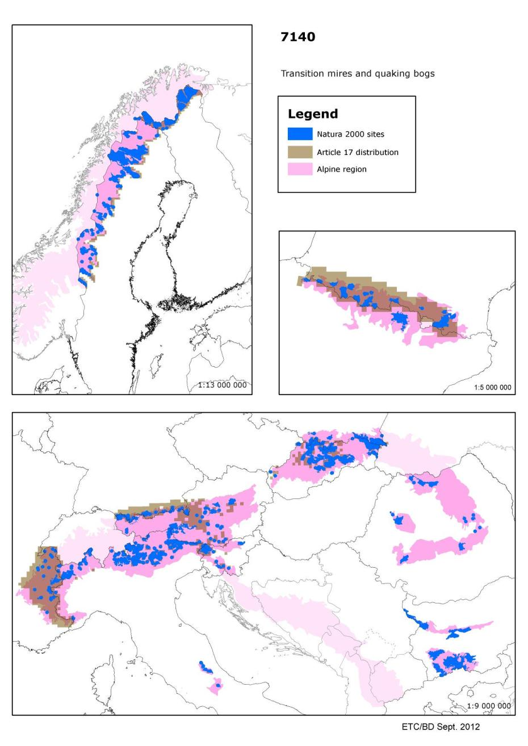

7230 - Alkaline fens

Habitats Manual 2007
Wetlands mostly or largely occupied by peat- or tufa-producing small sedge and brown moss communities developed on soils permanently waterlogged, with a soligenous or topogenous baserich, often calcareous water supply, and with the water table at, or slightly above or below, the substratum. Peat formation, when it occurs, is infra-aquatic. Calciphile small sedges and other Cyperaceae usually dominate the mire communities, which belong to the Caricion davallianae, characterised by a usually prominent "brown moss" carpet formed by Campylium stellatum, Drepanocladus intermedius, D. revolvens, Cratoneuron commutatum, Acrocladium cuspidatum, Ctenidium molluscum, Fissidens adianthoides, Bryum pseudotriquetrum and others, a grasslike growth of Schoenus nigricans, S. ferrugineus, Eriophorum latifolium, Carex davalliana, C. flava, C. lepidocarpa, C. hostiana, C. panicea, Juncus subnodulosus, Scirpus cespitosus, Eleocharis quinqueflora, and a very rich herbaceous flora including Tofieldia calyculata, Dactylorhiza incarnata, D. traunsteineri, D. traunsteinerioides, D. russowii, D. majalis ssp.brevifolia, D.cruenta, #Liparis loeselii, Herminium monorchis, Epipactis palustris, Pinguicula vulgaris, Pedicularis sceptrum-carolinum, Primula farinosa, Swertia perennis. Wet grasslands (Molinietalia caerulaea, e.g. Juncetum subnodulosi & Cirsietum rivularis, 37), tall sedge beds (Magnocaricion,53.2), reed formations (Phragmition, 53.1), fen sedge beds (Cladietum mariscae, 53.3), may form part of the fen system, with communities related to transition mires (54.5, 54.6) and amphibious or aquatic vegetation (22.3, 22.4) or spring communities (54.1) developing in depressions.
The subunits listed in the Habitats Manual, which can, alone or in combination, and together with codes selected from the categories just mentioned, describe the composition of the fen, are understood to include the mire communities sensu stricto (Caricion davallianae), their transition to the Molinion, and assemblages that, although they may be phytosociologically referable to alkaline Molinion associations, contain a large representation of the Caricion davallianae species listed, in addition to being integrated in the fen system; this somewhat parallels the definition of an integrated class Molinio-Caricetalia davallianae in Rameau et al., 1989. Outside of rich fen systems, fen communities can occur as small areas in dune slack systems (16.3), in transition mires (54.5), in wet grasslands (37), on tufa cones (54.121) and in a few other situations. Rich fens are exceptionally endowed with spectacular, specialised, strictly restricted species. They are among the habitats that have undergone the most serious decline. They are essentially extinct in several regions and gravely endangered in most.

Conservation status (CS) assessed at the Alpine region and MS level:
N2K code | Habitat name |  | AT | BG | DE | ES | FI | FR | IT | PL | RO | SE | SI | SK | REGION
7230 | Alkaline fens | range | FV |  | FV | XX | FV | FV | FV | FV |  | FV | FV | U1 | FV
 |  | area | U1 |  | U1 | XX | FV | U1 | FV | FV |  | FV | U2 | U1 | U1
 |  | structure | XX |  | U1 | XX | FV | U1 | FV | U1 |  | FV | U1 | U1 | U1
 |  | future | U2 |  | FV | XX | FV | U1 | FV | FV |  | FV | U1 | U1 | U1
 |  | overall | U2 |  | U1 | XX | FV | U1 | FV | U1 |  | FV | U2 | U1 | U1

This habitat includes a wide variety of fens with alkaline groundwater, they occur where the groundwater is suitable throughout Europe but rare in the south. The vegetation is usually dominated by small sedges (Carex species), is often species rich and sometimes with Annex II and IV species such as the fen orchid (Liparis loeselii).

Assessed as ‘unfavourable-inadequate' for the Alpine and Boreal regions. However in the Alpine region there is much variation between countries and the habitat is ‘favourable' in the Fennoscandian subregion. Assessed as ‘unfavourable-bad' for the Atlantic, Continental, Mediterranean and Pannonic regions. Within these regions only Greece (Mediterranean) and Italy (Continental and Mediterranean) assessed this habitat as ‘favourable'. A variety of threats and pressures have been reported but many countries mention changes to the water regime, changes in agricultural practices and pollution/eutrophication. Better information required particularly from Spain (Summary sheet of the online report on Article 17 of the Habitats Directive).

Species associated to Alkaline fens and their CS at the Alpine region and MS level
N2K code | Species name | Group |  | AT | DE | PL | SE | SI | SK | REGION
1013 | Vertigo geyeri | Molluscs | range | XX | XX | XX | FV | XX | XX | XX
 |  |  | population | XX | XX | XX | FV | XX | XX | XX
 |  |  | habitat | U2 | U1 | XX | FV | XX | XX | U1
 |  |  | future | U2 | U1 | U1 | FV | XX | XX | U1
 |  |  | overall | U2 | U1 | U1 | FV | XX | XX | U1

N2K code | Species name | Group |  | AT | DE | FR | IT | PL | RO | SI | SK | REGION
1014 | Vertigo angustior | Molluscs | range | XX | FV | U2 | FV | FV |  | FV | FV | XX
 |  |  | population | XX | XX | U2 | FV | XX |  | FV | FV | XX
 |  |  | habitat | U1 | U1 | U2 | FV | XX |  | U1 | FV | XX
 |  |  | future | U1 | U1 | XX | XX | XX |  | U1 | FV | XX
 |  |  | overall | U1 | U1 | U2 | FV | XX |  | U1 | FV | XX

N2K code | Species name | Group |  | AT | ES | RO | SK | REGION
1016 | Vertigo moulinsiana | Molluscs | range | XX | XX |  | XX | XX
 |  |  | population | XX | XX |  | XX | XX
 |  |  | habitat | U1 | XX |  | XX | XX
 |  |  | future | U1 | XX |  | U1 | XX
 |  |  | overall | U1 | XX |  | U1 | XX

N2K code | Species name | Group |  | AT | BG | DE | ES | FR | IT | RO | SI | REGION
1065 | Euphydryas aurinia | Invertebrates | range | FV |  | FV | XX | FV | FV |  | FV | FV
 |  |  | population | FV |  | XX | XX | FV | FV |  | U1 | U1
 |  |  | habitat | U1 |  | FV | XX | FV | FV |  | U1 | U1
 |  |  | future | U1 |  | FV | U1 | FV | FV |  | U1 | U1
 |  |  | overall | U1 |  | FV | U1 | FV | FV |  | U1 | U1

N2K code | Species name | Group |  | AT | BG | DE | ES | FI | FR | IT | PL | RO | SE | SI | SK | REGION
1393 | Drepano-  cladus vernicosus | Non-vascular plants | range | U2 |  | U1 | XX | XX | FV | U1 | FV |  | FV | FV | XX | XX
 |  |  | population | U2 |  | U1 | XX | XX | U2 | U1 | U1 |  | FV | XX | XX | XX
 |  |  | habitat | U1 |  | U1 | XX | XX | U2 | XX | U1 |  | FV | U1 | XX | XX
 |  |  | future | U2 |  | U1 | XX | XX | U2 | U1 | U1 |  | FV | U1 | XX | XX
 |  |  | overall | U2 |  | U1 | XX | XX | U2 | U1 | U1 |  | FV | U1 | XX | XX

N2K code | Species name | Group |  | FI | RO | SE | REGION
1528 | Saxifraga hirculus | Vascular plants | range | FV |  | FV | FV
 |  |  | population | FV |  | FV | FV
 |  |  | habitat | FV |  | FV | FV
 |  |  | future | FV |  | FV | FV
 |  |  | overall | FV |  | FV | FV

N2K code | Species name | Group |  | AT | BG | FR | PL | RO | SK | REGION
1758 | Ligularia sibirica | Vascular plants | range | FV |  | FV | XX |  | FV | U2
 |  |  | population | U1 |  | FV | U1 |  | FV | U1
 |  |  | habitat | U1 |  | FV | U1 |  | U1 | U1
 |  |  | future | U2 |  | U1 | XX |  | U1 | U2
 |  |  | overall | U2 |  | U1 | U1 |  | U1 | U2

N2K code | Species name | Group |  | AT | DE | FR | IT | RO | SI | SK | REGION
1903 | Liparis loeselii | Vascular plants | range | FV | FV | U2 | FV |  | FV | FV | FV
 |  |  | population | FV | U1 | U1 | FV |  | U1 | U2 | U1
 |  |  | habitat | U1 | XX | U2 | XX |  | U1 | U1 | XX
 |  |  | future | U1 | FV | U2 | FV |  | U1 | FV | U1
 |  |  | overall | U1 | U1 | U2 | FV |  | U1 | U2 | U1

N2K code | Species name | Group |  | DE | FR | RO | SE | REGION
4038 | Lycaena helle | Invertebrates | range | U2 | FV |  | XX | U2
 |  |  | population | U1 | XX |  | XX | XX
 |  |  | habitat | U1 | FV |  | XX | U1
 |  |  | future | U1 | FV |  | XX | U1
 |  |  | overall | U2 | FV |  | XX | U2

Main pressures to Alkaline fens and their importance to associated species
Pressure description (2nd level) | Alkaline fens | Vertigo geyeri | Vertigo angustior | Vertigo moulinsiana | Euphydryas aurinia
Cultivation | x |  |  |  | x
Grazing | x |  |  |  | x
General Forestry management | x
Drainage | x | x | x | x
Modification of hydrographic functioning | x | x

Pressure description (2nd level) | Drepanocladus vernicosus | Saxifraga hirculus | Ligularia sibirica | Liparis loeselii | Lycaena helle
Cultivation
Grazing |  |  | x
General Forestry management |  |  | x
Drainage | x | x | x | x
Modification of hydrographic functioning |  |  | x

Main threats to Alkaline fens and their importance to associated species
Threats description (2nd level) | Alkaline fens | Vertigo geyeri | Vertigo angustior | Vertigo moulinsiana | Euphydryas aurinia
Cultivation | x |  |  |  | x
Grazing | x |  |  |  | x
General Forestry management | x
Drainage | x | x | x | x
Modification of hydrographic functioning | x | x
Biocenotic evolution | x |  |  | x

Threats description (2nd level) | Drepanocladus vernicosus | Saxifraga hirculus | Ligularia sibirica | Liparis loeselii | Lycaena helle
Cultivation |  |  |  | x
Grazing |  |  | x
General Forestry management |  |  | x | x
Drainage | x | x | x
Modification of hydrographic functioning |  |  | x
Biocenotic evolution | x |  | x

Other information
According to the ETC/BD calculations 51-75 % of the area of this habitat type are within SCIs. This means that Natura 2000 network provides an important framework for the management of this habitat type.

Number of SCIs and habitat area (ha) within SCIs per Member State in the Alpine biogeographical region
 | AT | BG | DE | ES | FI | FR | IT | PL | RO | SE | SI | SK
Number of sites | 49 | 3 | 36 | 23 | 7 | 74 | 109 | 16 | 10 | 38 | 8 | 79
Habitat area (ha) | 1523 | 6 | 1206 | 1948 | 59 | 7254 | 3407 | 808 | 1052 | 7011 | 1178 | 366
The figures include all SCIs where the habitat type is mentioned including sites coded as D.

Map of SCIs proposed for Alkaline fens & Article 17 distribution
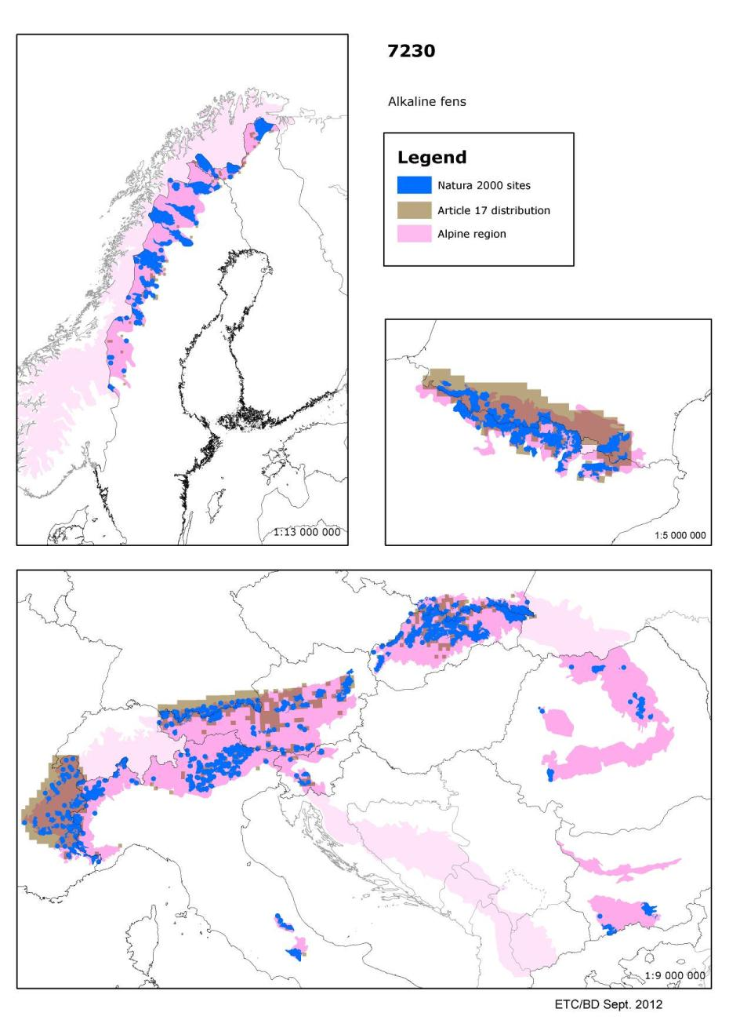

91D0 - Bog woodland

Habitats Manual 2007
Coniferous and broad-leaved forests on a humid to wet peaty substrate, with the water level permanently high and even higher than the surrounding water table. The water is always very poor in nutrients (raised bogs and acid fens). These communities are generally dominated by Betula pubescens, Frangula alnus, Pinus sylvestris, Pinus rotundata and Picea abies, with species specific to bogland or, more generally, to oligotrophic environments, such as Vaccinium spp., Sphagnum spp., Carex spp. [Vaccinio-Piceetea: Piceo-Vaccinienion uliginosi (Betulion pubescentis, Ledo-Pinion) i.a.]. In the Boreal region, also spruce swamp woods, which are minerotrophic mire sites along margins of different mire complexes, as well as in separate strips in valleys and along brooks.
Sub-types :
44.A1 - Sphagnum birch woods
44.A2 - Scots pine mire woods
44.A3 - Mountain pine bog woods
44.A4 - Mire spruce woods

Conservation status (CS) assessed at the Alpine region and MS level:
N2K code | Habitat name |  | AT | BG | DE | FI | FR | IT | PL | RO | SE | SI | SK | REGION
91D0 | Bog woodland | range | FV |  | FV | FV | FV | FV | FV |  | FV | FV | U1 | FV
 |  | area | FV |  | FV | FV | U2 | U1 | U1 |  | FV | FV | U1 | U1
 |  | structure | XX |  | XX | FV | U1 | FV | U1 |  | FV | FV | U1 | U1
 |  | future | U1 |  | FV | FV | U1 | FV | U1 |  | FV | FV | U1 | U1
 |  | overall | U1 |  | FV | FV | U2 | U1 | U1 |  | FV | FV | U1 | U1

Coniferous and broad-leaved forests on peaty soils where the water level is permanently high and the groundwater is very poor in nutrients. Downy birch (Betula pubescens), alder buck thorn (Frangula alnus), pines (Pinus sylvestris, P. rotundata) or spruce (Picea abies) form the tree layer which is often low with many stunted trees while Vaccinium spp., bogmosse s (Sphagnum spp) and sedges (Carex spp) form the undergrowth. This habitat is often found in association with bog habitats such as 7110 and 7140.

The conservation status in the Pannonian region, where the habitat occurs at only one locality in the Czech Republic is ‘favourable’. The conservation status in the Boreal, Alpine and Macaronesian regions is ‘unfavourable -inadequate’ and only assessed as ‘unfavourable-bad’ for the Alpine region in France. The anthropogenic pressure in these regions is lower than in the Atlantic and Continental, where the status is assessed as ’unfavourable-bad’. Structure and functions of this habitat are closely connected to the oligotrophic character of the peat and its water regime. The major threats to this habitat are changes in hydrologic conditions due to various human activities but also include natural processes (Summary sheet of the online report on Article 17 of the Habitats Directive).

Main pressures to Bog woodland and their importance to associated species
Pressure description (2nd level) | Bog woodland
General Forestry management | x
Peat extraction | x
Drainage | x
Modification of hydrographic functioning | x

Main threats to Bog woodland and their importance to associated species
Threats description (2nd level) | Bog woodland
General Forestry management | x
Peat extraction | x
Pollution | x
Modification of hydrographic functioning | x
Biocenotic evolution | x

Other information
According to the ETC/BD calculations 0-50% of the area of this habitat type are within SCIs. This means that potentially important part of the management needs of this habitat types occurs outside Natura 2000 network.

Number of SCIs and habitat area (ha) within SCIs per Member State in the Alpine biogeographical region
 | AT | BG | DE | ES | FI | FR | IT | PL | RO | SE | SI | SK
Number of sites | 33 | 4 | 11 | 1 | 14 | 11 | 47 | 9 | 23 | 37 | 3 | 23
Habitat area (ha) | 2457 | 45 | 226 | 22 | 44947 | 282 | 919 | 1081 | 2215 | 43397 | 548 | 1539
The figures include all SCIs where the habitat type is mentioned including sites coded as D.

Map of SCIs proposed for Bog woodland & Article 17 distribution
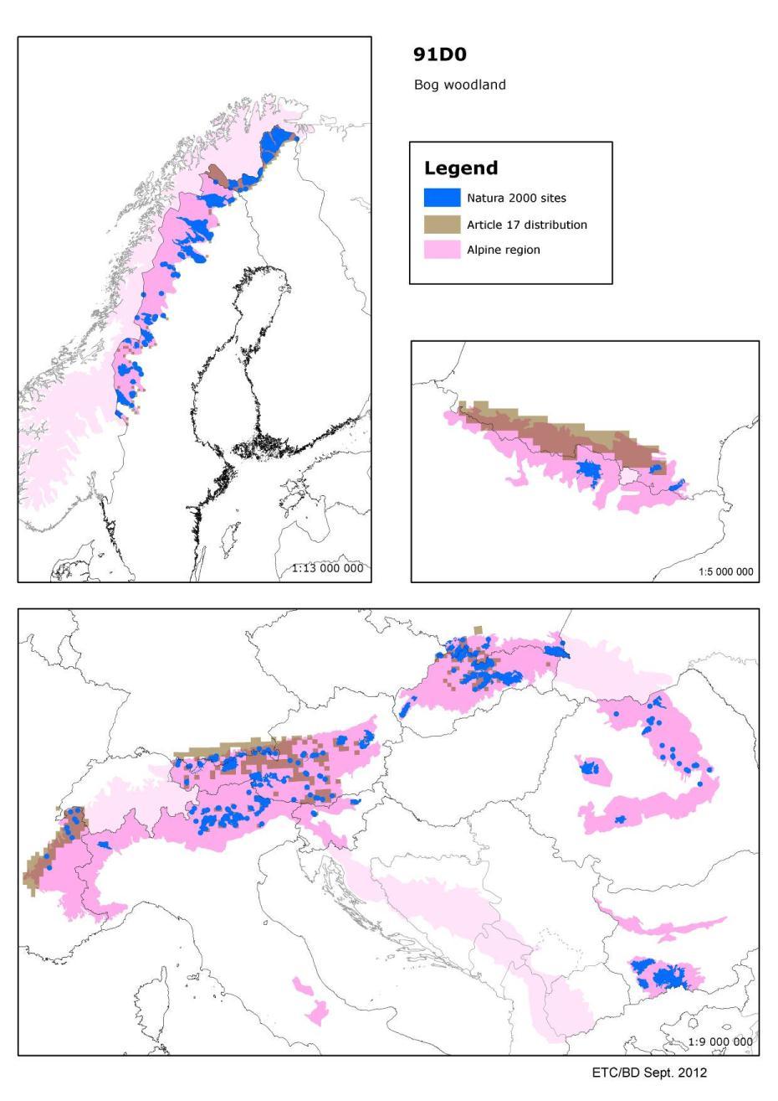

91E0 - Alluvial forests with Alnus glutinosa and Fraxinus excelsior (Alno-Padion, Alnionincanae, Salicionalbae)

Habitats Manual 2007
Riparian forests of Fraxinus excelsior and Alnus glutinosa, of temperate and Boreal Europe lowland and hill watercourses (44.3: Alno-Padion); riparian woods of Alnus incanae of montane and sub-montane rivers of the Alps and the northern Apennines (44.2: Alnion incanae); arborescent galleries of tall Salix alba, S. fragilis and Populus nigra, along medio-European lowland, hill or sub-montane rivers (44.13: Salicion albae). All types occur on heavy soils (generally rich in alluvial deposits) periodically inundated by the annual rise of the river (or brook) level, but otherwise well-drained and aerated during low-water. The herbaceous layer invariably includes many large species (Filipendula ulmaria, Angelica sylvestris, Cardamine spp., Rumex sanguineus, Carex spp., Cirsium oleraceum) and various vernal geophytes can occur, such as Ranunculus ficaria, Anemone nemorosa, A. ranunculoides, Corydalis solida.
This habitat includes several sub-types: ash-alder woods of springs and their rivers (44.31 – Carici remotae-Fraxinetum); ash-alder woods of fast-flowing rivers (44.32 - Stellario-Alnetum glutinosae);ash-alder woods of slow-flowing rivers (44.33 - Pruno-Fraxinetum, Ulmo-Fraxinetum); montanegrey alder galleries (44.21 - Calamagrosti variae-Alnetum incanae Moor 58); sub-montane grey alder galleries (44.22 - Equiseto hyemalis-Alnetum incanae Moor 58); white willow gallery forests (44.13 - Salicion albae). The Spanish types belong to the alliance Osmundo-Alnion (Cantabric atlantic andsoutheast Iberia peninsula).
Most of these forests are in contact with humid meadows or ravine forests (Tilio-Acerion). A succession towards Carpinion (Primulo-Carpinetum) can be observed (Summary sheet of the online report on Article 17 of the Habitats Directive).

Conservation status (CS) assessed at the Alpine region and MS level:
N2K code | Habitat name |  | AT | BG | DE | ES | FI | FR | IT | PL | RO | SE | SI | SK | REGION
91E0 | Alluvial forests with Alnus glutinosaand Fraxinus excelsior (Alno-Padion, Alnion incanae, Salicion albae) | range | FV |  | FV | U1 | FV | FV | FV | FV |  | FV | FV | U1 | FV
 |  | area | U1 |  | FV | U1 | FV | U2 | U1 | U1 |  | FV | U1 | U1 | U2
 |  | structure | U1 |  | XX | U1 | FV | U2 | XX | U1 |  | FV | FV | U1 | U2
 |  | future | U1 |  | FV | U2 | FV | U2 | FV | XX |  | FV | FV | FV | U2
 |  | overall | U1 |  | FV | U1 | FV | U2 | U1 | U1 |  | FV | U1 | U1 | U2

This varied habitat type includes riparian ash (Fraxinus excelsior) and alder (Alnus glutinosa) forests and willow (Salix alba, S. fragilis) and black poplar (Populus nigra )galleries along lowland and hill watercourses together with grey alder (Alnus incana)riparian forests of sub-montane to sub-alpine rivers. The habitat occurs on heavy and periodically inundated soils. The herb layer is composed of tall herb species preferring humid and nutrients rich soils.
This habitat type is relatively wide-spread, but occurs as fragmentary stands where the hydrologic regime is favourable. It is, especially in lowland areas, seriously threatened due to management of water levels and regulation of water courses. The conservation status is ‘unfavourable bad’ in all regions. Member State assessments for the Atlantic, Continental and Pannonian regions are mostly ‘unfavourable-bad’. In the Alpine and Mediterranean regions only France assessed this habitat as ‘unfavourable-bad’ while in the Boreal only Finland assessed this habitat as ‘unfavourable-bad’. In these regions, at the country level, the status of the habitat was mostly ‘unfavourable-inadequate’ (Summary sheet of the online report on Article 17 of the Habitats Directive).

Species associated to Alluvial forests with Alnus glutinosa and Fraxinus excelsior (Alno-Padion, Alnion incanae, Salicion albae) and their CS at the Alpine region and MS level
N2K code | Species name | Group |  | AT | DE | FR | PL | RO | SE | SK | REGION
1337 | Castor fiber | Mammals | range | U1 | FV | FV | FV |  | FV | FV | FV
 |  |  | population | U1 | FV | FV | FV |  | FV | FV | FV
 |  |  | habitat | XX | FV | XX | FV |  | FV | FV | FV
 |  |  | future | U1 | FV | FV | FV |  | FV | FV | FV
 |  |  | overall | U1 | FV | FV | FV |  | FV | FV | FV

N2K code | Species name | Group |  | AT | BG | DE | ES | FR | IT | PL | RO | SI | SK | REGION
1381 | Dicranum viride | Non-vascular plants | range | U1 |  | FV | XX | XX | U1 | FV |  | FV | XX | U1
 |  |  | population | XX |  | FV | XX | XX | U1 | U1 |  | XX | XX | XX
 |  |  | habitat | U1 |  | FV | U2 | XX | XX | U1 |  | U1 | XX | U1
 |  |  | future | U1 |  | FV | U2 | XX | XX | U1 |  | U1 | XX | U1
 |  |  | overall | U1 |  | FV | U2 | XX | U1 | U1 |  | U1 | XX | U1

N2K code | Species name | Group |  | AT | BG | DE | ES | FR | IT | PL | RO | SI | SK | REGION
1386 | Buxbaumia viridis | Non-vascular plants | range | U2 |  | XX | U2 | FV | FV | U1 |  | FV | XX | U2
 |  |  | population | U2 |  | XX | XX | FV | FV | U2 |  | XX | XX | U2
 |  |  | habitat | U1 |  | XX | XX | FV | XX | U1 |  | FV | XX | XX
 |  |  | future | U2 |  | XX | U2 | XX | FV | U2 |  | XX | XX | U2
 |  |  | overall | U2 |  | XX | U2 | FV | FV | U2 |  | XX | XX | U2

N2K code | Species name | Group |  | AT | ES | FR | IT | REGION
1387 | Orthotrichum rogeri | Non-vascular plants | range | U1 | XX | FV | XX | XX
 |  |  | population | U2 | XX | FV | XX | U2
 |  |  | habitat | U1 | XX | XX | XX | XX
 |  |  | future | U1 | XX | XX | XX | XX
 |  |  | overall | U2 | XX | XX | XX | U2

N2K code | Species name | Group |  | BG | PL | RO | SK | REGION
4116 | Tozzia carpathica | Vascular plants | range |  | FV |  | FV | FV
 |  |  | population |  | FV |  | FV | FV
 |  |  | habitat |  | FV |  | FV | FV
 |  |  | future |  | FV |  | XX | XX
 |  |  | overall |  | FV |  | FV | FV

Main pressures to Alluvial forests with Alnus glutinosa and Fraxinus excelsior (Alno-Padion, Alnion incanae, Salicion albae) and their importance to associated species
Pressure description  (2nd level) | Alluvial forests with Alnus glutinosa and Fraxinus excelsior (Alno-Padion, Alnion incanae, Salicion albae) | Castor fiber | Dicranum viride | Buxbaumia viridis | Orthotrichum rogeri | Tozzia carpathica
General Forestry management | x |  | x |  | x
Communication networks | x | x
Modification of hydrographic functioning | x

Main threats to Alluvial forests with Alnus glutinosa and Fraxinus excelsior (Alno-Padion, Alnion incanae, Salicion albae) and their importance to associated species
Threats description  (2nd level) | Alluvial forests with Alnus glutinosa and Fraxinus excelsior (Alno-Padion, Alnion incanae, Salicion albae) | Castor fiber | Dicranum viride | Buxbaumia viridis | Orthotrichum rogeri | Tozzia carpathica
General Forestry management | x |  |  |  | x
Communication networks | x | x
Pollution | x |  | x | x
Modification of hydrographic functioning | x

Other information
According to the ETC/BD calculations 0-50% of the area of this habitat type are within SCIs. This means that potentially important part of the management needs of this habitat types occurs outside Natura 2000 network.

Number of SCIs and habitat area (ha) within SCIs per Member State in the Alpine biogeographical region
 | AT | BG | DE | ES | FI | FR | IT | PL | RO | SE | SI | SK
Number of sites | 49 | 17 | 21 | 22 | 10 | 41 | 127 | 23 | 49 | 11 | 3 | 105
Habitat area (ha) | 5173 | 1205 | 867 | 944 | 1127 | 17008 | 3167 | 4423 | 5513 | 4325 | 428 | 2311
The figures include all SCIs where the habitat type is mentioned including sites coded as D.

Map of SCIs proposed for Alluvial forests with Alnus glutinosa and Fraxinus excelsior (Alno-Padion, Alnion incanae, Salicion albae) & Article 17 distribution
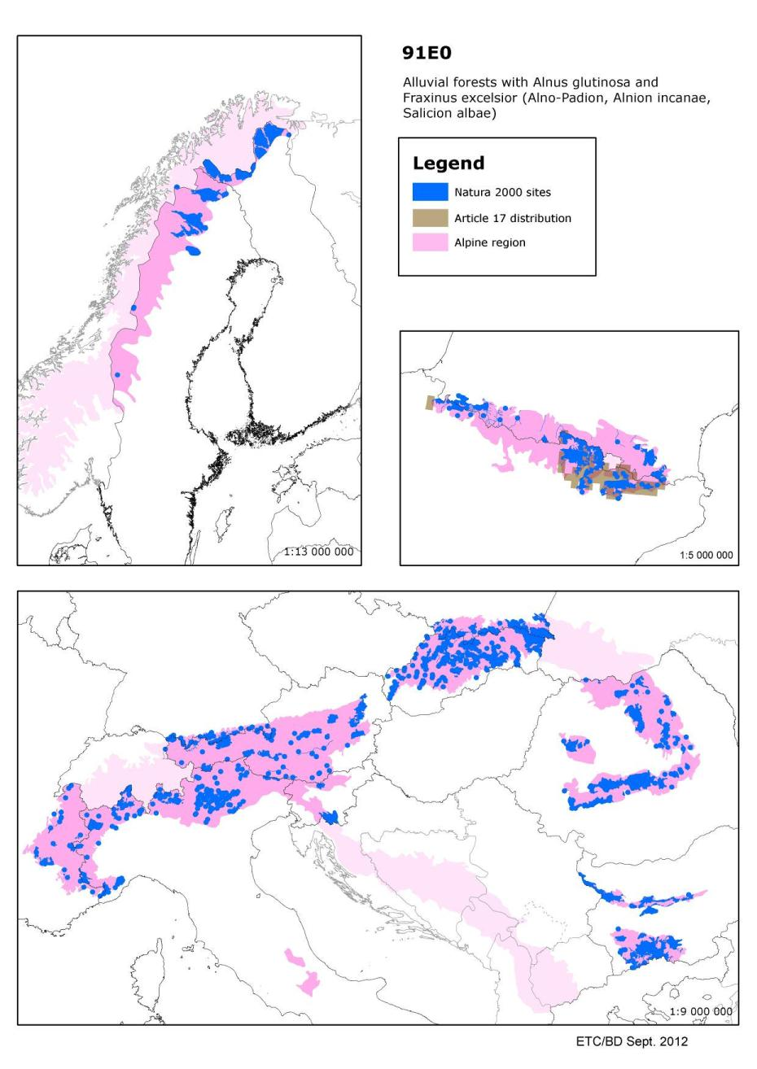

9130 - Asperulo-Fagetum beech forests

Habitats Manual 2007
Fagus sylvatica and, in higher mountains, Fagus sylvatica-Abies alba or Fagus sylvatica-Abies alba-Picea abies forests developed on neutral or near-neutral soils, with mild humus (mull), of the medio-European and Atlantic domains of Western Europe and of central and northern Central Europe, characterised by a strong representation of species belonging to the ecological groups of Anemone nemorosa, of Lamiastrum (Lamium) galeobdolon, of Galium odoratum and Melica uniflora and, in mountains, various Dentaria spp., forming a richer and more abundant herb layer than in the forests of 9110 and 9120.
Sub-types :
41.131 - Medio-European collinar neutrophilous beech forests
Neutrocline or basicline Fagus sylvatica and Fagus sylvatica-Quercus petraea-Quercus robur forests of hills, low mountains and plateaux of the Hercynian arc and its peripheral regions, of the Jura, Lorraine, the Paris basin, Burgundy, the Alpine piedmont, the Carpathians and a few localities of the North Sea-Baltic plain.
41.132 - Atlantic neutrophile beech forests
Atlantic beech and beech-oak forests with Hyacinthoides non-scripta, of southern England, the Boulonnais, Picardy, the Oise, Lys and Schelde basins.
41.133 - Medio-European montane neutrophilous beech forests
Neutrophile forests of Fagus sylvatica, Fagus sylvatica and Abies alba, Fagus sylvatica and Picea abies, or Fagus sylvatica, Abies alba and Picea abies of the montane and high-montane levels of the Jura, the northern and eastern Alps, the western Carpathians and the great Hercynian ranges.
41.134 - Bohemian lime-beech forests
Fagus sylvatica or Fagus sylvatica-Abies alba forests rich in Tilia spp., of the Bohemian basin.
41.135 - Pannonic neutrophile beech forests
Neutrophilous beech forests of medio-European affinities of the hills of the Pannonic plain and its western periphery.

Relict stands of collinar neutrophilous beech forests of the Macin Mountains of Dobrogea, Romania are the priority habitat 91X0*Dobrogean Beech forests.

Conservation status (CS) assessed at the Alpine region and MS level:
N2K code | Habitat name |  | AT | BG | DE | ES | IT | PL | RO | SK | REGION
9130 | Asperulo-Fagetum beech forests | range | FV |  | FV | FV | FV | FV |  | FV | FV
 |  | area | U1 |  | FV | FV | FV | FV |  | FV | U1
 |  | structure | U1 |  | FV | U1 | FV | FV |  | FV | U1
 |  | future | U1 |  | FV | FV | FV | XX |  | FV | U1
 |  | overall | U1 |  | FV | U1 | FV | FV |  | FV | U1

This type of beech (Fagus sylvatica) forest represents the climax vegetation on neutral or near-neutral soils of Western Europe, of central and northern Central Europe, and of mountainous regions of southern Europe. Beech dominates the tree layer, together with spruce (Picea abies) and Europe an silver fir (Abies alba) in the mountains. The herb layer is more diverse and abundant than with habitat type 9110, and is composed mainly of typical beech forest species.

The conservation status was assessed as favourable only in the Mediterranean region, where the habitat is present mainly in mountainous areas. The conservation status in the Pannonian and in the Boreal regions, where the climatic condition are in general inappropriate, the status of the habitat was assessed as ‘unfavourable bad’. The conservation status in other regions is ‘unfavourable inadequate’. However the range and habitat area are stable or increasing and sufficient in most of the countries except UK, Austria and Sweden. Unfavourable status of structure and function reflecting inappropriate forest management is usually responsible for unfavourable overall assessment (Summary sheet of the online report on Article 17 of the Habitats Directive).

Other information
According to the ETC/BD calculations 51-75 % of the area of this habitat type are within SCIs. This means that Natura 2000 network provides an important framework for the management of this habitat type.

Number of SCIs and habitat area (ha) within SCIs per Member State in the Alpine biogeographical region
 | AT | BG | DE | ES | FR | IT | PL | RO | SK
Number of sites | 23 | 20 | 28 | 8 | 17 | 69 | 26 | 44 | 145
Habitat area (ha) | 51016 | 136210 | 28677 | 2313 | 11679 | 25850 | 142796 | 72554 | 163212

Conservation status (CS) assessed at the Alpine region and MS level for Rosalia alpine
(this species is added here as the Steering Committee expressed a general interest to this species):
N2K code | Species name | Group |  | AT | BG | DE | ES | FR | IT | PL | RO | SI | SK | REGION
1087 | Rosalia alpina | Invertebrates | range | U1 |  | FV | XX | FV | U2 | XX |  | FV | FV | U1
 |  |  | population | U1 |  | FV | XX | XX | U2 | XX |  | XX | FV | XX
 |  |  | habitat | U1 |  | FV | XX | FV | FV | XX |  | U1 | FV | U1
 |  |  | future | U1 |  | FV | XX | FV | U1 | XX |  | U1 | FV | U1
 |  |  | overall | U1 |  | FV | XX | FV | U2 | XX |  | U1 | FV | U1
The rosalia longicorn is a beetle which is widely spread across Europe. Its preferred habitat is beech forest wherein it lays its eggs.

In all geographical regions (Alpine, Atlantic, Continental, Mediterranean and Pannonian) its overall assessment is ‘inadequate’ or ‘unknown’. However, in the Atlantic region its range is assessed to be ‘favourable’ and in the Pannonian region its range and future prospects are reported as ‘favourable’. The overall assessments differ among the countries, but most countries assessed its status as ‘inadequate’ or ‘unknown but not favourable’. Since species numbers are decreasing it has a protected status in several countries (Summary sheet of the online report on Article 17 of the Habitats Directive). The IUCN conservation status is of Least Concern at European level.

Map of SCIs proposed for Asperulo-Fagetum beech forests (9130) & Article 17 distribution
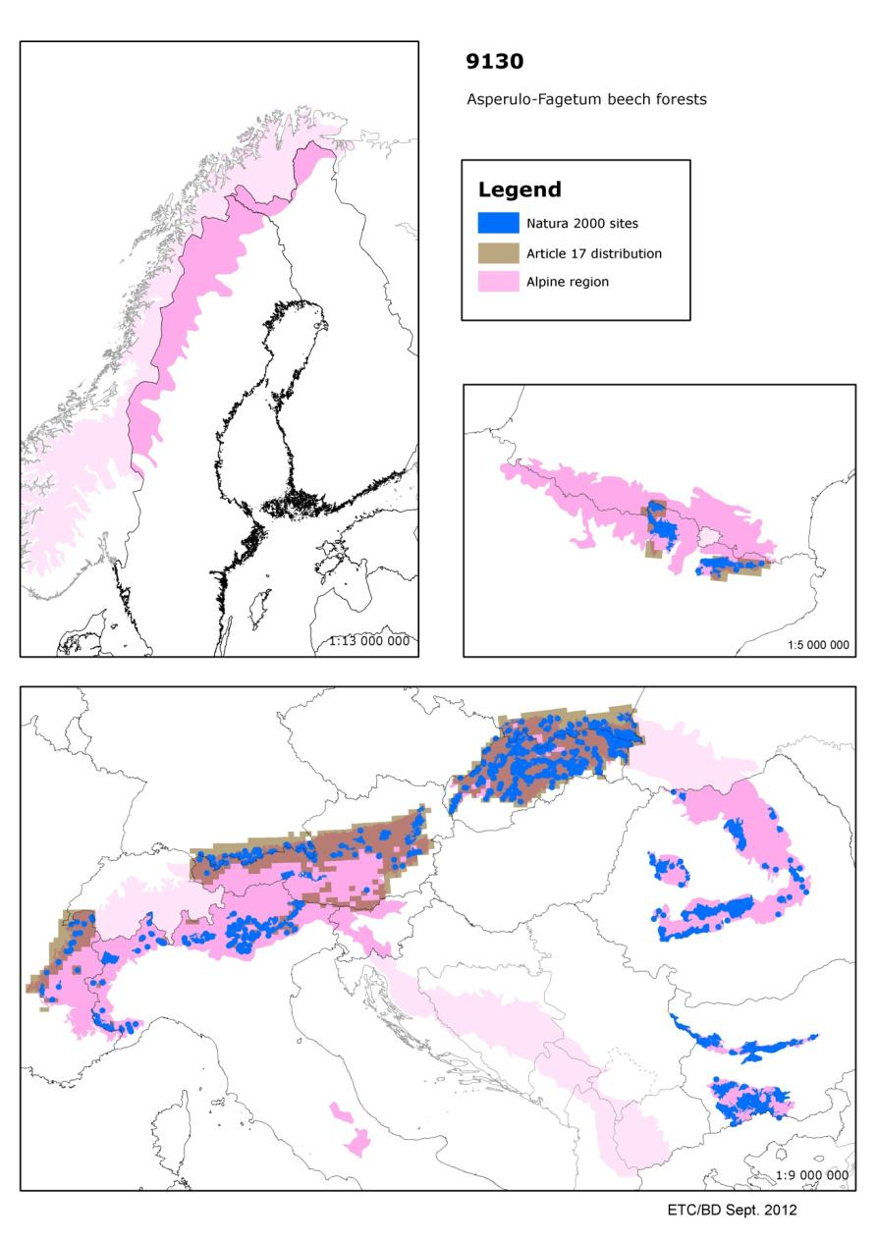

9170 - Galio-Carpinetum oak-hornbeam forests

Habitats Manual 2007
Quercus petraea-Carpinus betulus forests of regions with sub-continental climate within the central European range of Fagus sylvatica, dominated by Quercus petraea (41.261). Also included are related lime-oak forests of eastern and eastern-central European regions with a continental climate, east of the range of F. sylvatica (41.262).

Conservation status (CS) assessed at the Alpine region and MS level:
N2K code | Habitat name |  | AT | BG | PL | RO | SK | REGION
9170 | Galio-Carpinetum oak-hornbeam forests | range | FV |  | FV |  | U1 | FV
 |  | area | FV |  | U1 |  | U1 | U1
 |  | structure | XX |  | U1 |  | U2 | XX
 |  | future | U1 |  | U1 |  | U2 | U1
 |  | overall | U1 |  | U1 |  | U2 | U1

Mixed oak-hornbeam (Quercus spp-Carpinus betulus) forests of central Europe occurring mostly in the areas with a sub-continental climate on various types of soil. The conservation status in the Atlantic region, where the habitat occurs only in Germany and in the Pannonian region, where the species occurs only in the Czech republic is ‘unfavourable bad’. The status in the Atlantic and Continental regions is ‘unfavourable inadequate’ (Summary sheet of the online report on Article 17 of the Habitats Directive).

Other information
According to the ETC/BD calculations 76-100 % of the area of this habitat type are within SCIs. This means that Natura 2000 network provides an important framework for the management of this habitat type.

Number of SCIs and habitat area (ha) within SCIs per Member State in the Alpine biogeographical region
 | AT | BG | IT | PL | RO | SK
Number of sites | 7 | 21 | 1 | 11 | 22 | 4
Habitat area (ha) | 1619 | 89237 | 123 | 3022 | 10079 | 703

Map of SCIs proposed for Galio-Carpinetum oak-hornbeam forests (9170) & Article 17 distribution
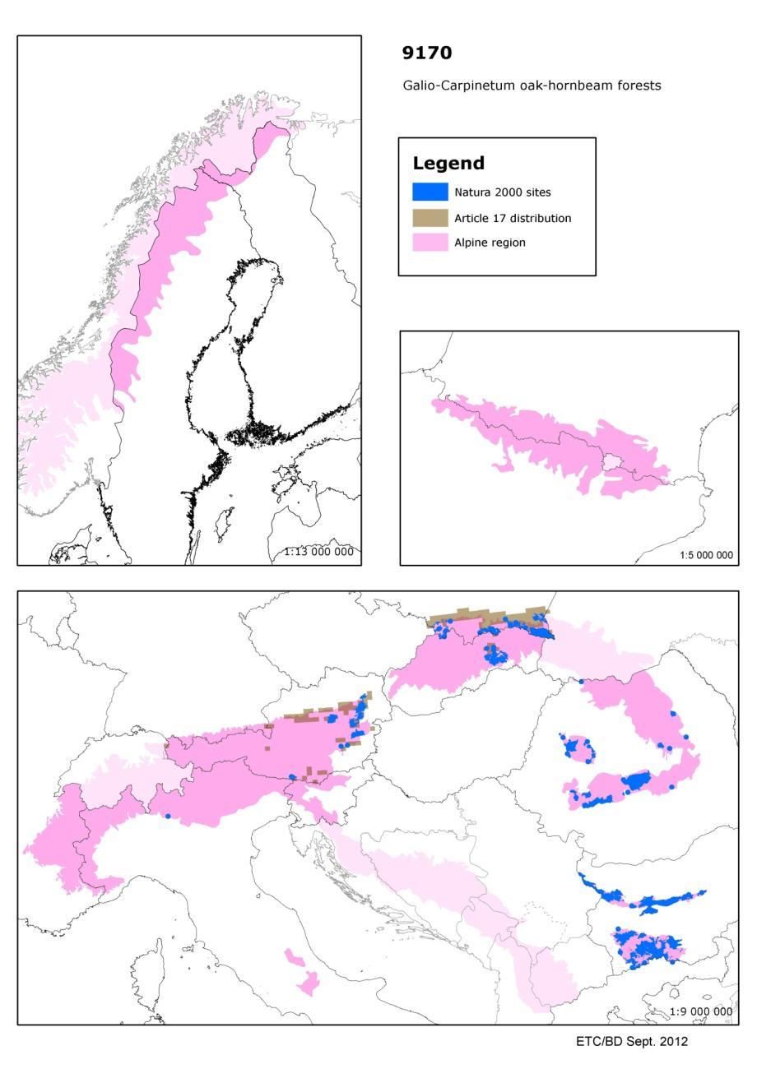

9180 - Tilio-Acerion forests of slopes, screes and ravines

Habitats Manual 2007
Mixed forests of secondary species (Acer pseudoplatanus, Fraxinus excelsior, Ulmus glabra, Tilia cordata) of coarse scree, abrupt rocky slopes or coarse colluvions of slopes, particularly on calcareous, but also on siliceous, substrates (Tilio-Acerion Klika 55). A distinction can be made between one grouping which is typical of cool and humid environments (hygroscopic and shade tolerant forests), generally dominated by the sycamore maple (Acer pseudoplatanus) - sub-alliance Lunario-Acerenion, and another which is typical of dry, warm screes (xerothermophile forests),generally dominated by limes (Tilia cordata, T. platyphyllos) - sub-alliance Tilio-Acerenion. The habitat types belonging to the Carpinion should not be included here.

Conservation status (CS) assessed at the Alpine region and MS level:
N2K code | Habitat name |  | AT | BG | DE | ES | FR | IT | PL | RO | SI | SK | REGION
9180 | Tilio-Acerion forests of slopes, screes and ravines | range | FV |  | FV | XX | FV | FV | FV |  | FV | U1 | U1
 |  | area | FV |  | FV | XX | U1 | FV | FV |  | FV | FV | FV
 |  | structure | U1 |  | FV | XX | XX | FV | FV |  | FV | FV | U1
 |  | future | U1 |  | FV | XX | U1 | FV | FV |  | FV | FV | U1
 |  | overall | U1 |  | FV | XX | U1 | FV | FV |  | FV | U1 | U1

Mixed forests composed of secondary species such as sycamore (Acer pseudoplatanus), ash (Fraxinus excelsior), elm (Ulmus glabra), and limes (Tilia spp) occurring on coarse scree , coarse sediments at the base of slopes or weathered, rocky slopes. Depending on the local climatic conditions, two subtypes can be recognised, a subtype with sycamore dominating in cooler and more humid environments and a second subtype with limes dominating in warm and dry situations.
The conservation status in the Pannonian and in the Atlantic region was assessed as ‘unfavourable bad’, in the other regions it was assessed as ‘unfavourable inadequate’ (Summary sheet of the online report on Article 17 of the Habitats Directive).

Species associated to Tilio-Acerion forests of slopes, screes and ravines and their CS at the Alpine region and MS level
N2K code | Species name | Group |  | AT | BG | DE | ES | FR | IT | PL | RO | SI | SK | REGION
1381 | Dicranum viride | Non-vascular plants | range | U1 |  | FV | XX | XX | U1 | FV |  | FV | XX | U1
 |  |  | population | XX |  | FV | XX | XX | U1 | U1 |  | XX | XX | XX
 |  |  | habitat | U1 |  | FV | U2 | XX | XX | U1 |  | U1 | XX | U1
 |  |  | future | U1 |  | FV | U2 | XX | XX | U1 |  | U1 | XX | U1
 |  |  | overall | U1 |  | FV | U2 | XX | U1 | U1 |  | U1 | XX | U1

N2K code | Species name | Group |  | AT | BG | DE | ES | FR | IT | PL | RO | SI | SK | REGION
1386 | Buxbaumia viridis | Non-vascular plants | range | U2 |  | XX | U2 | FV | FV | U1 |  | FV | XX | U2
 |  |  | population | U2 |  | XX | XX | FV | FV | U2 |  | XX | XX | U2
 |  |  | habitat | U1 |  | XX | XX | FV | XX | U1 |  | FV | XX | XX
 |  |  | future | U2 |  | XX | U2 | XX | FV | U2 |  | XX | XX | U2
 |  |  | overall | U2 |  | XX | U2 | FV | FV | U2 |  | XX | XX | U2

N2K code | Species name | Group |  | AT | BG | DE | ES | FR | IT | PL | RO | SE | SI | SK | REGION
1902 | Cypripedium calceolus | Vascular plants | range | FV |  | FV | U1 | U1 | FV | U1 |  | FV | FV | FV | FV
 |  |  | population | XX |  | FV | XX | FV | FV | U1 |  | FV | FV | U1 | XX
 |  |  | habitat | FV |  | FV | XX | FV | XX | U1 |  | FV | FV | FV | FV
 |  |  | future | FV |  | FV | U1 | U1 | FV | U1 |  | FV | FV | U1 | FV
 |  |  | overall | FV |  | FV | U1 | U1 | FV | U1 |  | FV | FV | U1 | FV

Main pressures to Tilio-Acerion forests of slopes, screes and ravines and their importance to associated species
Pressure description (2nd level) | Tilio-Acerion forests of slopes, screes and ravines | Dicranum viride | Buxbaumia viridis | Cypripedium calceolus
General Forestry management | x | x
Communication networks | x

Main threats to Tilio-Acerion forests of slopes, screes and ravines and their importance to associated species
Threats description (2nd level) | Tilio-Acerion forests of slopes, screes and ravines | Dicranum viride | Buxbaumia viridis | Cypripedium calceolus
General Forestry management | x |  |  | x

Other information
According to the ETC/BD calculations 51-75 % of the area of this habitat type are within SCIs. This means that Natura 2000 network provides an important framework for the management of this habitat type.

Number of SCIs and habitat area (ha) within SCIs per Member State in the Alpine biogeographical region
 | AT | BG | DE | ES | FR | IT | PL | RO | SI | SK
Number of sites | 27 | 20 | 22 | 29 | 45 | 110 | 16 | 28 | 6 | 110
Habitat area (ha) | 3890 | 11584 | 1044 | 3184 | 5075 | 9647 | 630 | 4223 | 1706 | 17060
The figures include all SCIs where the habitat type is mentioned including sites coded as D.

Map of SCIs proposed for Tilio-Acerion forests of slopes, screes and ravines & Article 17 distribution
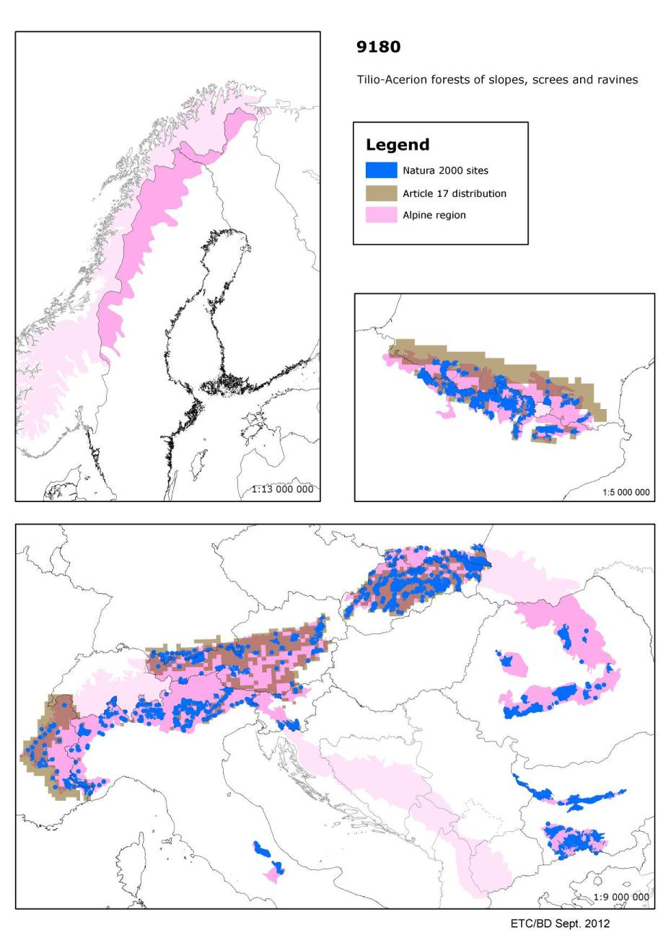

9260 - Castanea sativa woods

Habitats Manual 2007
Supra-Mediterranean and sub-Mediterranean Castanea sativa-dominated forests and old established plantations with semi-natural undergrowth.

Conservation status (CS) assessed at the Alpine region and MS level:
N2K code | Habitat name |  | AT | BG | FR | IT | RO | REGION
9260 | Castanea sativa woods | range | FV |  | FV | FV |  | FV
 |  | area | XX |  | U2 | FV |  | U2
 |  | structure | XX |  | U2 | FV |  | U2
 |  | future | U1 |  | U2 | FV |  | U2
 |  | overall | U1 |  | U2 | FV |  | U2

Natural forests and old established plantations of chestnut (Castanea sativa) with semi-natural undergrowth of Mediterranean mountains and the area to their north.
The conservation status in the Alpine and Continental regions is ‘unfavourable -bad’. In both regions this assessment results from the situation in France, where the habitat area has declined. Chestnut is subject to several diseases which decrease its competitivity with other trees such as oaks (Quercus spp). The conservation status in the Atlantic and in the Mediterranean regions is ’unknown’ due to the incomplete reports from Spain. However, for the Mediterranean regions, where there is a high proportion of the habitat reported as ‘unfavourable-inadequate’, it cannot be not be ‘favourable’ (Summary sheet of the online report on Article 17 of the Habitats Directive).

Other information
According to the ETC/BD calculations 76-100% of the area of this habitat type are within SCIs. This means that Natura 2000 network provides an important framework for the management of this habitat type.

Number of SCIs and habitat area (ha) within SCIs per Member State in the Alpine biogeographical region
 | AT | BG | ES | FR | IT | RO
Number of sites |  | 2 | 1 | 7 | 63 | 3
Habitat area (ha) |  | 150 | 170 | 1195 | 19905 | 1883

Map of SCIs proposed for Castanea sativa woods (9260) & Article 17 distribution
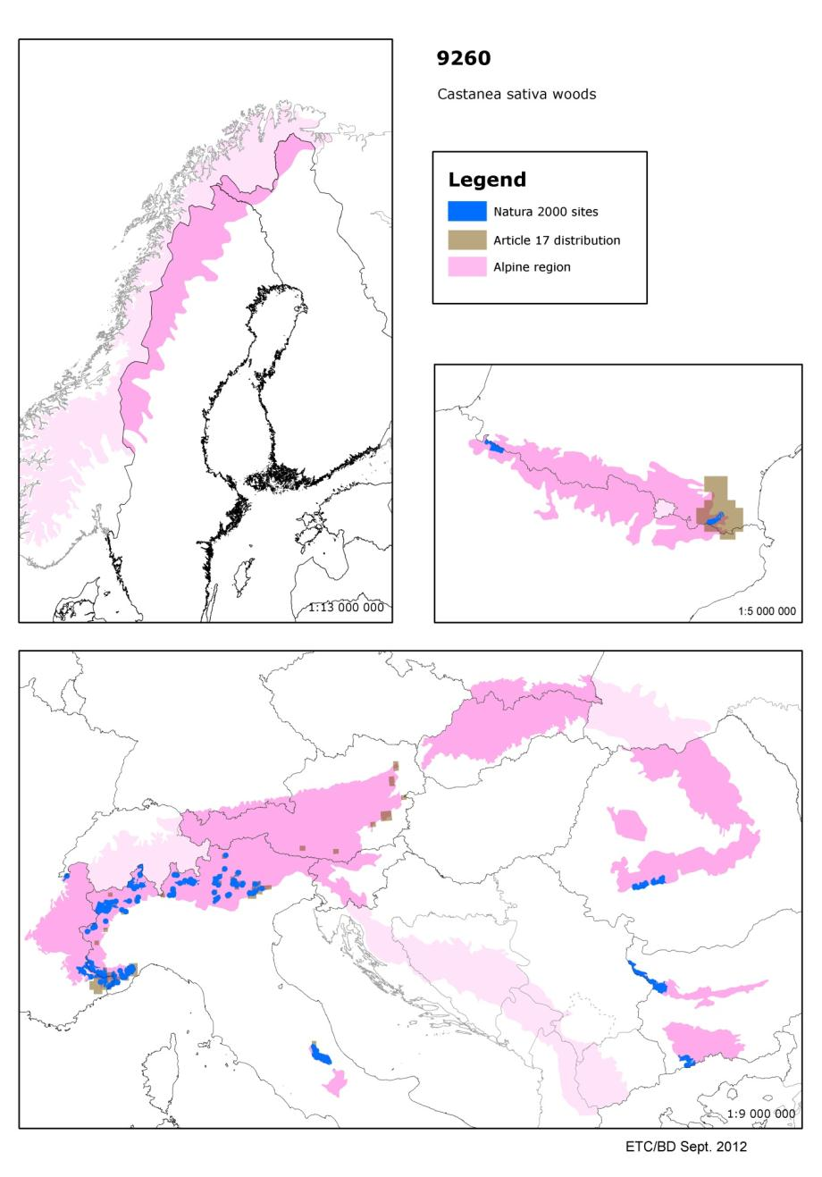

9410 - Acidophilous Picea forests of the montane to alpine levels (Vaccinio-Piceetea)

Habitats Manual 2007

Conservation status (CS) assessed at the Alpine region and MS level:
N2K code | Habitat name |  | AT | BG | DE | FR | IT | PL | RO | SI | SK | REGION
9410 | Acidophilous Picea forests of the montane to alpine levels (Vaccinio-Piceetea) | range | FV |  | FV | FV | FV | FV |  | FV | FV | FV
 |  | area | FV |  | FV | FV | FV | FV |  | FV | U1 | FV
 |  | structure | U1 |  | FV | XX | FV | FV |  | FV | FV | U1
 |  | future | FV |  | XX | FV | FV | FV |  | FV | FV | FV
 |  | overall | U1 |  | FV | FV | FV | FV |  | FV | U1 | U1

Sub-alpine and alpine coniferous forests dominated by Norway spruce (Picea abies) and oriental spruce (Picea orientalis). This habitat is wide spread in the Alps, Carpathians and Hercynian ranges. These forests also occur in the montane zone of the inner Alps and inner Carpathian basins in areas with a climate unfavourable to both beech (Fagus sylvatica) and fir (Abies alba). Outlying Norway spruce formations can also be found in the mountain ranges of southern and southeastern Europe and locally within the montane level of above mentioned mountain ranges.

Although at the national level in the Alpine region ‘favourable’ assessments are widespread, the biogeographical assessment is ‘unfavourable-inadequate’ as a result of assessments by Austria and Slovakia. In the Continental region, the status is ‘unfavourable-bad’ and this conclusion was provided by all the countries of the Hercynian mountain range. In the Mediterranean region the habitat is present only in Greece, where the conservation status is ‘favourable’. The major threats to this habitat include inappropriate forestry management, air pollution and at the higher altitudes development of resorts for winter sports (Summary sheet of the online report on Article 17 of the Habitats Directive).

Other information
According to the ETC/BD calculations 76-100 % of the area of this habitat type are within SCIs. This means that Natura 2000 network provides an important framework for the management of this habitat type.

Number of SCIs and habitat area (ha) within SCIs per Member State in the Alpine biogeographical region
 | AT | BG | DE | FR | IT | PL | RO | SI | SK
Number of sites | 39 | 13 | 22 | 37 | 152 | 12 | 59 | 4 | 27
Habitat area (ha) | 26010 | 62737 | 4195 | 20924 | 94736 | 22712 | 277029 | 1922 | 29313

Map of SCIs proposed for Acidophilous Picea forests of the montane to alpine levels (9410) & Article 17 distribution
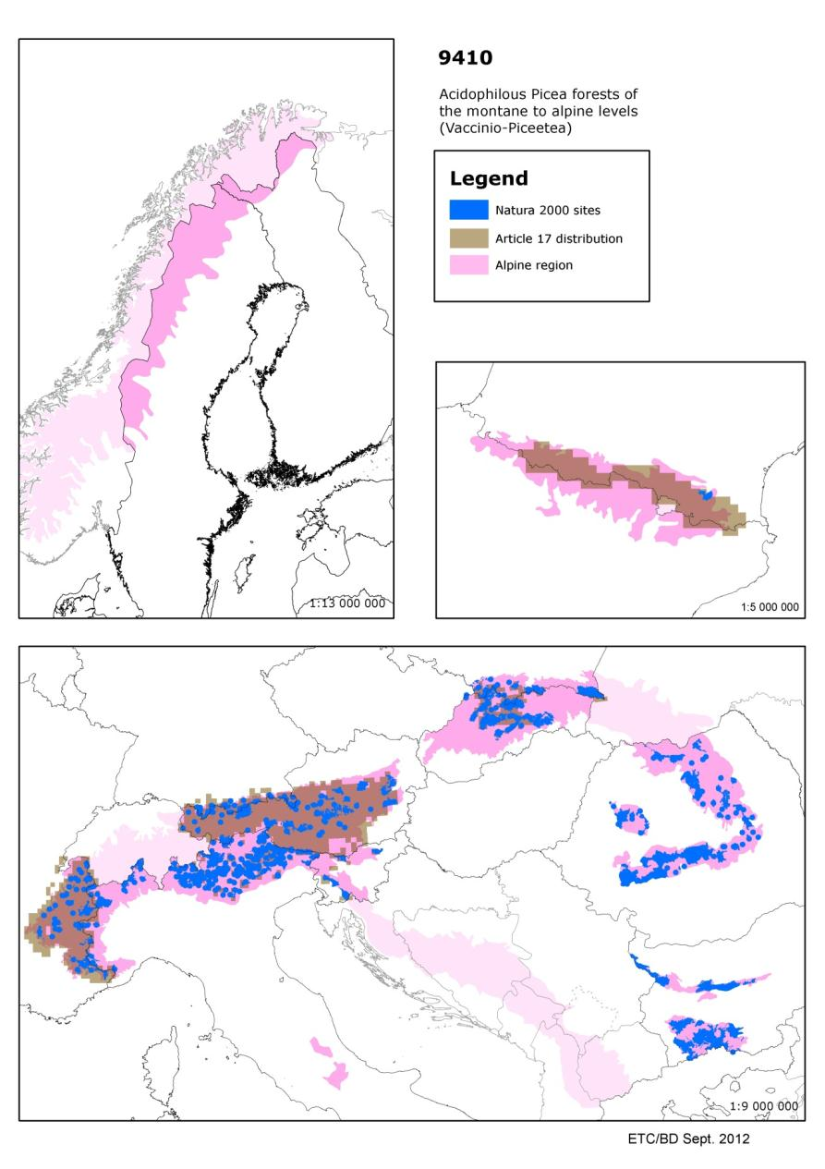

Available online at https://circabc.europa.eu/faces/jsp/extension/wai/navigation/container.jsp?FormPrincipal:_idcl=FormPrincipal:_id3&FormPrincipal_SUBMIT=1&id=31d9c683-b68d-47c7-b80e-900eca33c1e0&javax.faces.ViewState=rO0ABXVyABNbTGphdmEubGFuZy5PYmplY3Q7kM5YnxBzKWwCAAB4cAAAAAN0AAEzcHQAKy9qc3AvZXh0ZW5zaW9uL3dhaS9uYXZpZ2F0aW9uL2NvbnRhaW5lci5qc3A=
http://ec.europa.eu/environment/nature/legislation/habitatsdirective/docs/2007_07_im.pdf
The habitat area is calculated bit differently compared to the calculations for the Natura coverage, thus the habitat area in hectares given in tables of the chapter 6 should be considered as a minimum area.
http://forum.eionet.europa.eu/x_habitat-art17report/library/datasheets/species/invertebrates/invertebrates/rosalia_alpinapdf/download/1/Rosalia%20alpina.pdf?action=view
Nieto, A. and Alexander, K.N.A. 2010. European Red List of Saproxylic Beetles. Luxembourg: Publications Office of the European Union.

